St Joseph’s College (Autonomous), Bangalore-27
B.Sc. Electronics – II Semester
Semester Examination: April 2020
Amplifiers and Oscillators EL-218
Time: 2½ hrs Max.Marks:70
This paper contains three printed pages and three parts
Part A
Answer any five questions 8X5=40
- a) Differentiate between cascade and cascode amplifier.
b) Explain the working of two stage RC coupled amplifier and derive an expression for voltage gain 2+6
- a) With the necessary circuit explain the working of class B push pull amplifier and derive
b) Differentiate between voltage and power amplifier 6+2
- a) What is Barkhausen criterion for oscillations?
b) With the necessary circuit explain the working of Hartley oscillator. Derive an expression for the frequency of oscillations. 2+6
- a) Explain the working of astable multivibrator using transistors. Give the expression for frequency of oscillations
b) What is the need for voltage regulators? Name a variable voltage regulator IC 6+2
- a) Derive an expression for voltage gain of dual input balanced output differential amplifier.
b) Give two characteristics of ideal and practical OPAMP. 6+2
- a) Draw the block diagram of negative series feedback amplifier for OPAMP. Derive an expression for voltage gain for inverting and non-inverting OPAMP.
b) Explain the term virtual ground with respect to OPAMP. 6+2
- a) What is a comparator?
b) Explain the working of Butterworth first order high pass filter. Draw the frequency response. 2+6

Part B
Answer any five questions 4X5=20
- Calculate the voltage gain and input impedance of the circuit given below.
Given β₁ = β₂ = 100 ,Vin=1V

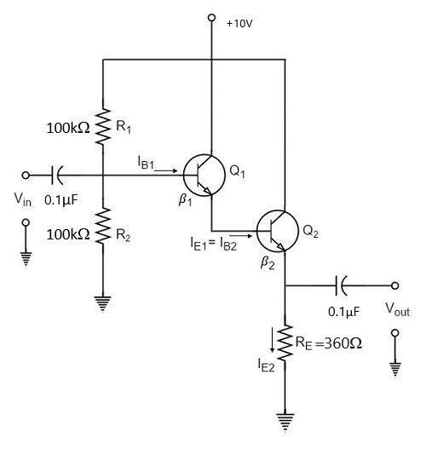
- A class A CE amplifier operates from V_{CC} = 20V draws a current I_{CQ} = 5A and feeds a load of 40Ω through a step-up transformer of N₁/N₂ = 3.16. Find the efficiency of the amplifier when it is properly matched for maximum power supply.
- In a Colpitt’s oscillator C₁ = 0.001µF and C₂ = 0.01 µF, L=10µH. Find the frequency of oscillations, feedback factor and voltage gain.
- In an astable multivibrator using IC555 R_{A} = 2.2kΩ R_{B} = 6.8kΩ and C = 0.01 µF. Calculate (i) T_{High} (ii) T_{Low} (iii) free running frequency and duty cycle.
- The IC741 is configured as a non-inverting amplifier. The following data is given for the circuit. A = 400,000 R₁ ₌ 470Ω R_{i} = 33MΩ R_{F} = 4.7kΩ R₀ = 60Ω. Supply voltage = ±15V. Calculate closed loop gain A_{F}.
- Design a differentiator to differentiate an input signal that varies in frequency from 10Hz to about 1kHz.
- Design a band pass filter with f_{L} = 400Hz f_{H} = 2kHz and passband gain = 4.

Part C
Answer any five questions 2X5=10
- Are power amplifiers large signal amplifiers? Justify your answer.
- Draw the frequency response curve of tight and lose coupling of double tuned amplifier.
- Name two AF oscillators.
- Which multivibrator is used to store 1bit of memory?
- Which ICs are used to get +5V and -12V ?
- What is the difference between first order and second order active Butterworth filter?
- Explain the terms CMRR and SVRR.

