Register Number:
DATE:
ST. JOSEPH’S COLLEGE (AUTONOMOUS), BANGALORE-27
SEMESTER EXAMINATION- APRIL 2020
B.SC. ELECTRONICS- II SEMESTER
EL218: AMPLIFIERS AND OSCILLATORS
Time: 2¹/₂ Hours Max. Marks: 70

This question paper has three parts and three printed pages.

PART-A

Answer any FIVE of the following: 5X8=40

- Write the circuit for a two stage RC coupled amplifier and explain its working. With its equivalent circuit, derive its voltage gain.

- a) With necessary circuits explain class B push pull amplifier and prove that its
maximum circuit efficiency is 78.5%.
b) Differentiate between single tuned and double tuned amplifiers. (6+2)

3. a) Draw an Wein bridge oscillator circuit and explain its working and write the
expression for frequency of oscillation.
b) Draw the circuit for a monostable multivibrator using transistor and explain its
working. Write its expression for its pulse width. (4+4)

4. a) Explain the working of IC555 with the help of its internal block diagram.
b) Define the terms: i) CMRR ii)Slew rate iii)Output Offset voltage. (5+3)

5. With the help of necessary circuits derive the voltage gain for dual input
balanced output differential amplifier.

6. a) Sketch and explain the block diagram of an op-amp.
b) What is a current mirror circuit? Draw the circuit and derive its output current.
(4+4)

7. a) Write the circuit for a voltage shunt feedback amplifier and derive its voltage
Gain.
b) With the help of necessary circuits explain an op-amp integrator. What is the
need for a practical integrator? (4+4)

PART-B

Answer any FIVE questions: 5X4=20

8. Determine the output for the given circuit. (V_{i}=100mV,B₁=B₂=300)

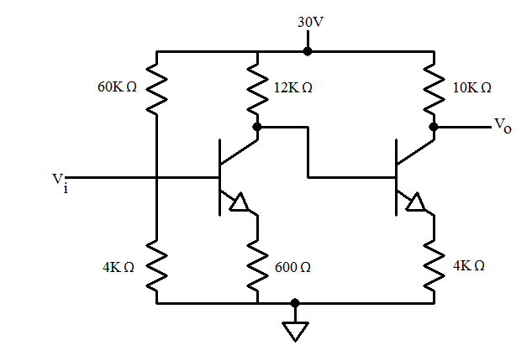
9. A class A amplifier works on 10V dc. If the maximum change in the collector
current is 50mA. Find the power transferred to 4Ω speaker through impedance
matching network.

10. For a given crystal oscillator determine series and parallel resonant frequencies
having the following values. R_{s}=2KΩ, L_{s}=0.1H and C_{s}=0.022pF, C_{m}=0.3pF.
Also find the Q factor for the circuit.

11. Determine the maximum and minimum frequencies of oscillation for given circuit.
Also find duty cycle for IC555 in Astable multivibrator mode when
R_{B}=50K

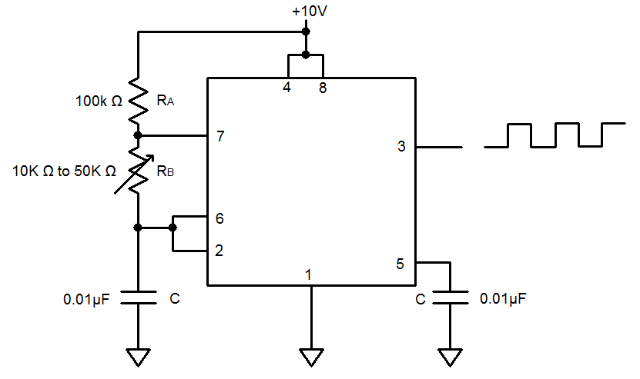

12. The 74IC op-amp having the following parameters is connected as a voltage
series feedback amplifier with R₁=10k and R_{F}=100k, A=2x10⁵, R_{i}=2MΩ,
R_{o}=75Ω, f_{o}=5Hz. Compute A_{F,} R_{iF}, R_{OF}, and f_{f.}

13. Determine V_{o} for the given circuit. (V_{cc}=12V and V_{EE}=-12V all the resistors
have the same value).

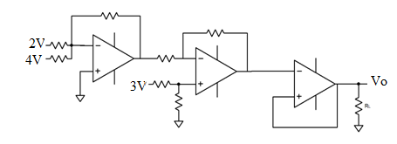

14. Design an active low pass filter for a midband gain of 10 and cut off frequency of
15kHz.

PART-C

Answer any FIVE questions: 5X2=10

15. Class C amplifier is also a tuned amplifier. Justify.

16.Mention the significance of Darlington pair transistor.

17. Bistable multivibrator is also known as a latch circuit. Why?

18. In the given circuit,
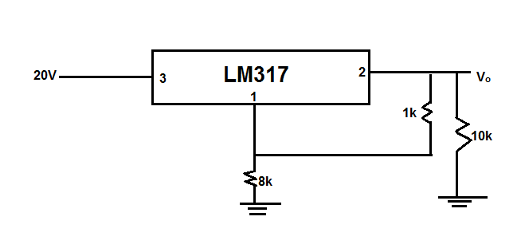
- What is the expected output?
- If 8k is shorted. What is the output?

19. What is meant by UGB? What is its significance.

20. Sketch the output for the following circuit.(V_{CC}=12V,V_{EE}=-12V)
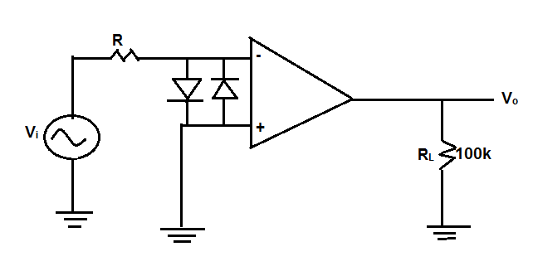
21. What is meant by 2nd order filters? Mention their advantages over first order
filters.

************************************************************************************************

