Register Number:
DATE:
ST. JOSEPH’S COLLEGE (AUTONOMOUS), BANGALORE
End Semester Examination - April 2020
Second Semester BA/ BSc/ BCom/ BBA- General English GE 214

Time: 2 ½ Hours Max. Marks: 70

INSTRUCTIONS
- This booklet contains three themes. You may answer any ONE of them.
- Indicate your stream and theme clearly on the front page of your answer booklet.
- Answer all sections under the theme you have chosen. Do not choose sections at random from different themes.
- You will lose marks for exceeding word limits.
- You are allowed to use a dictionary during the examination.

THIS PAPER HAS 9 PRINTED PAGES
THEME 1
I Read this essay entitled Where do you get your ideas? by Neil Gaiman and answer the questions that follow.
Every profession has its pitfalls. Doctors, for example, are always being asked for free medical advice, lawyers are asked for legal information, morticians are told how interesting a profession that must be and then people change the subject fast. And writers are asked where we get our ideas from.

In the beginning, I used to tell people the not very funny answers, the flip ones: 'From the Idea-of-the-Month Club,' I'd say, or 'From a little ideas shop in Bognor Regis,' 'From a dusty old book full of ideas in my basement,' or even 'From Pete Atkins.' (The last is slightly esoteric, and may need a little explanation. Pete Atkins is a screenwriter and novelist friend of mine, and we decided a while ago that when asked, I would say that I got them from him, and he'd say he got them from me. It seemed to make sense at the time.)

Then I got tired of the not very funny answers, and these days I tell people the truth:

'I make them up,' I tell them. 'Out of my head.'

People don't like this answer. I don't know why not. They look unhappy, as if I'm trying to slip a fast one past them. As if there's a huge secret, and, for reasons of my own, I'm not telling them how it's done.

And of course I'm not. Firstly, I don't know myself where the ideas really come from, what makes them come, or whether one day they'll stop. Secondly, I doubt anyone who asks really wants a three hour lecture on the creative process. And thirdly, the ideas aren't that important. Really they aren't. Everyone's got an idea for a book, a movie, a story, a TV series.

Every published writer has had it - the people who come up to you and tell you that they've Got An Idea. And boy, is it a Doozy. It's such a Doozy that they want to Cut You In On It. The proposal is always the same - they'll tell you the Idea (the hard bit), you write it down and turn it into a novel (the easy bit), the two of you can split the money fifty-fifty.

I'm reasonably gracious with these people. I tell them, truly, that I have far too many ideas for things as it is, and far too little time. And I wish them the best of luck.

The Ideas aren't the hard bit. They're a small component of the whole. Creating believable people who do more or less what you tell them to is much harder. And hardest by far is the process of simply sitting down and putting one word after another to construct whatever it is you're trying to build: making it interesting, making it new.

But still, it's the question people want to know. In my case, they also want to know if I get them from my dreams. (Answer: no. Dream logic isn't story logic. Transcribe a dream, and you'll see. Or better yet, tell someone an important dream - 'Well, I was in this house that was also my old school, and there was this nurse and she was really an old witch and then she went away but there was a leaf and I couldn't look at it and I knew if I touched it then something dreadful would happen...' - and watch their eyes glaze over.) And I don't give straight answers. Until recently.

My daughter Holly, who is seven years of age, persuaded me to come in to give a talk to her class. Her teacher was really enthusiastic ('The children have all been making their own books recently, so perhaps you could come along and tell them about being a professional writer. And lots of little stories. They like the stories.') and in I came.

They sat on the floor, I had a chair, fifty seven-year-old-eyes gazed up at me. 'When I was your age, people told me not to make things up,' I told them. 'These days, they give me money for it.' For twenty minutes I talked, then they asked questions.

And eventually one of them asked it.

'Where do you get your ideas?'

And I realized I owed them an answer. They weren't old enough to know any better. And it's a perfectly reasonable question, if you aren't asked it weekly.

This is what I told them:

You get ideas from daydreaming. You get ideas from being bored. You get ideas all the time. The only difference between writers and other people is we notice when we're doing it.

You get ideas when you ask yourself simple questions. The most important of the questions is just, What if...?

(What if you woke up with wings? What if your sister turned into a mouse? What if you all found out that your teacher was planning to eat one of you at the end of term - but you didn't know who?)

Another important question is, If only...

(If only real life was like it is in Hollywood musicals. If only I could shrink myself small as a button. If only a ghost would do my homework.)

And then there are the others: I wonder... ('I wonder what she does when she's alone...') and If This Goes On... ('If this goes on telephones are going to start talking to each other, and cut out the middleman...') and Wouldn't it be interesting if... ('Wouldn't it be interesting if the world used to be ruled by cats?')...

Those questions, and others like them, and the questions they, in their turn, pose ('Well, if cats used to rule the world, why don't they any more? And how do they feel about that?') are one of the places ideas come from.

An idea doesn't have to be a plot notion, just a place to begin creating. Plots often generate themselves when one begins to ask oneself questions about whatever the starting point is.

Sometimes an idea is a person ('There's a boy who wants to know about magic'). Sometimes it's a place ('There's a castle at the end of time, which is the only place there is...'). Sometimes it's an image ('A woman, sifting in a dark room filled with empty faces.')

Often ideas come from two things coming together that haven't come together before. ('If a person bitten by a werewolf turns into a wolf what would happen if a goldfish was bitten by a werewolf? What would happen if a chair was bitten by a werewolf?'). All fiction is a process of imagining: whatever you write, in whatever genre or medium, your task is to make things up convincingly and interestingly and new. And when you've an idea - which is, after all, merely something to hold on to as you begin - what then?

Well, then you write. You put one word after another until it's finished - whatever it is.

Sometimes it won't work, or not in the way you first imagined. Sometimes it doesn't work at all. Sometimes you throw it out and start again…

Sandman is, occasionally, a horror comic. But nothing I've written for it has ever gotten under my skin like this story I'm now going to have to wind up abandoning (with the deadline already a thing of the past). Probably because it cuts so close to home. It's the ideas - and the ability to put them down on paper, and turn them into stories - that make me a writer. That mean I don't have to get up early in the morning and sit on a train with people I don't know, going to a job I despise.

My idea of hell is a blank sheet of paper. Or a blank screen. And me, staring at it, unable to think of a single thing worth saying, a single character that people could believe in, a single story that hasn't been told before.

Staring at a blank sheet of paper.

Forever.

I wrote my way out of it, though. I got desperate (that's another flip and true answer I give to the where-do-you-get-your-ideas question. 'Desperation.' It's up there with 'Boredom' and 'Deadlines'. All these answers are true to a point.) and took my own terror, and the core idea, and crafted a story called Calliope, which explains, I think pretty definitively, where writers get their ideas from. It's in a book called DREAM COUNTRY. You can read it if you like. And, somewhere in the writing of that story, I stopped being scared of the ideas going away.

Where do I get my ideas from?

I make them up.

Out of my head.

I A Answer the questions that follow in 150 - 200 words: [4x15=60]
- Gaiman says that dream logic isn’t story logic. Narrate your strangest dream and then add a paragraph about whether you agree with him. Do you think there is a possible story in your dream?
- Write a story about a polite doctor who does not know how to deal with people who ask him for free medical advice. You’re allowed to let him lose his temper, if you want.
- Why do you think people look unhappy when Gaiman says he makes up his ideas? Do you think this is a valid answer?
- Gaiman says that the ideas aren’t the hardest bit. From your experience this semester, what do you think the hardest part of writing is?

II Now read this comic by Debbie Ohie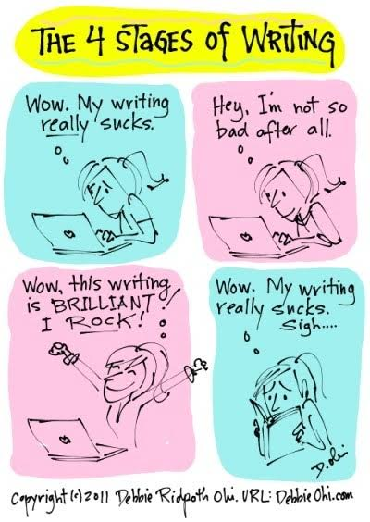
Panel 1 (left): Wow. My writing really sucks. Panel 2(right): Hey, I’m not so bad after all
Panel 3 (left): Wow, this writing is BRILLIANT! I ROCK!
Panel 4(right): Wow. My writing really sucks. Sigh…

II A Respond to the following questions in about 5 sentences: [2x5=10]

- Do you go through similar states of mind when you write?
- Of everything you have written in your General English classes, was there any writing you were proud of? What was it about?

THEME 2
I Read the following article entitled Remembering My Mother’s Table with Fresh Roti in America by Saadia Faruqi
My daughter is mad at me again. The ground beef I’ve cooked is too spicy for her, and what on earth are the green things in it? I tell her that’s cilantro and I only put a pinch of red chili powder. She’s not pacified; she’d rather have chicken nuggets or a grilled cheese sandwich. Anything but Pakistani food.
“Too bad,” I tell her, echoing my own mother from 30-some years ago. “This is what you’re eating tonight.”
My Dinner Table in Pakistan in the 1980s
My childhood dinner table was different in so many ways, but also somehow similar. The same chicken curry, with runny gravy, few spices, and lots of bone-in pieces, has been passed down through generations. It was Pakistan in the 1980s, and I lived with my two sisters, parents, and grandparents in a little house in a little lower-middle-class neighborhood. Our lives swung the pendulum from boring to worrisome. Military dictatorships, corruption, and poverty were on the news constantly, but the only thing I really cared about was what was for dinner.
Forget korma or daal fry (or literally anything with the word masala in the name) — the food at home was something totally different, much less spicy and more flavorful.
My mother, Ammi, was not a very inventive cook, and we got a regular rotation of goat meat (gosht) cooked with the vegetable of the day: aaloo gosht, palak gosht, bhindi gosht … the list was as exhaustive as it was unappetizing. If we were lucky, money-wise, there was chicken, and we fought like hungry cats over the drumstick.
I, of course, wanted nothing to do with her cooking. I came of age in a time when big multinationals were just realizing that third-world countries have exploding, starving populations. KFC opened a location near my college. Pizza Hut became a household name, although spoken in a hushed tone to confer the respect awarded to everything American. My sisters and I snuggled under the covers at night watching American movies and sitcoms. We watched with desperate envy as blonde mothers on the screen baked apple pies and teenagers ate cheeseburgers at diners. When we finally bought a microwave I woke up in the middle of the night to attempt a batch of brownies, just like in the movies.
Ammi in the meantime had graduated us from simple cooking tasks to making the dreaded roti. Also known as the chapatti, this thin, round bread is similar to the tortilla and an essential part of Pakistani home food. At a restaurant we might’ve ordered the carb-loaded naan, or at a wedding eaten the super-greasy sheermal, but at home we only ate the roti. And the woman of the house made it, from scratch. I envied those friends who had servants to cook their rotis for them. Ammi probably wished the same. But we were poor, so Ammi did the cooking.
My two sisters and I kneaded the dough, one girl each day, our little hands aching with the effort. Ten minutes, 15, sometimes 20. If I stopped too soon the rotis would suffer, and everyone would know that the dough had not been kneaded sufficiently. Ammi would come up behind me and push a finger into the mixture, checking for firmness, jabbing until satisfied. Then she’d refrigerate the dough for a few hours until it was time.
The routine was as familiar to me as it was hated. Take out the skillet, heat it up until a faint smoke rises to your eyes and makes them water. Make little round balls with the dough, pat them with dry flour, roll them into flat circles, and then place gently on the hot skillet and let cook. Roti-making is an art. You have to wait until just the right moment to flip the roti over. It should puff up thus, filled with heat that will burn your fingers if you get too close. You have to make the perfect circle. And it must always be warm and fresh.
Ammi, of course, couldn’t make fresh rotis all the time because she worked. To a nation of homemakers, this was weird and possibly terrible. She’d cook in the morning before heading out to her afternoon-shift college where she was first teacher and then principal, her clothes smelling of sweat and spices. Then she’d come back in the evening exhausted. No big deal. We would take the rotis out of the freezer, wrap them in cloth, and heat them in the microwave. As I got older, I understood that was the sole purpose of the microwave.
My American Dinner Table Today
Now, as an American woman in my 40s, my childhood in Pakistan is nothing but a distant memory. The rotis of my youth are usually replaced by frozen naan produced by Indian companies assured of their sales because of busy immigrant moms.
Now I am the bad mother, serving my children factory-manufactured, unhealthy, and (gasp!) frozen bread. I can imagine that for all the miles between us, Ammi and I aren’t that different. Sometimes one must give up traditions that sap all your energy and leave you a husk of a woman with watering eyes and ungrateful children.
My dinner table has changed. As a child, I often ate alone with my sisters after school. Now I make it a point for the family to eat at least one meal together. Of course, we are lax in our American ways. My father never allowed reading or television during mealtimes; we usually focused on the sounds of spoons against plates (or kicking each other under the table). Now my children have developed a tradition of their own: watching Netflix during dinner.
Then I wonder if every generation has the same worry of disappearing traditions in the face of new ones. From my grandmother to Ammi, and now to myself in a small house thousands of miles away from where I grew up, we all witness a loss of how our own table was set so long ago.
Some days, I want to feel closer to those early traditions, to Ammi. I knead some dough, just enough for a few rotis. I’m expecting the familiar wrist cramp, but it doesn’t come. My wrist is bigger, stronger. I heat the skillet, make little balls, drop half a bowl of flour on the counter in an attempt to act traditional. The watering in my eyes is the same, at least. My rotis come out stiff and elongated, nothing like the fluffy, perfectly round ones Ammi used to make. My daughter stands next to me, wide-eyed. She wants to know what this is, how to make it. In her excitement, she agrees to taste it, and I see the beginning of a smile on her little face.
“Can I?” she asks. I let her play with the dough, showing her how to knead correctly, how to use the finger to test its readiness. I wonder suddenly if this dying art of roti-making can indeed be passed down to a new generation, one that has not even cultivated the taste of real Pakistani foods.
I A Answer the questions that follow in 150-200 words: [3x10=30]

- The author refers to the art of roti-making as a dying art. Do you agree with this? Explain.
- Food is a way of staying in touch with our childhood. What are some other ways you keep your childhood alive?
- Each generation makes its own traditions. How have traditions changed over the years in your family?

II A Answer the questions that follow in 200-250 words: [2x15=30]

- Now, many dishes combine elements from Indian cooking and Western cooking (chicken tikka pizza, for instance). If you could create your own “fusion” dish what would it be and why did you choose that combination?
- What is the strangest thing you have ever eaten? Describe it.

III. Observe the below cartoon carefully:
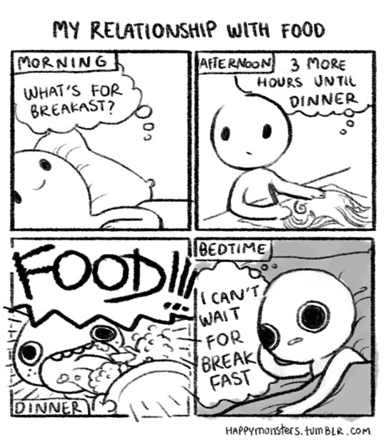
Panel 1 (left): Morning. What’s for breakfast? Panel 2 (right): Afternoon. 3 more hours until dinner Panel 3 (left): Dinner. FOOD!!! Panel 4 (right): Bedtime. I can’t wait for breakfast.
III A. 1. The character in the cartoon seems to enjoy food at all times. What is your experience? Do you have a favourite mealtime? [1 * 15 = 15]

THEME 3
I Carefully read the following review by Alison Flood of A boy, a mole, a fox and a horse :
When he sat down to draw a boy talking to a horse, the illustrator Charlie Mackesy was working out his own feelings. But his drawing of a horse confessing the bravest thing he’s ever said was “Help” became an online sensation. The book that image inspired is now topping charts on both sides of the Atlantic, with Mackesy’s publisher printing hundreds of thousands of copies to meet demand.
Mackesy, who has been a cartoonist for the Spectator and a book illustrator for Oxford University Press, says the straightforward, heartfelt conversations between the characters in The Boy, the Mole, the Fox and the Horse were drawn from “conversations I’ve had with my friends about what life really means, what’s important; it was a way for me to think aloud on paper with words and drawings.”

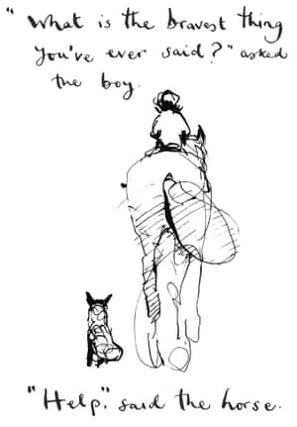

‘What is the bravest thing you’ve ever said?’ asked the boy. ‘Help,’ said the horse. Illustration: Extracted from The Boy, the Mole, the Fox and the Horse by Charlie Mackesy/Ebury Press
The first, featuring the horse and the boy, stemmed from “a conversation I had with my friend Bear [Grylls] about what courage really looked like” and “the bravest thing we’d ever done”. While Grylls may be “an emblem of courage”, Mackesy continued, “the bravest thing I’d ever done was when I was struggling and had the courage to ask for help. So I drew it.”
“I put that up on Instagram and forgot about it, and the next thing I knew was that hospitals and institutions had been using it, and the army had been using it for PTSD, it went crazy. I wasn’t aware of it. Occasionally I’d get emails saying ‘I hope you don’t mind we used it in our therapy unit, it’s helping people realise it’s a brave thing to show weakness’.”
Mackesy made the drawing at “a time of life when I had lost a friend, when things make you think harder about what really matters”.
“All four characters represent different parts of the same person,” he explained, “the inquisitive boy, the mole who’s enthusiastic but a bit greedy, the fox who’s been hurt so is withdrawn from life, slow to trust but wants to be part of things, and the horse who’s the wisest bit, the deepest part of you, the soul.”
An editor at Ebury, Laura Higginson, came across Mackesy’s pictures last summer, when the illustrator had already amassed 30,000 followers on Instagram. “It wasn’t a formal proposal from a literary agent,” she said, “I saw it and I thought ‘this is really moving’.” Higginson met him at an exhibition of his illustrations but according to the author, when he came up with the narrative thread which links his characters together “we both started crying”.
Published on 10 October, the book has sold 51,610 copies according to BookScan. It’s No 1 on Amazon, has hit bestseller charts in the UK and the US, and has been shortlisted for the Waterstones book of the year. “We initially costed the book on 10,000 copies,” said Ebury managing director, Joel Rickett. “Two weeks after publication we have 200,000 copies in print and we’re scrambling to find the capacity to print another 100,000.”
According to Waterstones’ Kate McHale, the hardback will be a key Christmas title. “It’s doing exceptionally well,” she said. “We’ve been absolutely delighted – it’s such a lovely book, about having courage in difficult times, about love and friendship and how that builds resilience, which makes it universal. People are coming in and buying multiple copies, for themselves and for their friends.”
Higginson said that readers – including one woman who bought 25 copies at an Oxford signing – were responding to Mackesy’s ability to “put just the right words and images together, as well as the universal values in the book”.
“No matter who you are, what age you are, what your belief system is, there are universal feelings and experiences which unite us all,” she said. “That might sound fluffy but I think it has come out at the perfect time – it’s the antidote to Brexit and its values just resonate.”
Mackesy confessed he was staggered by the book’s success and fears people will “suddenly realise it’s not a very good book”.
“Sometimes I wake up in the middle of the night feeling incredibly vulnerable that I’ve said these things and they’re so widely looked at but that’s fine,” he said. “I just hope it carries on helping people … Some, I’m sure, will loathe it but for people who it encourages inspires and lifts – what a privilege!”
I A Based on your reading, answer the questions that follow in 120-150 words: [4x10=40]

- Do you think it is brave to ask for help? Explain
- What is the bravest thing you wish you had done?
- “Sometimes I wake up in the middle of the night feeling incredibly vulnerable that I’ve said these things.” Do you agree that in showing your art to someone else, you are allowing yourself to be vulnerable?
- Why does Mackesy use animals to tell his story?

II A Provide responses to these questions in 150-200 words: [2x15=30]

- Madeline l’ Engle says, ““You have to write the book that wants to be written. And if the book will be too difficult for grown-ups, then you write it for children.” Do you think it is possible for children’s books to convey things that books for grown-ups cannot?
- What is the most important lesson you have learnt from a story?

