DATE:
REGISTER NO.:

ST. JOSEPH’S COLLEGE (AUTONOMOUS), BANGALORE- 27
END SEMESTER EXAMINATION- II SEMESTER BCA/BVC: APRIL 2020
GE 414 :GENERAL ENGLISH - MEDIA, CULTURE AND TECHNOLOGY (MCT)

Time: 2 ½ Hours Max. Marks: 70

INSTRUCTIONS:
- You are allowed to use a dictionary.
- This paper contains FIVE printed pages and THREE sections.
- You will lose marks for exceeding the word limit.

SECTION – A

I. Read the following post by Monica Tata on her Instagram page ‘Doodledrama’:

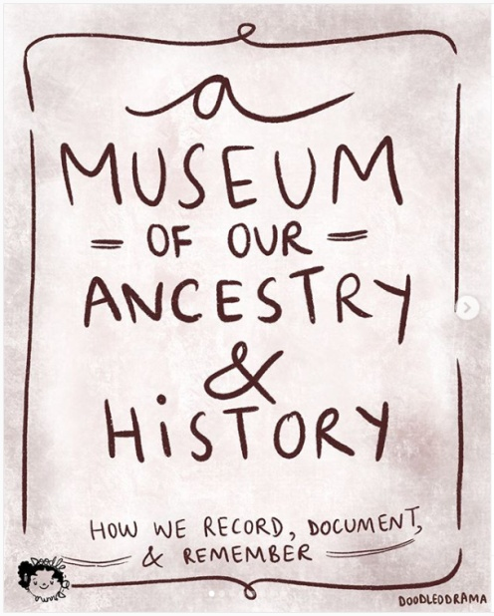
Image 1 – A museum of our ancestry and history – how we record, document and remember…

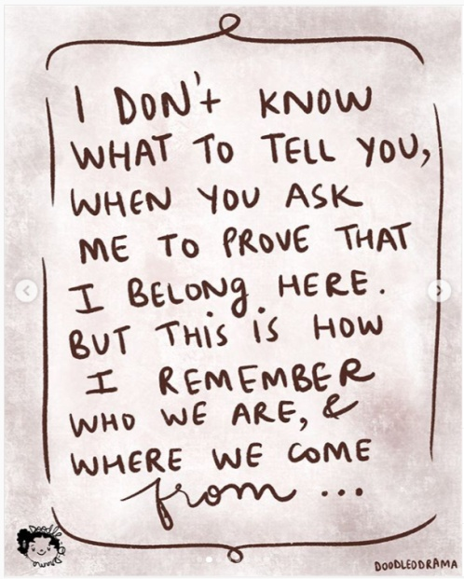
Image 2 – I don’t know what to tell you, when you ask me to prove that I belong here. But this is how I remember who we are and where we come from
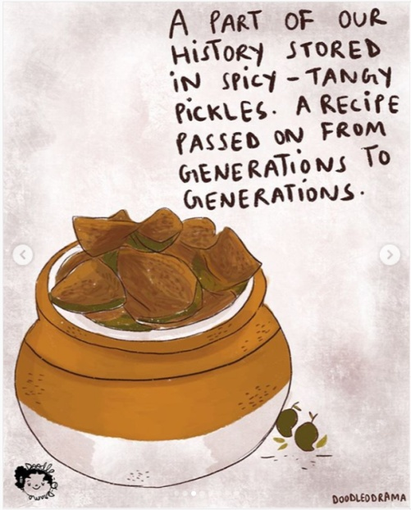
Image 3 – A part of our history stored in spicy – tangy pickles. A recipe passed on from generations to generations.

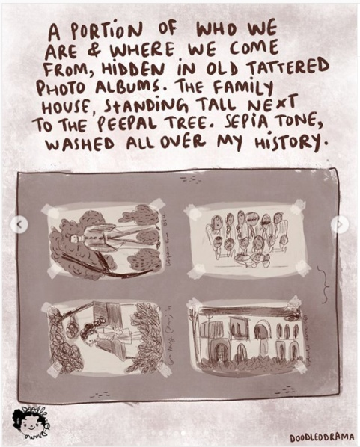
Image 4 – A portion of who we are and where we come from, hidden in old tattered photo albums. The family house, standing tall next to the peepal tree. Sepia tone, washed all over my history.
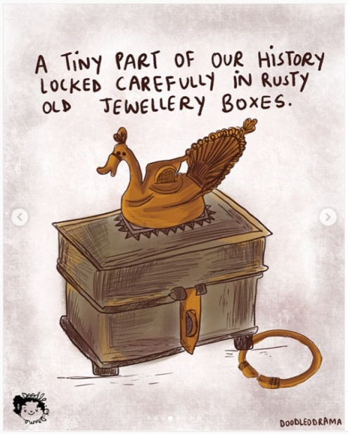
Image 5 – A tiny part of our history locked carefully in rusty old jewellery boxes.

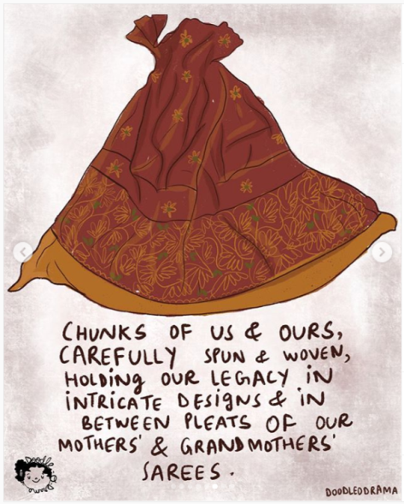
Image 6 – Chunks of us and ours, carefully spun and woven holding one legacy in intricate designs and in between pleats of our mothers’ and grandmothers’ sarees.
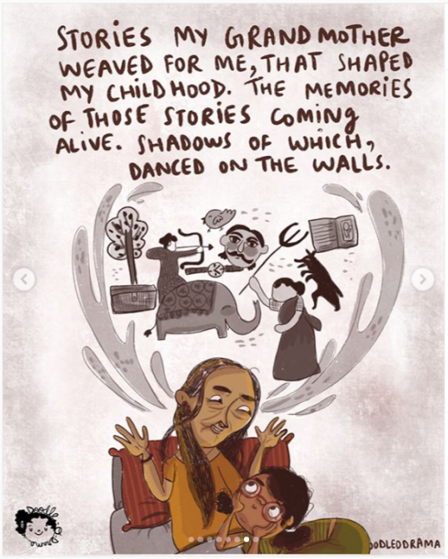
Image 7 – Stories my grandmother weaved for me that shaped my childhood. The memories of those stories coming alive. Shadows of which, danced on the walls.
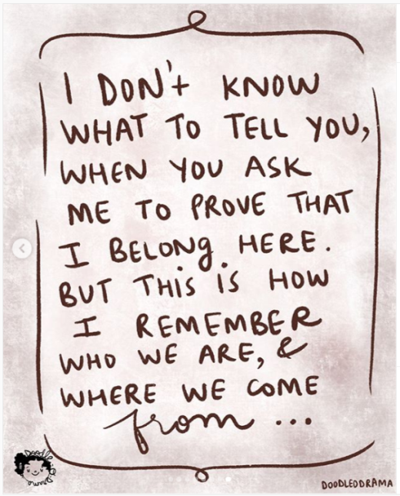
Image 8 – I don’t know what to tell you, when you ask me to prove that I belong here. But this is how I remember who we are and where we come from…

I. A. Based on your reading of the above post, answer the following questions in about 200 words each. (2 x 15 = 30)
1. “I don’t know what to tell you, when you ask me to prove that I belong here.” Identify the speaker in this line? What do you think is the dilemma the speaker is facing here? Elaborate.

2. The post is titled as ‘A Museum of our Ancestry and History.’ How do you understand the words ‘Museum’ and ‘History’? What understanding of these words do you derive from the post?
SECTION - B
II. Read the following excerpt from the article titled ‘The Future of Historical Sources – The Meme?’ from the website Hisdoryan.
When I was in my final year studying History I completed a module all about Georgian satirical cartoons as primary historical sources. I was immediately hooked by the lively work of Gillray, Rowlandson, Cruickshank and their friends. I spent happy hours pouring over their cartoons, deciphering the complex symbolism as if it was a code worthy of a Dan Brown novel.
The concept of a political cartoon actually dates back to the Renaissance when contemporaries of Leonardo Da Vinci would satirize his work. I can confidently say the political cartoon has endured and is now a recognised historical source. Every GCSE and A-level history student who sat their exams this summer will have encountered at least one cartoon source among their many papers.
However, the political cartoon has a serious contender – the modern-day meme. Like cartoons, memes stand at the crossroads of seriousness and light-heartedness. They often appear as a reaction to a topical event and in some cases can act as a political commentary. When you consider their function, there is every possibility a meme may end up as a historical source in a future history exam paper.
Could we actually use memes as historical sources?
The short answer is yes. Political cartoons and political memes essentially do the same thing – they exaggerate and simplify complex events so that they can be understood by a wider audience. They also offer a distinct insight into (a specific part of) public opinion at the time they were produced.
Like a political cartoon, the meme tries to make events as accessible as possible to the ordinary person. In fact, one could argue they are even more accessible than cartoons. Firstly, memes are disseminated via the internet and social media, and are therefore available to billions of people. In contrast, political cartoons are seen by an ever-decreasing audience as newspaper sales wane year-on-year. Secondly, whereas political cartoons use symbolism that may not be understood by everyone, memes often use a previous ‘established’ meme, take the same and picture and text, and then tweak it slightly. People know what the underlying message of the meme is, because they have seen the same meme format several times before.
Memes also share many weaknesses with their political cartoon cousins. Both can be seen as very unrepresentative. Political cartoons may reflect the readership or political bias of a political newspaper, whereas it can be argued that political memes are skewed towards representing the views of younger people. Both are hardly any attempts at an objective historical analysis...

II. A. Answer ANY TWO of the following questions based on your reading of the passage in about 150-175 words. (2 x 10 = 20)
3. The author compares modern day memes to *Georgian satirical cartoons as primary historical sources. Do you see them functioning similarly? Comment.
(*The Georgian era is a period in British history from 1714 to c. 1830–37)

4. “Memes also share many weaknesses with their political cartoon cousins. Both can be seen as very unrepresentative.” Look up the word ‘representative’ in the dictionary. What does the author mean by memes being unrepresentative? Explain.

5. ‘Like cartoons, memes stand at the crossroads of seriousness and light-heartedness.’ From your experience of reading memes online do you think this description is appropriate? Elaborate using examples.

II. B. Examine the image given below.
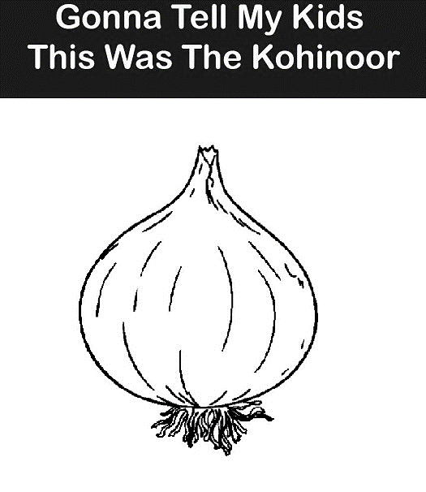
II. B. Based on your examination of the above meme answer the following questions in about 150 words. (1 x 10 = 10)
6. What recent incident does this meme highlight? What would a person viewing this image 100 years from now decipher from it? Elaborate.
SECTION - C
III. Answer the following question in about 250 words. (1 x 10 = 10)
7. Under the subject Media, Culture and Technology (MCT), if students in the year 2050 were to study ‘Internet Culture in the decade of 2010 – 2020’ in the ‘Internet as Archive’ module, what topics would you suggest should be included from the decade? Give three suggestions and explain your choices.

