Register Number:
Date: 08-04-2019
ST. JOSEPH’S COLLEGE (AUTONOMOUS), BANGALORE-27
M.COM – II SEMESTER
SEMESTER EXAMINATION: April 2019
CO 8118 – Cost and Management Accounting
Time- 2 ½ hrs Max Marks - 70
This paper contains 5 (FIVE) printed pages and four parts SECTION A
Answer any TEN (10) of the following (10 * 2 Marks = 20 Marks)
- What is differential costing?
- Explain Cost Volume profit Analysis
- From the following information, calculate the profit using marginal costing technique:
Fixed cost: 3,00,000
Variable cost per unit Rs 5
Selling price per unit Rs 10
Output level 1,00,000 units
- Differentiate cost drivers and cost activities.
- What is master budget?
- Explain the term ‘Incremental Costing’.
- Differentiate between ABC analysis and ABM analysis.
- Give example for variable and semi-variable costs.
- Explain the term ‘Zero Based Budgeting’.
- Explain variance analysis.
- What is target costing?
- What is lean costing?

SECTION B
Answer any THREE (3) of the following (3 * 5 Marks = 15 Marks)
- What are the features of marginal costing?
- What are the characteristics of budgetary control?
- The cost formulas for Swan Company’s manufacturing overhead costs are given bellow the costs cover range of 8,000 to 10,000 machine-hours.
Overhead Costs Costs Formula
Supplies Rs 0.20 per machine-hour
Indirect Labor Rs 10,000 plus Rs 0.25 per machine-hour Utilities Rs 0.15 per machine-hour
Maintenance Rs 7,000 plus Rs 0.10 per machine-hour
Depreciation Rs 8,000

Required:
Prepare a flexible budget in increments of 1,000 machine-hours. Include all costs in your flexible budget.
- The standard mix to produce one unit of product is as follows:
Material A 60 units @ Rs. 15 per unit = Rs. 9,00
Material B 80 units @ Rs. 20 per unit = Rs. 1,600
Material C 100 units @ Rs. 25 per unit = Rs. 2,500
240 units Rs. 5,000
During the month of April, 10 units were actually produced and consumption was as follows:
Material A 640 units @ Rs. 17.50 per unit = Rs. 11,200
Material B 950 units @ Rs. 18.00 per unit = Rs. 17,100
Material C 870 units @ Rs. 27.50 per unit = Rs. 23,925
2,460 units Rs. 52,225

Calculate and analyse the following variances:
- Material cost variance
- Material price variance

- Write short notes on: (answer any two)
  - throughput costing
  - Kaizen costing
  - Balance score card

SECTION C
Answer any TWO (2) of the following (2 * 10 Marks = 20 Marks)
- PBE Co. is an ice cream producer. Currently it produces at capacity and sells ice cream in two flavors: vanilla and mocha-almond. The company is using traditional costing, under which indirect costs are allocated based on direct labour hours. The operating data for PBE Co. in March 2017 is as follows.

 | Vanilla | Mocha - almond
Units produced and sold | 50,000 | 1,000
Price | Rs 30 | Rs 50
Direct labour hours per unit | 0.02 | 0.02
Direct labour cost per hour | Rs 50 | Rs 50
Machine hours per unit | 0.01 | 0.01
Machine setup hours per production run | 4 | 6
Number of production runs | 50 | 10
Direct materials used | Rs 300,000 | Rs 10,000

The company incurs manufacturing overheads totaling Rs 1,275,000 in March 2017. An interview with the production manager shows that the following activities are required in the production process during the month.

Activity | Hierarchy | Cost driver | Costs (Rs)
Run machine | Unit-level activity | Machine hours | 510,000
Handle production run | Batch-level activity | Production runs | 144,000
Setup machine | Batch-level activity | Machine setup hours | 520,000
Support products | Product-sustaining activity | Number of product | 101,000
 |  |  | 1,275,000

Required:
- Calculate the profit for each product using traditional costing.
- Calculate the profit for each product using ABC.
- Comment on the results calculated above

- Interpret the following Break even chart with your own understanding
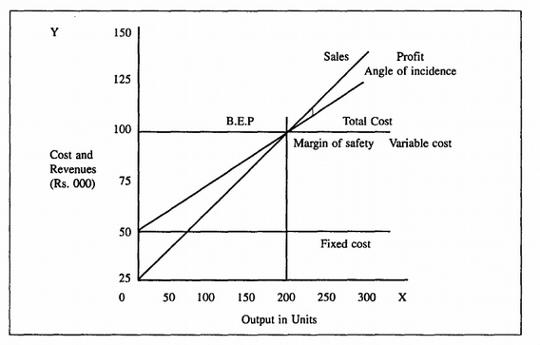
- The following forecast is available from the present budget being prepared by XWY Ltd
 | May | Jun | Jul | Aug
Sales | 800 | 900 | 800 | 700
Salaries | 150 | 180 | 180 | 220
Overhead | 100 | 150 | 170 | 170
Other information is as follows:
- All sales are made on credit to customers who pay in the month following sale
- All goods are bought on credit from suppliers who allow for payment in the month following purchase
- All sales are at cost plus 25%
- Salaries and wages are paid in the month in which they are earned.
- Overhead expenses include depreciation amounting to Rs50,000 each month. Payments are made in the month following the month in which expenses are incurred.
- A dividend amounting to Rs20,000 will be paid in July
- A delivery van is to be sold for Rs15,000 cash in August
- The balance at the bank on 1 June is expected to be Rs90,000

Required:
- Construct a monthly cash budget for the three months ending 31st August, showing the bank balance at each month end.
- Interpret the budget.

SECTION D
COMPULSORY QUESTION (1 * 15 Marks = 15 Marks)
- The Dynamic Company has three divisions. Each of which makes a different product. The budgeted data for the coming year are as follows:

Particulars | A (Rs) | B (Rs) | C (Rs)
Sales | 1,12,000 | 56,000 | 84,000
Direct Material | 14,000 | 7,000 | 14,000
Direct Labour | 5,600 | 7,000 | 22,400
Direct Expenses | 14,000 | 7,000 | 28,000
Fixed Cost | 28,000 | 14,000 | 28,000
Total | 61,600 | 35,000 | 92,400

The Management is considering to close down the division ‘C’. There is no possibility of reducing fixed cost. Advise whether or not division ‘C’ should be closed down.

--- End of the question paper ---

CO 8118_A_19

