ST. JOSEPH’S COLLEGE (AUTONOMOUS), BENGALURU-27.
Register Number:
Date:10/04/2019
M.Sc MICROBIOLOGY - II SEMESTER
SEMESTER EXAMINATION- APRIL 2019
MB -8218 Immunology

Time: 2 1/2hrs Max Marks: 70

This paper contains 2 printed pages and 4 parts

I. Answer any Five of the following 5 x 3 =15

- Define apoptosis. Mention two genes that initiate and inhibit apoptosis.

- What are APC’s? Classify and give examples.

3. Mention the functions of S protein, CI inhibitor and DAF regulatory proteins of the
complement system.

4.What is antigenic shift and drift?

5.Give the differences between B and T cell epitopes.

6. How do NK cells recognize potential target cells?

7. Mention the advantage and disadvantage of attenuated vaccines.

II. Answer any Five of the following 5 x 5 =25

8.Explain how nutrition affects immunity?

9. Explain Immunofluorescence.

10.How can nanogram amounts of total serum IgE be determined?

11. Describe HLA typing.

12. Draw a neat labelled diagram of the organ which filters blood borne pathogens.

13. Define immunological tolerance and add a note on clonal deletion of Bcells.

14. Write a note on cancer immunotherapy.

III.Answer any Two of the following 2x10=20

15. Explain the mechanism of recognition and activation of T cell.

16. Describe what happens in Myasthenia gravis and Multiple Sclerosis?

17. Give a detailed account of the mechanism involved in an inflammatory response.

IV. Answer the following 1 x10=10

18. a) An antibody made against the antigen tetanus toxoid (TT) reacts with it even when the
TT is denatured by disrupting all disulfide bonds. Another antibody against TT fails to
reactwhen the TT is similarly denatured. Explain giving a suitable reason.-5

b) An antigen—antibody immune complex in a C3-deficient individual will still result in
---------- .Give reasons for each of the following. -5
A) anaphylatoxin production.
B) depression of factor B.
C) production of chemotactic factors.
D) activation of C
E) activation of C5

MB -8218-A-19

M.Sc II Semester MB-8218A-19

Scheme of Evaluation APRIL -2019

      - Define – sequential orderly events of cell death or programmed cell death -1 .intiation – bax, capsases,Fas, bcl-X_{s} any two 0.5x2=1
inhibition – bcl-X_{l} ,bcl-2 0.5x2=1

      - APC’s –Antigen Presenting cells they process and present the antigens for immune
response -1
Classify -Professional APC- Bcells, Dendritic cells and Macrophages -1
Non Professional apc- Fibrobasts, glial cells ,vascular endothelia cells.-1

- S protein– Binds soluble C567 and prevents its insertion into the cell membrane-1
CI inhibitor - causes C1r₂s₂ to dissociate from C1q -1
DAF – accelerates the dissociation of C4b2a and C3bBb1

- antigenic shift -1.5
drift -1.5

5.Any three 1x3=3 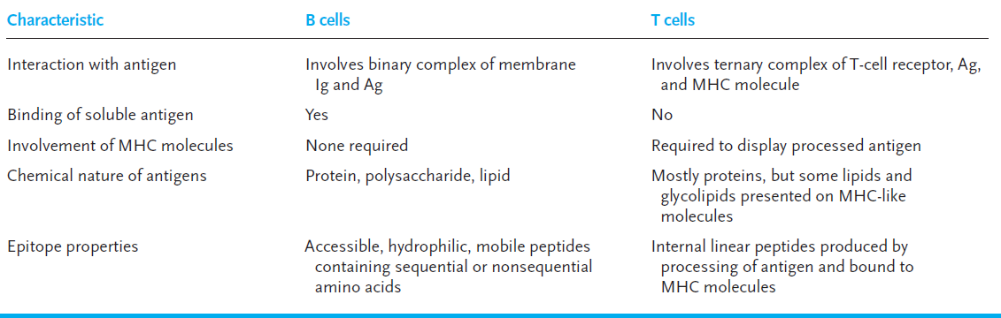

- NK-Natural killer or Null cells cells recognize potential target cells by
NK cells employ NK cell receptors to distinguish abnormalities, notably a reduction in the display of class MHC1 molecules and the unusual profile of surface antigens displayed by some tumor or virus infected cells.1.5
The other way is when tumors and viruses display antigens and the immune response produces antibodies against this . The NK cells produce CD16 receptor which binds the FC portion of the IgG antibody which in turn binds the tumor or viral antigen and brings about its cytotoxic effect. ADCC (Porins,granzymes)1.5

- Advantage -Attenuated vaccines provide prolong immune system exposure to the individual epitopes on the attenuated organisms, resulting in increased immunogenicity and production of memory cells. As a consequence, these vaccines require only a single immunization, eliminating the need for repeated boosters. 1.5
Disadvantage- Major revert to the virulent form causing disease. May be associated with complications similar to those seen in natural diseases. -1.5

II. Answer any Five of the following 5 x 5 =25

8.Explain –nutrition. Proteins, Cu, Fe Zn etc -5
9.Immunofluorescence-.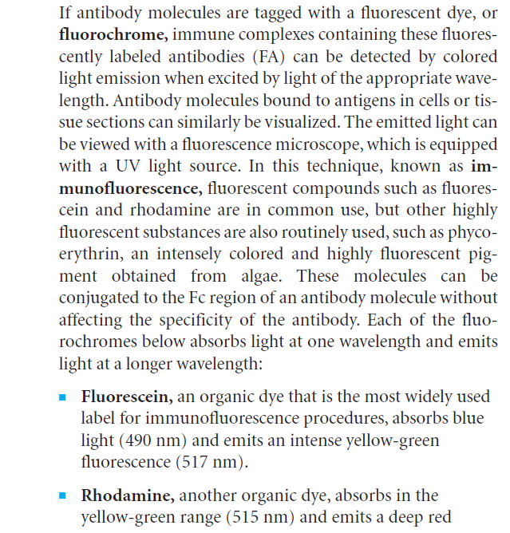

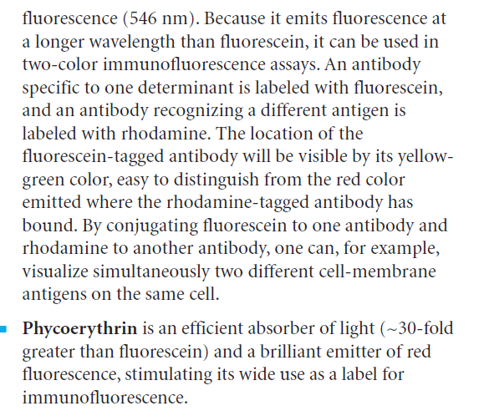

10.Explain RIST Radio immunosorbent test.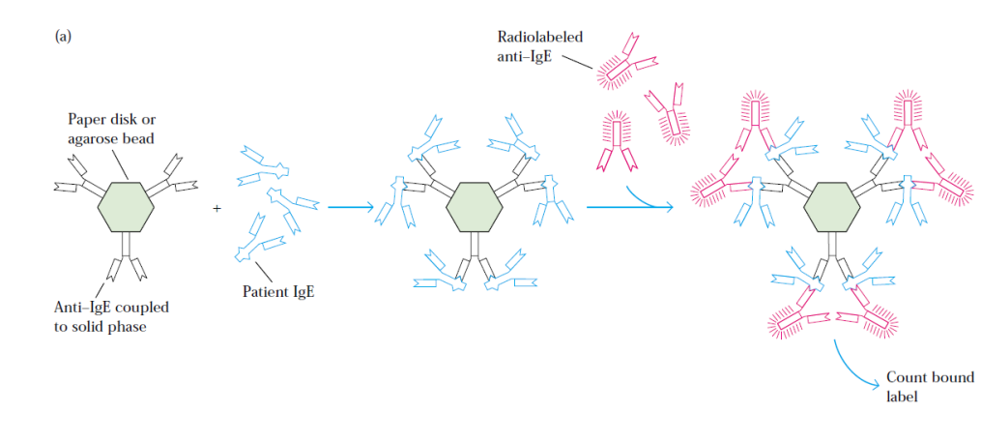
11.

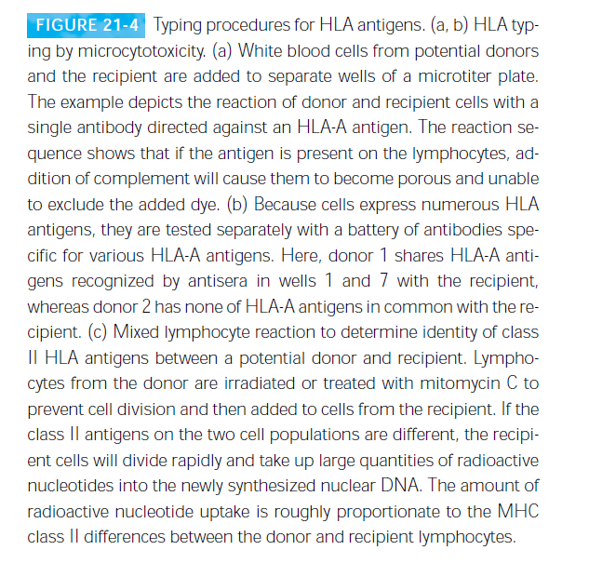
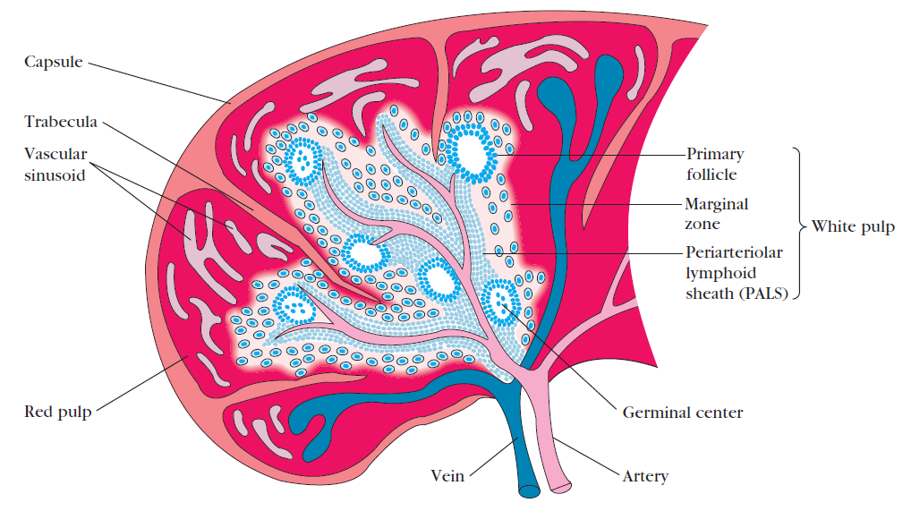
labelled diagram-5

13. Immunologica tolerance –the ability of the body to produce antibosies against nonself
antigens and tolerate (not to) produce antibodies against self antigens,-1
Clonal Deletion of B cells :- When self reactive immature B cells come across, the self antigen in the bone marrow, they manufacture is first arrested. The B cells machinery is reactivated to generate a new specificity ,which does not recognize self ag,If the B cell is successful in this endeavor it would no longer be self reactive and escapes negative selection.Such receptor editing has to be done quickly otherwise the cell dies.In this way many self reactive B cells are deleted during their developmental stage in the bone marrow,the primr ry lymphoid organ responsible for Bcell development.-4

14. Mab polypeptide conjugate. Mab, Cytokine therapy, Vaccination AND Mutagenic
DRUGS –mention and explanation briefly -5

III.Answer any Two of the following 2x10=20

15. mechanism of recognition and activation of T cell-

Signal-transduction pathwaysassociated with T-cell activation.(a) Phospholipase C_ (PLC) is activated byphosphorylation. Active PLC hydrolyzes aphospholipid component of the plasmamembrane to generate the second messengers,DAG and IP3. (b) Protein kinase C
(PKC) is activated by DAG and Ca2_.Among the numerous effects of PKC isphosphorylation of IkB, a cytoplasmic proteinthat binds the transcription factor NF-
_B and prevents it from entering thenucleus. Phosphorylation of IkB releases
NF-_B, which then translocates into thenucleus. (c) Ca2_-dependent activation of
calcineurin. Calcineurin is a Ca2_/calmodulindependent phosphatase. IP3 mediates
the release of Ca2_ from the endoplasmicreticulum. Ca2_ binds the protein calmodulin,
which then associates with and activatesthe Ca2_/calmodulin-dependent
phosphatase calcineurin. Active calcineurinremoves a phosphate group from
NFAT, which allows this transcription factorto translocate into the nucleus.

16. Myasthenia Gravis- Organ specific autoimmune disease-1
Autoantibodies are produced against the acetylcholine receptor on the motor end of the
Muscles, and prevents normal binding of aceylcholine and subsequent muscle activation
which leads to subsequent activation of complement leading to damage of the muscle
end plate resulting in progressive weakening of the skeletal muscles-4

Multiple Sclerosis-
Systemic autoimmune disease-1
Production of autoreactive T cells that participate in the formation of inflammatory lesions on the myelin sheath of nerve fibres. CSF contains Reactive T lymphocytes that infiltrate the brain tissue and cause inflammatory lesions destroying the myelin.Since Myelin is an insulation of the nerve fibres,a breakdown in the myelin sheath leads to numerous neurological dysfunction.4

17. mechanism –Explanation should include
Bumping,Rolling, Expression of CAMS on Neutrophils and Endothelial cells. Mucin,
Selectins,intergrins,and IgG like superfamily. Secretion of IL-8 by endothelial cells as a
chemokine which activates g coupled protein receptor on the neutrophils and brings
about the conformation of intergrins which now binds IgG superfamily leading to
transendothelial migration of the phagocytotic cells and phagocytosis to be explained.-
10

IV. Answer the following 1 x10=10

18.a) Antibodies can recognize single epitopes formed by primary sequence structures or secondary,
tertiary, and quaternary conformational structures. Denaturing a protein by disrupting disulfide
bonds generally destroys conformational determinants. Therefore it is likely that the first antibody
reacts with a primary amino acid sequence determinant that is present on both native and
denatured TT, while the second antibody sees a conformational determinant only on native TT -5

b) The immune complex will activate C2 (and C4) but will not activate C3 or any other components.
Since the alternative pathway of complement activation also requires C3, this pathway will not be
activated. Anaphylatoxins and chemotactic factor generation require C3, while the synthesis of
factor B is not related to C. Since C3 is deficient though C2 and 4 are activated ,C5 CANNOT BE
ACTIVATED -5

