
ST. JOSEPH’S COLLEGE (AUTONOMOUS), BENGALURU – 560 027
DATE: 9-4-19
M.SC. BOTANY – IV SEMESTER
SEMESTER EXAMINATION: APRIL 2019
BO 0115 – Methods in Plant Science and Biophysics
Time – 2 ½ hours Max Marks - 70
This paper contains ONE printed sheet and THREE parts
Draw diagrams wherever necessary

- Explain/Define any TEN of the following in one or two sentences 10x2=20
- Write the Bibliography for - MJP Publishers, 753 pages, Research Methodolgy: for Biological Sciences, N. Gurumani, 2006.
- Freeze etching
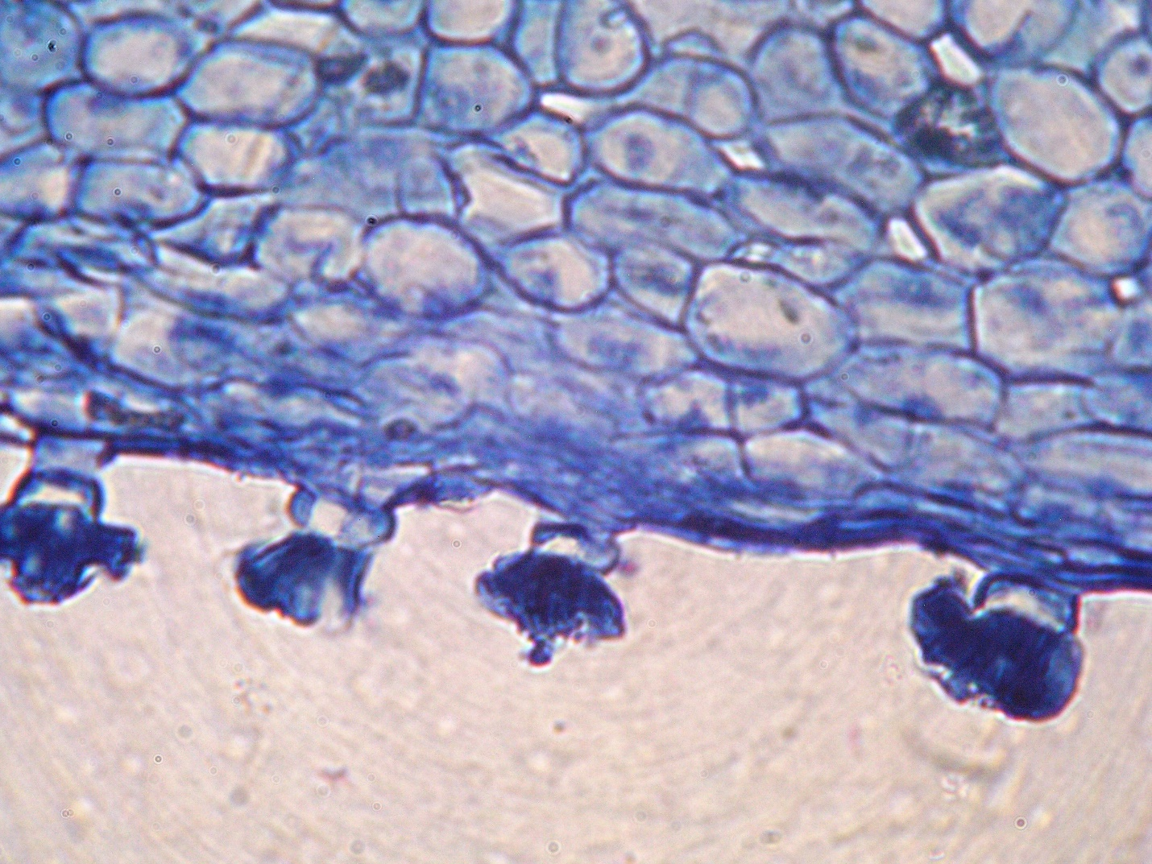
- Autoradiography
S – red color
C – green color
- T.S of calyx under fluorescent microscope.
Identify the principle stain in ‘S’ and ‘C’
based on fluorescence
- Objective ‘A’ has 1.25 NA and objective ‘B’ has 0.65 NA. Which has maximum resolution among objectives A and B?
- Properties of gases
- Tyndall effect
- Luciferase
- Biomechanics
- London forces of dispersion
- Charles Law
- Rf value

- Write critical notes on any FIVE of the following 5x6=30
- Differential and density gradient centrifugation
- Phase contrast microscope
- Fixatives and clearing agents in microtomy
- Gas chromatography
- Classification and properties of colloids
- Mechanism of Phosphorescence
- Protein engineering

- Give comprehensive account on any TWO of the following 2x10=20
- Principle, construction and application of UV-visible spectrophotometer
- Intra and intermolecular interactions
- Differences between bright field and electron microscopy

BO_0115_B_19

