DATE:27-6-19
ST. JOSEPH'S COLLEGE (AUTONOMOUS), BANGALORE-27
MA. JOURNALISM & MASS COMMUNICATION - IV SEMESTER
Special Supplementary Examination, JUNE 2019
MC 0416 - Film Studies
Supplementary candidates only.
Attach the question paper with the answer booklet

Time: 2 ¹/₂hrs Max. Marks:70
This paper contains THREE printed pages and THREE parts
Part A: Answer any TWO in about 500 words each (15x2=30 marks)
1.With the help of specific films made by Satyajit Ray and Girish Kasaravalli, compare their cinematic styles. (15 marks)
2. What makes film a language? Explain the various elements that go into the making of film as a language. (15 marks)
3. Trace the evolution of cinema worldwide from the time Lumiere brothers screened their actuality films till the time it established itself as a medium of communication. (15 marks)
Part B: Answer any TWO in about 300 words each (10x2=20 marks)
4. From the given screenshot, identify the film(1 mark), its director(1 mark), and describe the director's cinematic contribution (3 marks). Explicate the characteristics of the film movement that this film is associated with(3 marks). Explain how this film exemplifies those characteristics (2 marks).
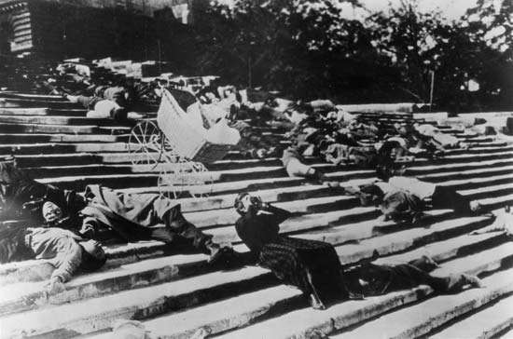
5.Which film does this frame refer to(1 mark), and who is the filmmaker(1 mark)? Write a short critique of this film in about 100words (3marks).Based on your understanding of the film, summarise the essential characteristics of the film movement to which this film belongs (5 marks).
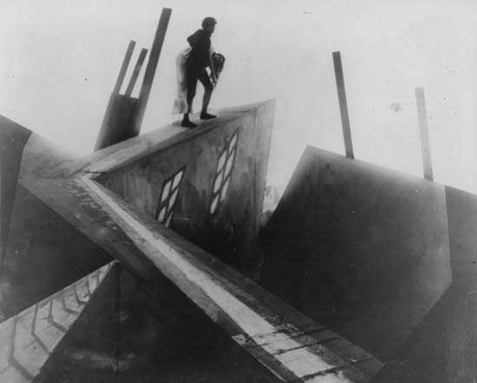
6. After identifying the film from which the following frame is taken (1 mark), and its film director (1 mark), explain what does the gesture refer to (1 mark). What is the significance of that reference in the overall scheme of the film movement to which this film belongs (2 marks)? What newness did this film movement bring about in its film practices different from the reigning film practices? (5 marks).
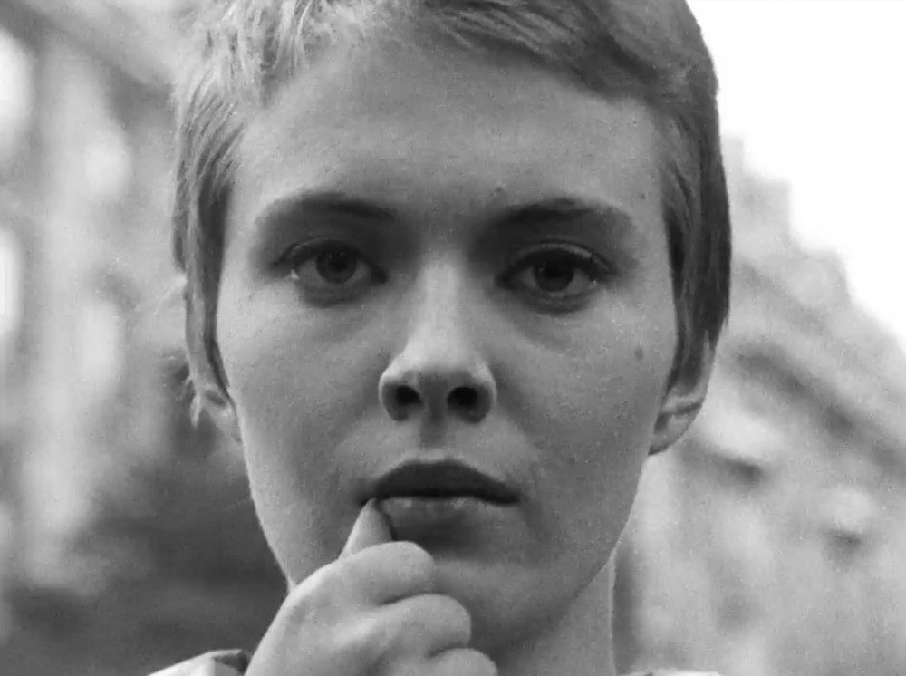
Part C: Answer any FOUR in about 100-150 words each (5x4=20 marks)
7.Akira Kurosawa
8.Syntagmatic and paradigmatic analysis in a film
9. 3-D cinema and loss of imagination
10. Bell Hooks
11.Georges Melies
12.Mise-en-scene

