Register Number:
Date: 22-04-2019

ST. JOSEPH’S COLLEGE (AUTONOMOUS), BANGALORE-27
B.Com - VI SEMESTER
SEMESTER EXAMINATION: APRIL 2019
BCDEF6516–Investment Banking
Time- 2 1/2 hrs |  |  | Max Marks-70
This paper contains two printed pages and four parts

Section A
- Answer any five of the following: 5X2=10
- Give any two reasons for the repeal of Glass Steagall Act 1933
- Mention any two constraints of investment banking in India
- Name any four leading investment banks in India
- Give the meaning of private equity
- Name any four fee-based services of investment banks
- What is divestiture? Give an example.
- Name the various types of players in Investment Banking

Section B
- Answer any three of the following: 5X3=15
- Differentiate between investment banking and merchant banking
- Explain the structure of Investment banking in India
- Illustrate “buy side” Vs “sell side” of investment banker with an example
- Explain the role of investment banks in equity market.
- Explain the portfolio services of merchant Bankers in the secondary market

Section C
- Answer any three of the following: 10X3=30
- What is leveraged buy out? Explain its types
- Explain the role of investment Bankers in the following
  - Underwriting
  - Corporate restructuring
- Explain in brief the support services of investments banks in the secondary market
- Explain the origin and regulatory framework of investment banks in India.
- Explain the role of investment banks in the developing economy.

Section D
- Compulsory question: 15X1=15
- Wells Fargo spent $7.3 billion to help buy an earnings beat — was it worth it?
Wells Fargo & Company is an American multinational financial services company headquartered in San Francisco, California, with central offices throughout the United States. It is the world's second-largest bank by market capitalization and the fourth largest bank in the US by total assets. Wells Fargo is ranked 26th on the 2018 Fortune 500 rankings of the largest US corporations by total revenue. In July 2015, Wells Fargo became the world's largest bank by market capitalization, edging past ICBC, before slipping behind JPMorgan Chase in September 2016, in the wake of a scandal involving the creation of over 2 million fake bank accounts by Wells Fargo employees. Wells Fargo surpassed Citigroup to become the third-largest US bank by assets at the end of 2015 but fell behind Bank of America to third in bank deposits in 2017.
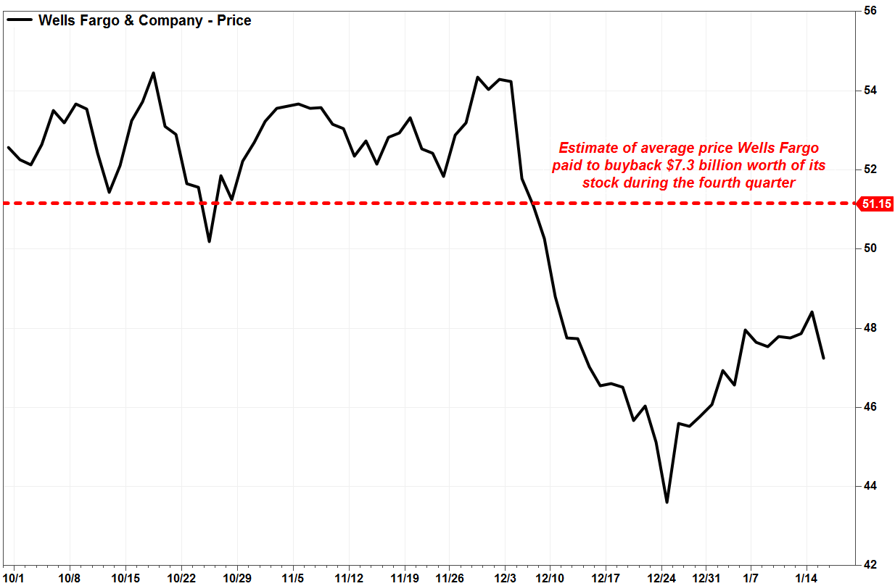
In the recent developments, Wells Fargo & Co. spent $7.3 billion on share repurchases during the fourth quarter failed to prop up its stock price, but it effectively helped the bank one-up its blue-chip rival JPMorgan Chase & Co. with earnings beat. Was it worth it.With the stock WFC, -1.11% closing Tuesday 22nd January 2019 down 1.6%, as the earnings beat was offset by a revenue miss -- revenue can’t be influenced by share repurchases -- it’s understandable for investors to believe it was a pretty bad trade. Meanwhile Wells Fargo said it spent $7.299 billion to buy back 142.7 million common shares, implying an average price paid per share of $51.15

Meanwhile, Wells’s stock tumbled 12.3% during the quarter. Although it has bounced slightly since Dec. 31, it closed at $47.67 on Tuesday.That puts the stock 6.8% below the average buyback price, which suggests the value of the shares repurchased would now be $6.803 billion, or about $496 million less than what Wells paid. In comparison, JPMorgan said it spent about $5.9 billion to buy back 55.5 million shares at an average price of $106.80. The stock is currently trading about 4.7% below that price.
Over the past 12 months, Wells’s stock has dropped 23.7% although the bank spent a net $17.9 billion on share repurchases. Earlier The Federal Reserve took unprecedented actions against Wells Fargo after what might be called unprecedented misconduct that lasted for years.In the wake of surprise Federal Reserve sanctions against Wells Fargo & Co., the bank will likely lose customers. Unless it won’t. The Fed’s directive that the bank replace multiple board members and clean up its act is an easily remedied situation that’s already in the works – or it might take until 2021 to resolve. Other regulatory shoes may drop – or not.
Questions:
- Did Wells Fargo make the right decision? Justify (5marks)
- Is share repurchase sole reason for the stock fall of WF? Give various factors affecting stock prices. (5marks)
- As a professional consultant what are the alternatives would you suggest to WF to recover from this downfall? (5marks)

******************

