Register Number:
DATE: 24-04-2019
ST. JOSEPH’S COLLEGE (AUTONOMOUS), BANGALORE-27
B.Com– VI SEMESTER
SEMESTER EXAMINATION: APRIL 2019

BCDEF 6616: Securities Analysis and Portfolio Management

Time- 2 ½ hrs Max Marks-70

This paper contains three printed pages and four parts
Section A
I Answer any five of the following (5 X 2 = 10marks)
- Is investment the same as gambling?
- What are masala bonds?
- Mention any four assumptions of CAPM.
- What is meant by the alpha of an investment?
- State any two benefits that arise from global investment.
- Give the meaning of fundamental analysis.
- What are global mutual funds?
Section B
II Answer any three of the following (3 x 5 = 15 marks)
- Given below are three chart patterns. What chart pattern is depicted below and what do they indicate?
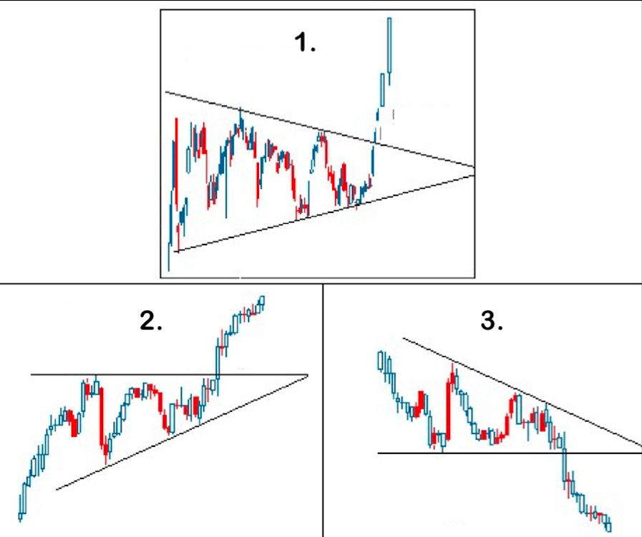
- Rank the following portfolios according to Sharpe’s Ratio
Portfolio | Return (%) | σ (%) | Beta
A | 15 | 27 | 0.82
B | 11 | 18 | 0.53
C | 9 | 14 | 0.40
D | 18 | 19 | 0.73
Market | 6 | 11
91 Day T-Bills | 5
- From the information given below, make buy, sell or hold decisions using CAPM.
Stock | Expected Return (%) | Beta
A  B  C  D  NIFTY | 46  22  35  34  26 | 1.7  0.6  1.2  1.6  1
Risk free rate of return is 16%.

- Enumerate the classifications of industries according to the business cycle.
- Explain the various assumptions of the Capital Market Theory.

Section C
III Answer any three of the following (3 x 10 = 30 marks)
- Explain the various tools that can be used for economic analysis.
- Bruce is a potential client for your firm. Give your client a detailed explanation of the portfolio management process.
- Write a note Modern Portfolio Theory.
- An investor is considering investing in either the stocks of YOko Ltd or of ONO Ltd. Both the stocks are currently selling for INR 1500/share. The rupee return (dividend plus price) of these stocks for the next year would be as follows:
State of the economy | Probability | Return of YOko Ltd | Return of ONO Ltd
1 | 0.2 | 750 | 540
2 | 0.4 | 450 | 825
3 | 0.1 | 300 | 450
4 | 0.3 | 375 | 600
Which stock would be a better investment option? Substantiate with respect to the risk and return of each stock.
- The returns on Ox Co. and the market portfolio are given below:
Year | Ox Co (%) | Market Portfolio (%)
1 | 10 | 12
2 | 6 | 5
3 | 13 | 18
4 | -4 | -8
5 | 13 | 10
6 | 14 | 16
7 | 4 | 7
Compute the β and α of Ox Co.

Section D

IV Compulsory Question (1 X 15 = 15 marks)
- A financial analyst is analysing two investment alternatives, stock A and stock B. The estimated rates of return are given below:
Year | Rates of return (%)
 | Stock A | Stock B
1 | 22 | 5
2 | 14 | 15
3 | 10 | 20
4 | 8 | 25
5 | -4 | 30

  - Determine the rates of return, variance and standard deviation of stocks A and B.
  - Is stock A comparatively riskier than stock B?
  - If the analyst wants to invest half in A and half in B, would it reduce the risk? Explain.

(8 + 2 + 5)
******************************

BCDEF 6616_A-19

