Register Number:
Date: 24-4-19

ST. JOSEPH’S COLLEGE (AUTONOMOUS), BANGALORE – 27
BA-CPE--VI SEMESTER: END-SEMESTER EXAMINATION: APRIL 2019
CE 6317 – COMMUNICATIVE ENGLISH
WRITING & PRODUCING FOR MULTIMEDIA JOURNALISM

Time- 2^{1/2} hrs Max Marks- 70

Instructions:

- This paper is for students of VI semester CPE who have opted for the Writing and Producing for Media elective.
- The paper has THREE SECTIONS and TWO printed pages.
- You are allowed to use a dictionary.
- Don’t exceed the word limit.

- Examine the given infographics and answer the questions below.
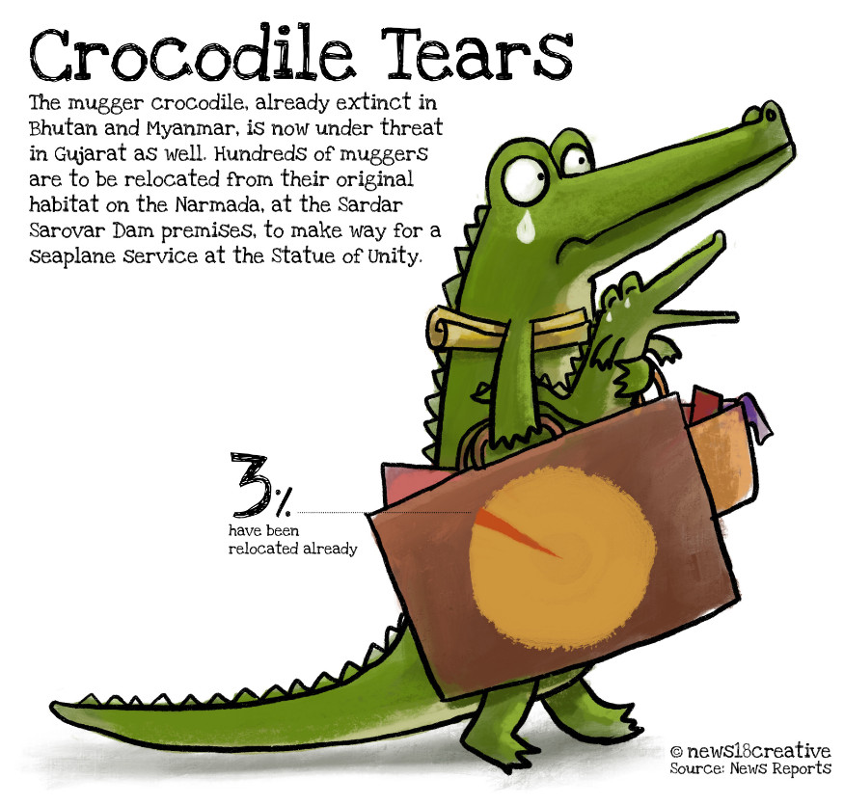
  - Figure 1 – The mugger crocodile, already extinct in Bhutan and Myanmar, is now under threat in Gujarat as well. Hundreds of muggers are to be relocated from their original habitat on the Narmada, at the Sardar Sarovar Dam premises, to make way for a seaplane service at the Statue of Unity.
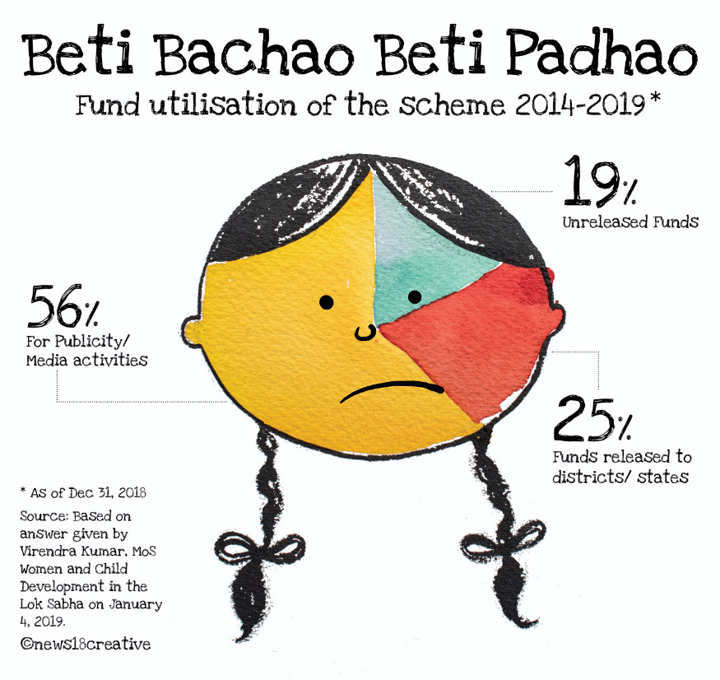
Figure 2
- Answer the following questions in 150 words each. (2x15=30)

  - Write a short article using the information provided in the two images. Give it an apt headline.
  - If you were making a series of such images for the upcoming elections, what would the other images show? Draw at least one other image. Give it a caption.

- You are running a website that curates the experiences, and offers agony-aunt type advice to Non-Karnataka students. What are some of the multimedia pieces that you would commission for this website? What would you call this website? Write in 200-250 words. (20 marks)

- Answer the following questions in 100 words each. (2x10=20)
- What are some of the problems you encountered while making podcasts? What suggestions would you give to someone making a podcast for the first time?

- Write about a valuable learning experience from your Communicative English classes in the last three years.

CE-6317-B-19

