Register No
Date
ST. JOSEPH’S COLLEGE (AUTONOMOUS), BANGALORE-27
BVOC FILMAKING & ANIMATION - IV SEMESTER
SEMESTER EXAMINATION: APRIL 2019
VO 4116 – LANGUAGE IV

Time- 2 ½ hours Maximum Marks: 70

This paper consists of TWO printed pages and TWO parts

- Answer any FOUR of the following in about 150 words each: (4 x 10 = 40)
- Elucidate any two instances from Peter Colaco’s novel.
- Identify any two themes from the ‘Twin Tales from Kutcch’ and brief about them.
- Critically appreciate how Saeed Ibrahim has sketched his characters in his Novel?
- From the two novels covered in class, choose any one and comment on the style of writing and delivery.
- Write a brief summary of any one chapter from the ‘Twin Tales from Kutcch’.

- Answer any TWO of the following in about 350 words: (2 x 15 = 30)
- Look at the picture below. Write a creative essay associated with it.
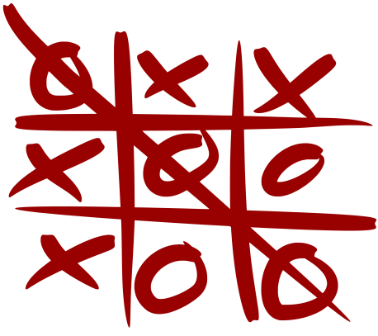
- What are your views on Bengaluru city? Write a creative piece on the city and the transformations it has seen over the years.
- Write a detailed review on any film watched in class.

