Register Number:
DATE:
ST. JOSEPH’S COLLEGE (AUTONOMOUS), BANGALORE-27
B.A. VISUAL COMMUNICATION - IV SEMESTER
SEMESTER EXAMINATION: APRIL 2019
VC 4217 – WRITING FOR MEDIA

Time- 2 ½ hours Maximum Marks: 70

This paper consists of TWO printed pages and TWO parts

- Answer any SIX of the following in about 100 – 150 words each: (6 x 5 = 30)
- Define Target Audience. Articulate the term with an example.
- What is a media kit? Explain
- What are the types of programmes on radio?
- Elucidate the features of online written content.
- What is a creative strategy in advertising?
- What is a crisis? Exemplify how communication takes place in a crisis.
- Choose one platform – Radio OR TV/ Web series. With regard to this, what are the limitations of scripting content?

- Answer any FOUR of the following. (4 x 10 = 40)
Follow instructions accordingly

- Read the following and follow instructions carefully.
On the occasion of India’s 70th Republic Day – 26 January, 2019, Dulux Paints launched the #HomesOfTheBrave initiative. The campaign aimed to celebrate brave hearts of the Indian Armed Forces who left their homes to protect ours.
The digital campaign #HomesOfTheBrave showcased the stories of two such personnel from the armed forces: Sumitra Devi, Assistant Sub-Inspector, CRPF; and Ajoy Kumar Rabha, Sipahi, CRPF. The video campaign featured Farhan Akhtar, the brand ambassador of Dulux. It highlighted how the armed forces protect the country while staying away from their homes for extended periods of time.
Through #Homesofthebrave, Dulux Weathershield initiated painting the homes of these heroes as a gesture of gratitude and a homecoming gift.
Consider the above information as an example and develop a script for a 30 second video ad campaign with a brand and product of your choice. The ad should convey the brand’s unique selling proposition.
- Look at the following image and create a print ad sketch for a standard daily newspaper with the same information. You can add more information if required. Also, justify your target audience in 60 words.

- Your college is celebrating its annual national intercollegiate media fest. Your team has invited renowned media professionals and participants from all over the country. Develop a suitable press release that will help the press to publish news regarding the same. Write the press release on a fresh page with a clear structure.

- Develop a 30 second Radio Ad script for the product shown below.

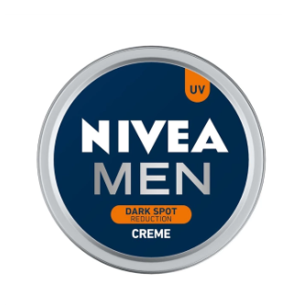

- Create an e-commerce website of any company of your choice and develop a creative strategy for the same.

VC 4217_B_19
***

