Register Number:

Date:
ST. JOSEPH’S COLLEGE (AUTONOMOUS), BANGALORE – 27
CBCS (ZOOLOGY) – IV SEMESTER
SEMESTER EXAMINATION, APRIL 2019
ZO OE 4116 – A JOURNEY INTO ANIMAL WORLD AND HUMAN LIFE

Time: 1.5 hour Max. Marks: 35
This paper contains two printed pages and three parts
PART A
Answer the following 1 X 10 = 10
- Name the type of reproduction in Protozoans given in the diagram below__________
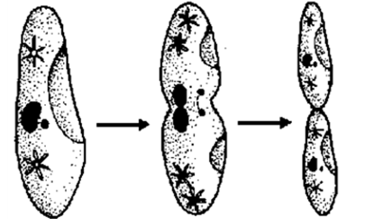.

- Echinoderms have the ability to reproduce a broken arm (true/ false)
- Mention the type of signals (Tactile/Auditory/chemical) involved in
- Bird song b. Monkey grooming

- Mention any one flight adaptation in birds.

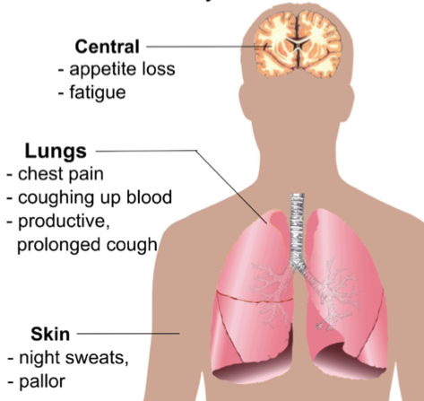 | The image shows major symptoms of which disease?

- ____________ is the organ maintaining blood glucose levels
- Stomach b. Small Intestine c. Pharynx d. Pancreas

- _____________ blood group is universal donor

- The great blood vessels of a human heart are________________
- Aorta b. Pulmonary artery c. Vena Cava d. All of the above

- Identify and name the threatened species shown below

a | b
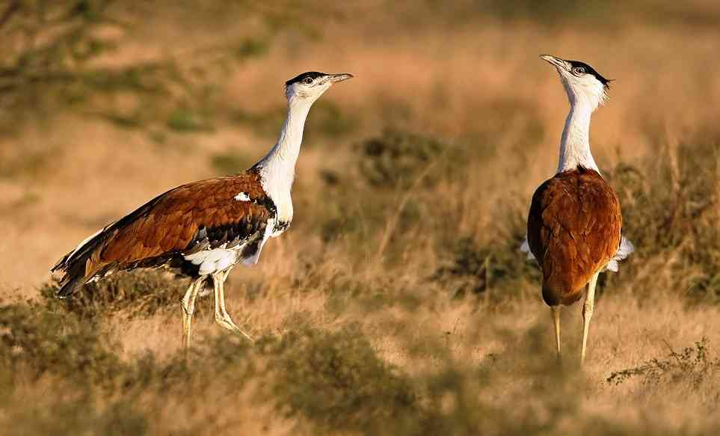 | 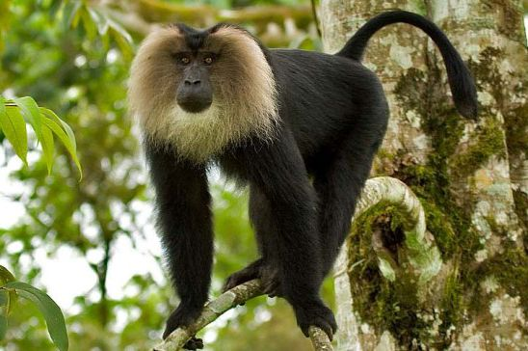
- Mention one first aid procedure when a person is choking _________

PART B
Answer any FIVE of the following 5 X 2 = 10

- What is an endocrine gland? Give an example
- What is a menstrual cycle?
- What is liver cirrhosis?
Disease | Vector | Pathogen
____________ | Anopheles stephensi | Protozoan
Dengue | _________________ | Virus
Plague | _________________ | Bacteria
Schistosomiasis | Snail | ___________________
- In relation to vector borne diseases fill in the blanks in the table given below
- What are the modes of HIV transmission?
- Depict the pedigree of a family comprising an elder son and younger daughter and the father affected with a genetic disease.

PART C
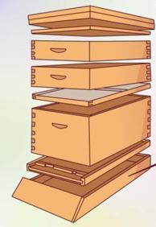
Answer any THREE of the following 3 X 5= 15

- What is cancer? Mention any two properties of a cancer cell and name any two types of cancer.
- Briefly describe the structure of human lungs and breathing process with a neat labelled diagram.
- Write a short note on heart attack and its prevention.
X
- Draw a neat labelled diagram of the urinary system.
- a. List any two barriers to mitigate Human-elephant conflict.
b. What is the name of the structure you see in the picture and state why ‘X’ is important?

