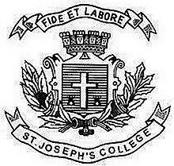
Register No:
Date: 15.04.2019

ST. JOSEPH’S COLLEGE (AUTONOMOUS), BENGALURU – 27
B.A. VISUAL COMMUNICATION – II SEMESTER
SEMESTER EXAMINATION – April 2019
VC 2318– Media Laws and Ethics

Time: 2 ½ Hrs Maximum Marks:70

This question paper has ONE printed page and THREE parts

I. Write short notes on any FOUR of the following in not more than 100 words each: (4x5 = 20)

1. Ombudsman
2. Lord Wellesley
3. Press Council Act
4. ‘S’
5. Data Diddling
6. Prasoon Joshi

II. Answer any TWO questions in about 200 words each: (2x 10= 20)
7. Elaborate on Defamation Act with examples
8. What are cyber crimes? How they could be contained through IT Act 2000
9. Elaborate on salient features of Cinematograph Act.

III. Answer any TWO of the following questions in about 400 words: (2 x 15 = 30)
10. Suppose you want to start a press, which act you should know and how do you follow it? Give the essential details.
11. Write an essay on the Fundamental Rights a citizen of India is entitled to.
12. Media Ethics are eroding day by day in India. What is your take on it?

VC 2318_A_19

