Date: 10-4-19

ST. JOSEPH’S COLLEGE (AUTONOMOUS), BANGALORE-27
BACHELOR OF VOCATION (Filmmaking and Animation) – IV SEMESTER
SEMESTER EXAMINATION: APRIL 2019
VO 4214: Language III
SUPPLEMENTARY CANDIDATES ONLY
ATTACH THE QUESTION PAPER WITH THE ANSWER BOOKLET

Time-3 hrs Max Marks-100

This paper contains TWO printed pages and TWO parts

- Answer any SEVEN in about 150 words each: (7 x 10 = 70)
- What is intertextuality? What are the different types?
- Elucidate on any one writing of Roland Barthes that you have come across.
- What is genre? What are the types?
- Highlight some of the characteristics of online readers, these days.
- Write a review of any recently watched film of your choice.
- Elaborate on ‘translation’ of texts.
- How does language take different forms? Explain.
- Write a critical appreciation of any text covered in your language class.

- Answer any TWO. Follow instructions given below: (2 x 15 = 30)
- Look at the picture below. Analyse it. Develop your own idea and write an essay that suits the idea in about 250 words.
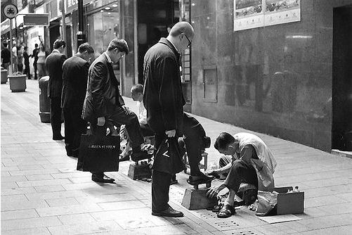

- Write a creative piece of about 250 words entitled ‘Twenty minutes at the cafe’.
- Read the following note on Anxiety by Paulo Coelho. Answer questions that follow:
Although we cannot control God’s time, it is part of the human condition to want to receive the thing we are waiting for as quickly as possible.

Or to drive away whatever is causing our fear.

How can you tell a passionate heart to be still and contemplate the miracles of Creation in silence, free of tension, fear and unanswerable questions?

Anxiety is part of love, and should not be blamed because of that.
How can you tell someone not to worry when he has invested his money and his life in a dream and has yet to see any results? The farmer cannot speed the progress of the seasons in order to pick the fruit he planted, but he waits impatiently for the coming of autumn and harvest-time.
How can you ask a warrior not to feel anxious before a battle?
He has trained to the point of exhaustion for that moment, he has given of his best, and while he believes he is prepared, he fears that all his efforts could prove to be in vain.

Anxiety was born in the very same moment as mankind. And since we will never be able to master it, we will have to learn to live with it – just as we have learned to live with storms.

Questions:
- What is anxiety? Can you describe an event in your own life to elaborate the meaning? (5 marks: 70 to 100 words)
- According to the author, what are the examples that justify the fact that we have to learn to live with anxiety? (5 marks: 70 to 100 words)
- Give the meaning of all the three words and make sentences with any two of them (a) battle; (b) exhaustion; and (c) contemplate (5 marks)

***** VO4214-a-19

