ST. JOSEPH’S COLLEGE (AUTONOMOUS), BANGALORE – 27
DATE: 8-4-19
B.Sc CHEMISTRY – VI SEMESTER
SEMESTER EXAMINATION- APRIL 2019
CH 6115- Inorganic Chemistry
SUPPLEMENTARY CANDIDATES ONLY
Time : 2 ½ hours Max. Marks: 70
This paper contains 2 printed pages and three parts
Element | Sc | Ti | V | Cr | Mn | Fe | Co | Ni | Cu | Zn
Atomic number | 21 | 22 | 23 | 24 | 25 | 26 | 27 | 28 | 29 | 30
Part A
Answer any six of the following. 6 x 2 = 12 M
- The outer electronic configuration of a d- block element is 3d¹⁰4s¹. How many ’d’ electrons the metal ion has when it’s oxidation state is +2?
- What is Ziegler-Natta polymerization?
- Give one example each for an ambidentate ligand and a bidentate ligand.
- Hybridisation of central metal ions in two complexes is dsp² and d²sp³. What will be their geometries?
- Give two consequences of lanthanide contraction.
- Write two significant features of Ellingham’s diagram.
- What is a Pourbaix diagram?
- Give any two roles of copper in biological systems.
Part B
Answer any eight of the following 8 x 6 = 48M
- Discuss the following characteristic properties of d- block elements.
i) variable oxidation states ii) magnetic properties.
- a) Calculate EAN of the central metal ions in the following complexes.
i) Ni[(CO)₄] ii) K₄[Fe(CN)₆]
b) Draw the optical isomers of [Co(en)₂Cl₂]⁺. Write the structure of another isomer of this complex which does not exhibit optical isomerism. (3+3)M
11. a) Give the IUPAC names of the following i) [Co(NH₃)₆ ][Cr(CN)₆] ii) Fe(CO)₅
iii) [Pt(NH₃)₅Cl]Br₃
b) Write the structural formulae of the following complexes.
i) Hexaaquachromium(III)chloride ii) Tetracyanidonickelate(II) ion
- Chloridobis(ethylenediamine) nitrito-қOcobalt(III)ion (3+3)M
- [Co(NH₃)₆]³⁺ is diamagnetic whereas [CoF₆]³⁻ is paramagnetic. Explain with the help
of valence bond theory (VBT).
- Give one method of preparation and structure of each of the following: i) Mn₂(CO)₁₀ ii) W(CH₃)₆.
- With an orbital overlap diagram, discuss the bonding in metal carbonyls. What is meant by synergic effect?
- Using ion exchange chromatography how do you separate individual lanthanides from its solution? Write relevant equations involved in the process.
- What are metalloporphyrins? Give the structure of a haeme unit. Discuss the oxygen binding characteristics of haemoglobin and myoglobin.
- How is lithium extracted from lepidolite?
- One of the complexes of chromium, [CrF₆]³⁻ is green in color whereas another chromium complex, [Cr(CN)₆]³⁻, is yellow in color. Explain using spectrochemical series.
Part C
Answer any two of the following 2 x 5 = 10M
- The crystal field stabilisation energy in a tetrahedral complex is found to be 0Dq with no pairing energy. Draw the crystal field splitting pattern with electron arrangement and calculate the magnetic moment of this complex.
- If ‘M’ is the metal ion with oxidation state +3 and coordination number 6 and if ‘A’ is an anionic uninegative species and ‘B’ is a neutral species, write the formulae of the coordination compounds formed by the combination of these species with the metal ion which are i) most conductive and ii) least conductive.
- From the Frost diagram for nitrogen given below answer the following i) Identify the most stable species of nitrogen and give reason for the choice ii) Identify the species which undergoes disproportionation and give the corresponding equation iii) list three species which are equally stable.
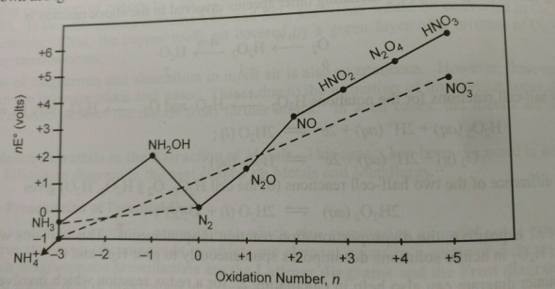
CH-6115-B-19

