DATE: 28-06-2019

ST. JOSEPH’S COLLEGE (AUTONOMOUS), BENGALURU-27
B.Sc. MICROBIOLOGY - VI SEMESTER
Special Supplementary Examination, JUNE 2019
MB 6116– Food and Fermentation Technology

Supplementary candidates only.

Time- 2 1/2 hrs Max Marks-70
This paper contains2 printed pages and4parts
- Answer any Five of the following 5 x 3 = 15

- What is the importance of the lacto peroxidase system in milk?
- How do organic acids preserve food?
- Differentiate between precursors and inducers with an example each.
- What is stormy fermentation of milk?
- How do electrical resistance thermometers help in monitoring temperature?
- Describe the California Mastitis Test.
- How are fats degraded by microorganisms in foods?

- Answer any Five of the following 5 x 5 = 25

- How are Bacterial inoculaprepared for industrial use?
- Give an account of aflatoxins and their effect on human health.
- List the food control agencies and give its importance.
- Discuss the recovery of a product by liquid-liquid extraction.
- Describe the process of continuous fermentation.
- Write a note on B.cereus food poisoning.
- Comment on the principle and applications of the air lift fermenter.

- Answer any Two of the following 2 x 10 = 20

- Draw and describe the structure of a typical stirred tank bioreactor.
- Discuss the parameters of food that influence microbial growth.
- Illustrate the process of cheddar cheese production.

- Answer the following 1x 10 = 10

- a. An antibiotic producing strain is tested using the technique depicted in the following image 1. Identify and comment on the technique. Interpret the results shown in the image with valid justification. (5)
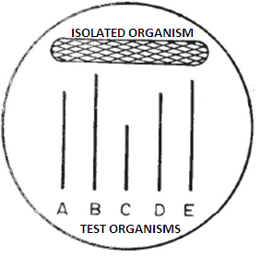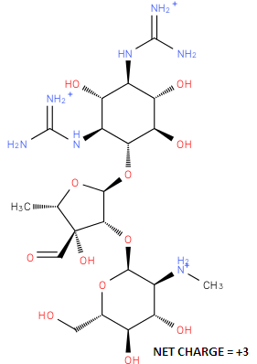
IMAGE 2
IMAGE 1

b. The above strain produces an antibiotic with the structural details as given in image 2. Post fermentation, the filtered broth is processed using the following techniques to extract and purify the produced antibiotic.
- Cationic ion exchange chromatography
- Anionic ion exchange chromatography
- Crystallization
What would be the expected outcome of using each of the three techniques? Which of the techniques would be most efficient for the extraction and purification of the antibiotic and why? (5)

