Date: 1-7-19

ST. JOSEPH’S COLLEGE (AUTONOMOUS), BANGALORE – 27
B.Sc. ZOOLOGY – VI SEMESTER
Special Supplementary Examination, JUNE 2019
ZO 6215 – Developmental Biology and Evolution

Supplementary candidates only.

Time: 2.5 hours Max. Marks: 70
This paper contains two printed pages and three parts.
Note: Draw neat labelled diagrams wherever necessary
Indicate the question numbers clearly.

PART A

Answer the following 15 X 1 = 15

- Preformed embryo in a spermatozoan was referred as __________
- ________ proposed the theory of epigenesis
- Superficial Cleavage is the characteristic feature of __________ lecithel eggs
- The oblique shift in spindle fibers causes __________ cleavage

- The figure depicts gastrula of __________________
- Frog blastula is referred as _______________
- In the frog gastrula grey crescent area develops into _________ .
- Maternal part of the placentome is called______________
- Name the phenomemon: The optic vesicle and lens induce each other.
- __________ homone is secreted by trophoblast cells of pre-embryo
- Fill in the blank: GnRH _______Leydig cells Testosterone
- Phylogeny recapitulates__________
- Era of mammals: _________
- Evolution of horse exhibits transition from plantigrade to____________ foot
- Premolars becoming successively molariform during evolution of horse is attributed to their transformation from browsers to __________

PART B

Answer any FIVE of the following 5 X 5 = 25

- Explain the formation and role of primitive streak in chick embryo.
- Explain the types of eggs based on distribution and quantity of yolk with suitable examples.
- With a diagram explain the structure and functions of yolk sac in chick embryo.
- a. Explain cortical changes during fertilization and its significance (3m)
- Draw and label a implanting blastocyst (2m)
- Name the evolutionary concept depicted in the following images using the hint

 | 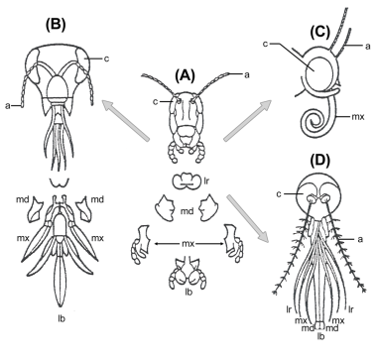 | 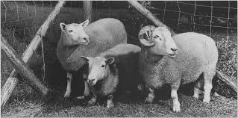
- Lamarck | - Homology | - Variation
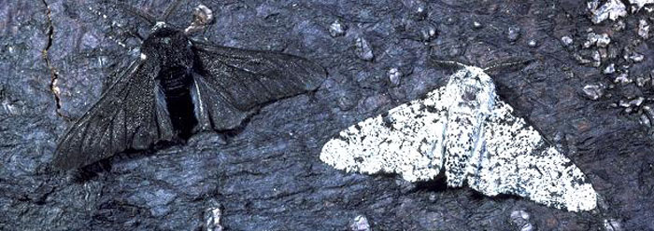 | 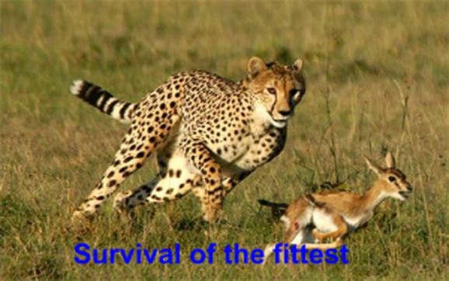
- Industrial revolution | - Darwin
- Mention any four features of hominization. List three differences between Neanderthal and Cro-magnon man.
- Explain potassium- argon method of radiometric dating and give reason why ⁴⁰Ca is less useful as a geochronometer?
PART C

Answer any THREE of the following 3 X 10 = 30

- Why morphogenetic movements are called so? Explain their role during gastrulation in frog embryo.
- Diagrammatically explain neurulation and mesogenesis in frog embryo.
- a. State H-W Equilibriumand give reason why it cannot be achieved in a population. b. Explain how genetic drift and migration alter gene pool. (3 + 7m)
- Define the term species. Explain the allopatric and sympatric modes of speciation.
- With neat diagrams explain the histological changes in the endometrium during menstrual cycle and deliberate on the role of Hypothalamo-hypophyseal-ovarian axis.
Z0-6215-b-19

