St. JOSEPH’S COLLEGE (AUTONOMOUS) BENGALURU-27
JOURNALISM - VI SEMESTER
SEMESTER EXAMINATION: APRIL2018
JN6113: Advanced Journalism

Time- 2^{1/2} hrs Max Marks- 70

Instructions
- This paper is meant for VI semester students of BA –EJP course
- Please stick to the word-limits suggested
- You are allowed to use a dictionary
- This paper contains FIVE pages and THREE sections

- Read this article by Robert Simpson from the Aeon Magazine and answer the question below.
Free speech is important. It guards against governments’ dangerous tendency to repress certain kinds of communication, including protest, journalism, whistleblowing, academic research, and critical work in the arts. On the other hand, think of a doctor dispensing bogus medical advice, or someone making a contract that she plans to breach, or a defendant lying under oath in court. These all involve written or spoken statements, but they don’t seem to fall within the domain of free speech. They are what the legal theorist Frederick Schauer at the University of Virginia calls ‘patently uncovered speech’: communication that warrants no special protection against government regulation.
However, once we extrapolate beyond the clear-cut cases, the question of what counts as free speech gets rather tricky. A business whose website gets buried in pages of search results might argue that Google’s algorithm is anti-competitive – that it impedes fair competition between sellers in a marketplace. But Google has dodged liability by likening itself to a newspaper, and arguing that free speech protects it from having to modify its results. Is this a case of free speech doing its proper work, or an instance of free speech running amok, serving as cover for a libertarian agenda that unduly empowers major corporations?
To answer this question, we need a principled account of the types of communication covered by free speech. But attempts to provide such an account haven’t really succeeded. We can pick out cases on either side of the divide – ‘Protections for journalism and protest? Yes! For perjury and contracts? No’ – but there aren’t any obvious or natural criteria that separate bona fide speech from mere verbal conduct. On the contrary, as theorists have told us since the mid-20th century, all verbal communication should be understood as both speech and conduct.
Some authors see these definitional difficulties as a fatal problem for the very idea of free speech. In There’s No Such Thing as Free Speech: And It’s a Good Thing Too (1994), the American literary critic and legal scholar Stanley Fish argued that ‘free speech’ is really just a rhetorically expedient label that people assign to their favoured forms of communication. There’s a grain of truth in this; but it doesn’t change the fact that governments still have a tendency to repress things such as protest and whistleblowing, and that we have good reasons to impose institutional safeguards against such repression if possible.
Instead of throwing out free speech entirely, a better response might be to keep the safeguards but make their sphere of application very broad. This is roughly what happens in Canadian law, where nearly any type of conduct can fall within the constitutional ideal of ‘free expression’, provided that it is trying to convey some kind of meaning. The downside is that if nearly anything can qualify as ‘expressive’ in the relevant sense, then we cannot categorically privilege expression itself as an inviolable norm. All we can ask lawmakers to do is factor in the interests that such expression serves, and try to strike a balance with all the other, competing interests (such as ‘equality’, for example, or ‘national security’). While such trade-offs are standard in Commonwealth legal systems, they have the unwelcome effect of making it easier for governments to justify their repressive tendencies.
I’d propose a third way: put free ‘speech’ as such to one side, and replace it with a series of more narrowly targeted expressive liberties. Rather than locating actions such as protest and whistleblowing under the umbrella of ‘free speech’, we could formulate specially tailored norms, such as a principle of free public protest, or a principle of protected whistleblowing. The idea would be to explicitly nominate the particular species of communication that we want to defend, instead of just pointing to the overarching genus of ‘free speech’. This way the battle wouldn’t be fought out over the boundaries of what qualifies as speech, but instead, more directly, over the kinds of communicative activities we think need special protection.
Take the idea of public protest. Standard free-speech theory, concerned as it is with what counts as speech, tends to draw a line between interference based on the content of the speech, such as the speaker’s viewpoint (generally not allowed), and interference that merely affects the time, place and manner in which the speech takes place (generally allowed). But this distinction runs into trouble when it comes to protest. Clearly governments should be blocked from shutting down demonstrations whose messages they oppose. But equally they shouldn’t be able to multiply the rules about the time, place and manner in which demonstrations must take place, such that protests become prohibitively difficult to organise. One reason to have a dedicated principle of free public protest, then, is to help us properly capture and encode these concerns. Instead of seeing demonstrations as merely one application of a generic free-speech principle, we can use a narrower notion of expressive liberty to focus our attention on the distinctive hazards faced by different types of socially important communication.
If this all seems a bit optimistic, it’s worth noting that we already approach some types of communication in this way – such as academic freedom. Universities frequently come under pressure from political or commercial lobby groups – such as big oil, or the Israel lobby – to defund research that runs counter to their interests. This kind of threat has a distinctive underlying causal mechanism. In light of this problem, universities safeguard academic freedom via laws and regulations, including guidelines that specify the grounds for which academics can be fired or denied promotion. These moves are not just a specific implementation of a general free-speech principle. They’re grounded in notions of academic freedom that are narrower than and distinct from freedom of speech. My suggestion is that all our expressive liberties could be handled in this way.
The subdivision of expressive liberties isn’t going to magically fix all the genuinely controversial issues around free speech, such as what to do about search engines. However, we don’t need to resolve these debates in order to see, with clarity and confidence, that protest, journalism, whistleblowing, academic research and the arts need special protection. The parcelled-out view of expressive liberties captures the importance of these activities, while sidestepping the definitional problems that plague standard free-speech theory. These are not merely theoretical advantages. Any time a country is creating or revising a bill of rights, the question of how to protect communicative practices must be considered afresh. Multiple expressive liberties is an approach worth taking seriously.
- Answer any three of the following in about 150 words each. (3X10=30)

- Do you agree with the argument that free speech is a label that people apply to their favoured form of communication? Elaborate your answer with regards to your experience of the concept in Journalism.

- What are the external influences on free speech?

- The author uses the term ‘expressive liberties’ in the article. What is your understanding of the term? Elaborate your answer with sufficient explanations.

- The author has clubbed different kinds of communication under the same umbrella. Do you agree with this? Does any specific form of communication deserve separate attention?
II. Read this excerpt from an article written by Mathew L Williams and answer the questions below.
Collecting and publishing data collected from social media sites such as Twitter are everyday practices for the data journalist. Recent findings from Cardiff University’s Social Data Science Lab question the practice of publishing Twitter content without seeking some form of informed consent from users beforehand. Researchers found that tweets collected around certain topics, such as those related to terrorism, political votes, changes in the law and health problems, create datasets that might contain sensitive content, such as extreme political opinion, grossly offensive comments, overly personal revelations and threats to life (both to oneself and to others). Handling these data in the process of analysis (such as classifying content as hateful and potentially illegal) and reporting has brought the ethics of using social media in social research and journalism into sharp focus.
Ethics is an issue that is becoming increasingly salient in research and journalism using social media data. The digital revolution has outpaced parallel developments in research governance and agreed good practice. Codes of ethical conduct that were written in the mid twentieth century are being relied upon to guide the collection, analysis and representation of digital data in the twenty-first century. Social media is particularly ethically challenging because of the open availability of the data (particularly from Twitter). Many platforms’ terms of service specifically state users’ data that are public will be made available to third parties, and by accepting these terms users legally consent to this. However, researchers and data journalists must interpret and engage with these commercially motivated terms of service through a more reflexive lens, which implies a context sensitive approach, rather than focusing on the legally permissible uses of these data.
- Answer any one of the following in around 200 words. (1x20=20)
- What is your understanding of Data Journalism? Have you ever used this form of journalism in your writing? Describe your experience.

- Give your opinion on the ethical concerns of using only existing data for journalism in the present time where the potential for unsubstantiated data circulating in the digital universe is high.

- Here are some artistic impressions produced in 1900 predicting how life will be in the year 2000.
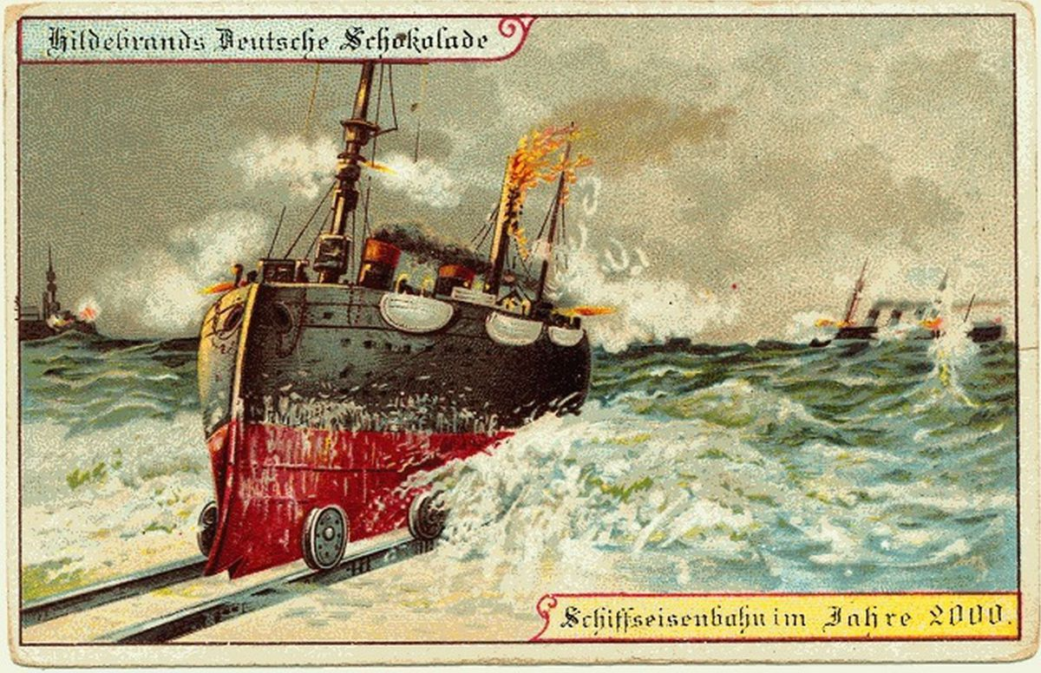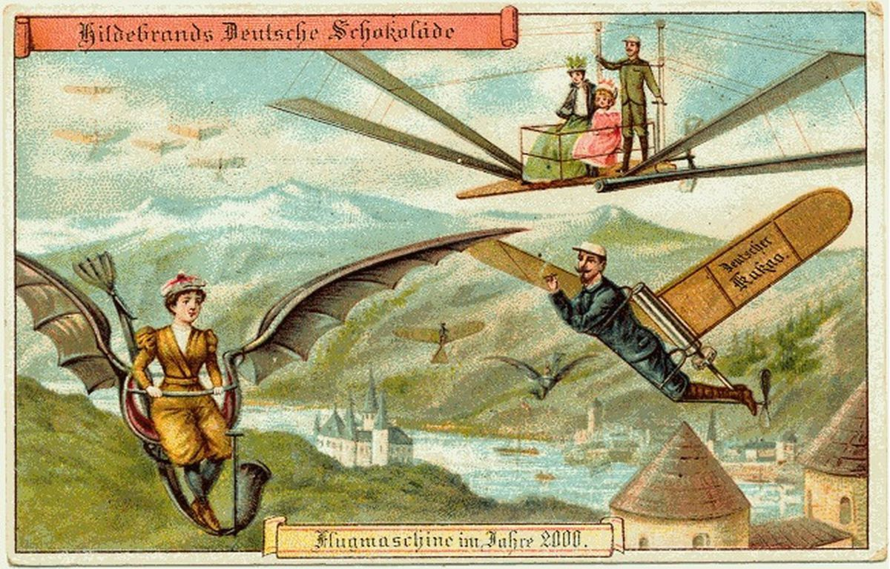
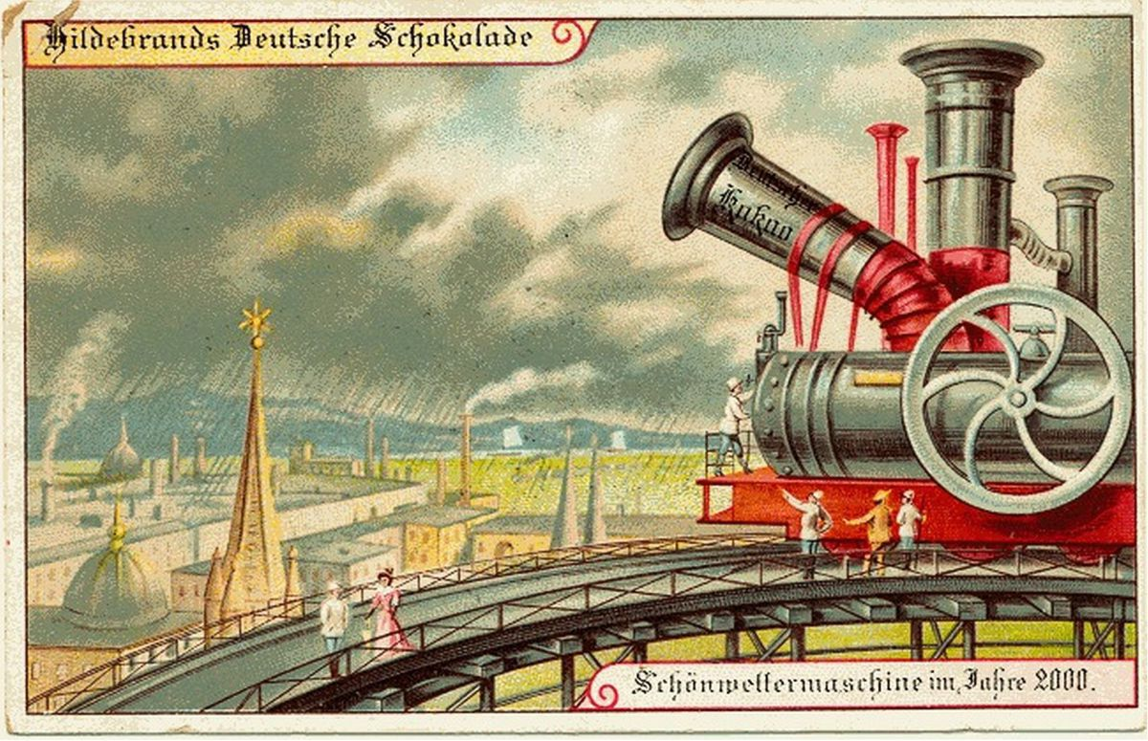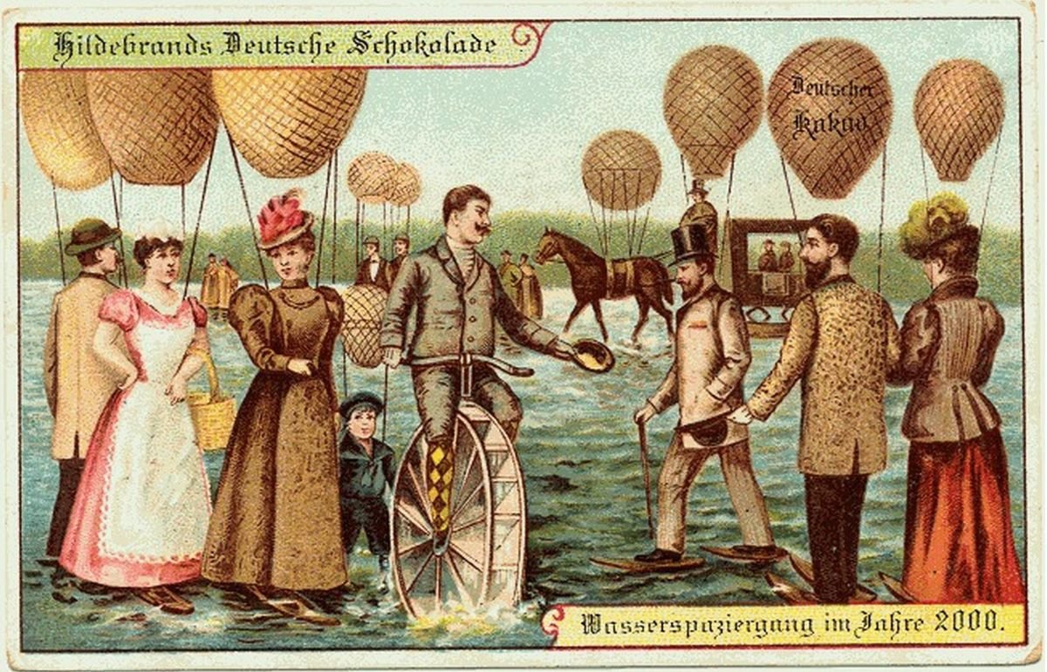
Answer any one of the following in around 250 words. (1x20=20)

- Critically analyse the vision of the future represented in these images. Do you see any shifts in the mode of thinking in the 21st century?

- Do you see any striking commonalities between the images and do any of these resonate with times we live in?

