ST. JOSEPH’S COLLEGE (AUTONOMOUS), BANGALORE-27
M.Sc. CHEMISTRY: IV SEMESTER
SEMESTER EXAMINATION-APRIL 2018
CH 0415: Solid State Chemistry
Time: 2½ hours Max Marks: 70
This question paper contains 2 pages and 3 parts
PART-A
Answer any SIX of the following questions: 6 x 2 = 12
- Give any two characteristics of a second order phase transition.
- Explain isotopic effect in superconductors.
- Identify, in the following cases, the type of lattice in cubic crystal system based on the following observed reflections from:
- (110), (200), (103), (202), (211) planes.
- (111), (200), (113), (220), (222) planes.
4. What is reciprocal lattice? Give its significance.
5. What is Frenkel defect?
6. State and explain Bloch theorem.
7. Show that a ‘hole’ may be considered as a ‘positive electron’.
8. Draw the unit cell of Illmenite, FeTiO₃.

PART-B
Answer any FOUR of the following questions: 4 x 12 = 48
9. a. Explain and show graphically the variation of i) induced magnetic field and ii) magnetization versus the applied external magnetic field strength in the case of Type II superconductors.
b. What is indexing of x-ray reflections? How is indexing done by graphical method in the case of cubic crystal system?
c. What is limiting sphere? Give its significance. (4 + 4 + 4)
10. a. What are glide planes? Explain any four types of glide planes associated with crystals.
b. Give all the point groups that result by combining a rotation axis with a parallel reflection plane. Also give their stereographic projections. (6 + 6)
11. a. Using the expression for intensity of (hkl) reflection, calculate the intensities of (100) and (110) reflections in the case of a body centered cubic crystal lattice.
b. Using Euler’s formula check whether each of the following combination of rotation axes is allowed or not: (i) 642 and (ii) 322. (6 + 6)
12. a. Calculate the density of a crystal belonging to hexagonal system (containing one asymmetric unit per lattice) which has the following unit cell dimensions. a = 22.6 Å, c = 7.7 Å. The formula weight of the compound is 255. How many reflections can be obtained from this crystal if MoK_{α} (λ= 0.711Å) radiation is used.
b. Explain (i) stacking faults and (ii) turbostratic disorder.
c. Define ‘second order phase transition’. Give an example. (4 + 5 + 3)
13. a. What is (i) ferromagnetism and (ii) antiferromagnetism? Derive the expression for the magnetic susceptibility of an antiferromagnetic material.
b. Show that a n-type semiconductor – metal junction is (i) ohmic when φ_{M} < φ_{S} and (ii) rectifying when φ_{M} > φ_{S}. (6 + 6)
14. a. What are Brilluoin zones? Draw the first Brilluoin zone of a simple cubic lattice.
b. Describe the olivine structure taking forsterite, Mg₂SiO₄, as example.
c. What are the advantages and limitations of neutron diffraction? (4 + 4 + 4)

PART-C
Answer any TWO of the following questions: 2 x 5 = 10
15. What information can be drawn with respect to systematic absences by calculating F_{hkl} values in the case of P_{c} and P2₁ space groups. For c glide the atomic positions are
(x, y, z) and (x, -y, z + 0.5). For 2₁ screw axis parallel to b-axis the atomic positions are
(x, y, z) and (-x, y +0.5, -z)
16. a. Identify the point group, lattice type and the crystal system present in the following space groups: (i) I_{mm2} and (ii) P₃₂
b. Identify the type of material (metal, insulator, intrinsic/n-type/p-type semiconductor) in the following cases.
(i) Resistivity decreases with temperature; the Hall coefficient is positive.
(ii) Plot of logσ against 1/T gives a straight line with a negative slope. (3 + 2)
17. a. Explain why the alloys made of A and B show different behavior when quenched or annealed as shown in the following graph.
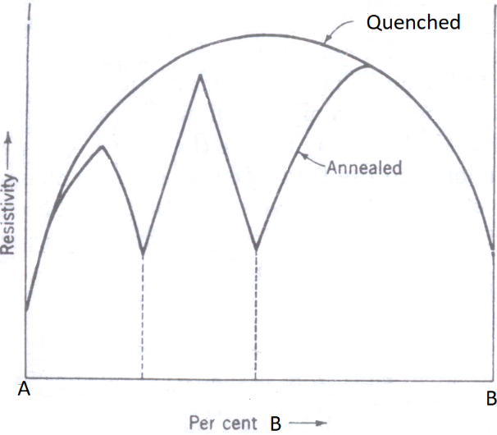
b. Calculate the difference in energy between the Fermi level and the top of the valence band for an intrinsic semiconductor whose UV-visible absorption onset is 350 nm. (3 + 2)
_______________________________________________________________

