Register Number:
DATE: 10-04-2016 ( 1pm )

ST.JOSEPH’S COLLEGE (AUTONOMOUS), BANGALORE- 27
M.A. ECONOMICS–IV SEMESTER
SEMESTER EXAMINATION- April2018
EC 0116 Advanced Econometrics

Time : 21/2 hrs Maximum marks : 70
This paper contains 2 printed page and 3 parts
PART A Answer any TEN of the following 2 X10=20
- What is Granger causality?
- Write the equation of an ARDL model.
- Why is it unnecessary to apply the two-stage least-squares method to exactly identiﬁed equations?
- What is order condition of identiﬁcation?
- Explain the concept of deterministic and stochastic trends.
- Define autocorrelation.
- What is Unit root test?
- Define covariance stationary.
- What is an ACF function?
- What is meant by an integrated time series?
- Give the meaning of the term spurious regression.
- What is the error correction mechanism (ECM)?

PART B Answer any TWO of the following 10 X2=20
- a. Explain the Koyck model.
- Whenever the lagged dependent variable appears as an explanatory variable, the R² is usually much higher than when it is not included. What are the reasons for this observation?
- How will you test presence of endogeneity problem? Explain the indirect least square method of estimation.
- Explain the problem of trend stationary and difference stationary in time series analysis. How will you correct each one of these problems?
PART C Answer any TWO of the following 15 X2=30
- From the quarterly data for the period 1950–1960, following demand function for labor was obtained the for an economy(the ﬁgures in parentheses are standard errors)
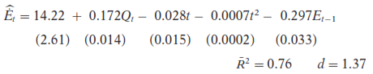
Where E_{t} = (E_{t} - E_{t-1}), Q = output and t = time
The preceding equation was based on the assumption that the desired level of employment E_{t}* is a function of output, time, and time squared and on the hypothesis that E_{t} - E_{t-1} = δ (E_{t}* - E_{t-1}), Where δ , the coefficient of adjustment, lies between 0 and 1.
- Interpret the regression.
- What is the value of δ?
- How would you test for serial correlation in the model?

- Consider the following modiﬁed Keynesian model of income determination:
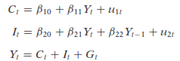
where C = consumption expenditure
I = investment expenditure
Y = income
G = government expenditure
G_{t} and Y_{t-1} are assumed predetermined

- Obtain the reduced-form equations and determine which of the preceding equations are identiﬁed (either just or over).
- Which method will you use to estimate the parameters of the over-identiﬁed equation and of the exactly identiﬁed equation? Justify your answer.

- From the U.K. private sector housing starts (X) for the period 1948 to 1984, Terence Mills obtained the following regression results
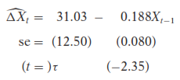
Note: The 5 percent critical ז value is -2.95 and the 10 percent critical ז value is -2.60.
- On the basis of these results, is the housing starts time series stationary or nonstationary? Alternatively, is there a unit root in this time series? How do you know?
- If you were to use the usual t test, is the observed t value statistically signiﬁcant? On this basis, would you have concluded that this time series is stationary?

