Register Number:

Date:

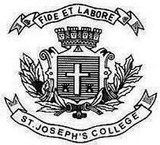

ST JOSEPH’S COLLEGE (AUTONOMOUS), BANGALORE-27
BCA JAVA PROGRAMMING-IV SEMESTER
SEMESTER EXAMINATION:APRIL 2017
CA 4315- Java Programming

Time-2 ½ hrs Max Marks-70

I Answer all the following 2*10= 20
1.What is Object Oriented Programming
2.Explain Data Abstraction.
3.Whats the difference between a String and a Character
4.Define Method overriding
5.Explain Vectors in Java.
6.What is a Final Class.
7.Whats an Exception in Java
8.Define Thread
9.What are applets?
10.What are Stream Classes?

II.Answer any FIVE of the following. 5*6= 30
11.Explain Abstract class with an example
12.Explain Method Overloading with example
13.Explain Packages in Java with example
14.Explain Multi threaded concept in Java with example.. .
15.What is an Exception? Explain try and Catch statements
16.Explain Applet Life Cycle
17.Explain Creation of Files in Java

III Answer any TWO of the following. 2*10=20
18.How do we achieve Multiple Inheritance in Java. Explain in detail with example.
19.Write the Features of Java in detail.
20.a)Write any three different ways of accepting Input in Java(5)
b)Write any simple Applet Program and explain.(5)

