Registered Number:
DATE: 20 -04-2018 (9AM)
ST. JOSEPH’S COLLEGE (AUTONOMOUS), BENGALURU-27
GENERAL ENGLISH- B.C.A / B.V.C.
SEMESTER EXAMINATION- APRIL 2018
MCT 414 - General English-Media, Culture and Technology

Time: 2 I/2 Hours Max. Marks- 70

INSTRUCTIONS

1. You are allowed to use a dictionary during the examination.

2. This paper contains seven printed pages.

3. You will lose marks for exceeding word limits.

For MCT ‘A’- Online Lives In Web
I. Read the following article from The Conversation . 4x10=40
Priapus is alive and well in cyberspace – the age-old art of trolling
Deep in the dank, dark anonymity of cyberspace dwell trolls – fearsome online guardians of digital values – ever vigilant, never sleeping. When called to arms, they mobilize with swift and deadly efficiency against anyone crossing bridges to trespass on hallowed ground. Despite the archaic tag, they are often seen as an unsavoury but inescapable consequence of modern online life – a squalid by-product of the 24-hour news cycle and the ever escalating appetite for online titillation. We tend to see this sort of abuse as quintessentially modern but it may surprise you to learn that these violent, sexualised responses to perceived boundary violations are nothing new. They would be instantly familiar to ancient Romans, as their threatening tone, graphic language and malicious intent are strikingly similar to those associated with the rustic fertility god Priapus.

Weapons of choice in this – mostly online – “war on error” habitually include graphic threats of rape and brutal sexual violence. When cornered, these trolls often radiate astonishment that their threats were taken seriously. They claim they were merely exercising their right to free speech, that they were obviously only joking – and anyway, their targets should just toughen up.
The majority of targets of such highly-sexualised harassment are female. Recent examples include the ongoing strident crusade against feminist media critic Anita Sarkeesian, initially over her campaign to crowd source funding for videos that critique the ingrained sexism within the gaming industry. And then there’s the vicious campaign waged against the feminist activist and journalist Caroline Criado-Perez for her suggestion that female faces were underrepresented on British banknotes; or even the umbrage taken at Richard Glover‘s musings on the methodology of climate change sceptics. As a recent Conversation article observed, euphemisms such as “unpleasant” or “sexually explicit” just don’t cut it when it comes to conveying the violence and vitriol of these outbursts. If we don’t say it like it is, we run the risk of undermining our perception of the serious effect these attacks have on the victims. And so, to the past. Within the Roman Empire, statues of Priapus were often placed in gardens and orchards to act as scarecrows or guardians, routinely accompanied by warnings of sexual violence against thieves and trespassers of either sex. Priapus is thought to have begun life in the Greek colonies of Asia Minor. Our earliest record of him comes from a play by the Greek author Xenarchus in the 4th century BC and references become more common as his worship spreads throughout Greece and on to Italy.
By the time he was absorbed into the Roman pantheon, Priapus, like many Roman gods, had quite an extensive portfolio. Among his responsibilities were human sexuality, the fertility and abundance of livestock, gardens, orchards, grapevines and bees as well as the protection of sailors and boundaries. He commonly featured in Roman erotic art and literature, especially a series of short, obscene, anonymous verses collectively known as the Priapea. Although often portrayed as a comic figure, as a guardian of boundaries, Priapus represented the distillation of masculine sexual aggression, dominance and power – the embodiment of rape. So, we have brutal sexual threats against perceived trespassers, made anonymously, with the expectation that they will be seen as “humorous”. Sound familiar?
Ancient Rome was undoubtedly a man’s world and the masculine drive to conquer and dominate drove the voracious expansion of the Empire. Roman attitudes to sex and sexuality were similarly male-centric and, to modern western sensibilities, quite alien. For male citizens (it was a very different situation for slaves and women), when it came to sex, pretty much the only requirement was that they remain the “active” partner. In this context, threatening to rape another man who had “crossed a line” was seen as a display of male dominance rather than an expression of homosexuality. A good deal of the content of Priapea is very close to the present day online sexual harassment trolls, an indication that such behaviour was not very uncommon in the ancient Roman world.
All of the writers, ancient and modern, clearly believe that some sort of line has been crossed. All radiate righteous wrath, advocating sexual violence to “correct” this transgression or (in some cases literally) to silence unwelcome criticism. Some of our modern boundaries may no longer be tangible and literal but the triggers – the aggressively masculine voice, anonymity and highly violent, sexualised threats – remain uncannily consistent over time. Although he may be posing as a troll, it looks like the ancient god Priapus – or at least his voice – is alive and well and thriving in cyberspace.
I. Answer the following questions in 150 words each: (4x10=40)
1. What do you understand by trolling? Have you ever been trolled or found yourself involved in trolling? Narrate your experience.
2. Do you think Priapus exists even today? What could be the psychological basis of some obnoxious online behaviour of people in your opinion?
3. Would you consider the cyber space a safe and protected area? What are some of the measures we can take to maintain our safety in social media?
4. Do women become easy targets of trolling or online harassment? Justify your answer.

II. Examine the cartoons given below and answer the questions that follow in 200 words each: ( 2x15=30)
5.
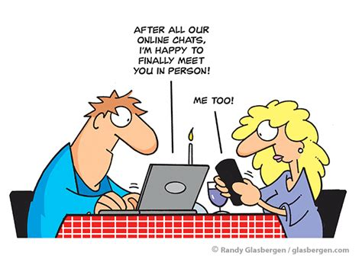

Do you think social media has reduced our conversational skills practically? [Text in speech bubble: Man- AFTER ALL OUR ONLINE CHATS, I’M HAPPY TO MEET YOU IN PERSON. Woman: ME TOO]

6.
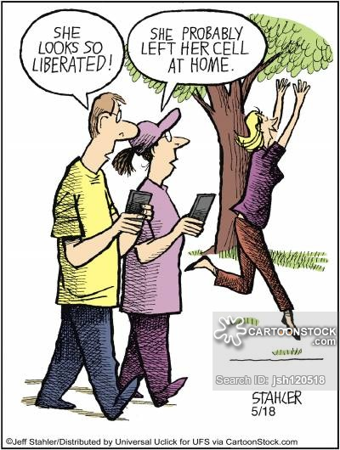

Describe how you made sense of the cartoon? [Text in speech bubble. Man: SHE LOOKS SO LIBERATED! Woman: SHE PROBABLY LEFT HER CELL AT HOME]

For MCT ‘B’- Images As Text
I. Read the following article from THE ARTIFICE and answer the questions

Female Superhero Representation in Comics
Black Widow. Wonder Woman. Scarlet Witch. Cat Woman. These might be some of the characters that come to mind when asked to think about female superheroes. Now, think about what they’re wearing.Ever since the dawn of superhero comics in the early twentieth century, women have been objectified within those square windows, no matter how powerful or likable the character is. This is often done through their skin-tight and usually suggestive costumes, gender ratio, and more. However, over the years, women have been gaining more ground in the comic book world. According to Graphic Policy’s article about “Comic Fandom on Facebook”, in July of 2015, women made up approximately 42% of American Facebook users who “like” comics and anything associated with them. Eventbrite states that 40% of people who attended fan conventions in 2014 were female.Women are becoming more and more prominent in the comic book world, especially as people grow more confident with bringing issues to the forefront. It can be assumed that the more people talk about feminism and its representation in superhero fiction, the more women will feel better about admitting that they like comics, even if those same issues still exist (for now).Ever since the dawn of superhero comics in the early twentieth century, women have been objectified within those square windows, no matter how powerful or likable the character is. This is often done through their skin-tight and usually suggestive costumes, gender ratio, and more. However, over the years, women have been gaining more ground in the comic book world. According to Graphic Policy’s article about “Comic Fandom on Facebook“, in July of 2015, women made up approximately 42% of American Facebook users who “like” comics and anything associated with them. Eventbrite states that 40% of people who attended fan conventions in 2014 were female.
Women are becoming more and more prominent in the comic book world, especially as people grow more confident with bringing issues to the forefront. It can be assumed that the more people talk about feminism and its representation in superhero fiction, the more women will feel better about admitting that they like comics, even if those same issues still exist (for now).Black Widow is a fictional superhero appearing in American comic books published by Marvel Comics. The Black Widow's first appearances were as a recurring, non-costumed, Russian-spy antagonist in the feature "Iron Man", beginning in Tales of Suspense #52 (April 1964). Five issues later, she recruits the besotted costumed archer and later superhero Hawkeye to her cause. Her government later supplies her with her first Black Widow costume and high-tech weaponry. When someone pictures Black Widow, what is she wearing? Probably a skin-tight leather catsuit. Catwoman? The same thing. Wonder Woman wears a colourful unitard and various accessories. Scarlet Witch wears a unitard* as well, also with various accessories that don’t cover much. Furthermore, Emma Frost and Starfire are both well known for being scantily clad. Several female superheroes have iconic uniforms, but does that mean that they should always save the day without wearing any forms of protection whatsoever? As times change, so does fashion and the need for a sense of realism in comics. Comic book duo David and Meredith Finch, who drew and wrote Wonder Woman #41 respectively, took Diana Prince’s original costume and came up with a new design created to represent her status as an amazon queen. It was designed to look something along the lines of what she would really wear to a fight. The new costume was made up primarily of armour in her signature colours, leaving only her hands and face bare.
In an interview with CBR News (where you can take a look at the costume), Meredith Finch states that,
“… [Wonder Woman is] also a warrior, so I wanted [it] to be a really strong, solid costume. It hints at the Amazon culture but also fits in[to] the modern world… It’s strong and reflective of who Diana is, and is still very recognizable as a Wonder Woman costume.”
Some fans complained about the lack of skin showing, claiming that feminists think women should cover up everything. Comic book artist J. Scott Campbell (known for his work on Danger Girl) made a comment on the design as well.
“I rarely comment about comic book industry matters on my personal [Facebook] page, but I gotta say, shoulder pads, especially big bulky metal ones NEVER look good on women. Everything about them is unfeminine and lacks style. No grace to this approach at all. And on a side note, I find the continued knee-jerk reaction to internet message board critics demands to keep female heroines covered from head to toe in fabric an overreaction. She’s an Amazon Warrior, she’s NOT in the Taliban!”
Campbell brings up an interesting point. The notion that fans want super heroines to be completely covered is unrealistic in and of itself. It’s illogical to think that just because you can’t see a woman’s skin that she’s being correctly represented in comics. Captain Marvel’s latest uniform covers all except her face (except when she wears her mask) and she is loved by critics and fans alike. It’s not because she isn’t showing any skin. The Finch couple’s decision to completely cover Wonder Woman appears to be a stylistic choice based off the fact that they wanted it to be form fitting and stylish, but useful in battle. While the storms about overt sexualization of female characters in comics may have influenced their decision, a character does not need to be covered head-to-toe in order not to feel like she’s showing too much.
Feminism in comics doesn’t consist of wanting to hide women’s attributes; it consists of not blatantly showing them off to appeal to the male audience while the character completely lacks development. If the reader can’t answer the question of “Why would this person wear something like that to a fight?” then it is not a realistic representation of female superheroes. Granted that the word “realistic” must be used lightly in correlation with the world of superpowered heroes, mutants, villains, and aliens, but part of what makes comics fun to read is imagining what the world would be like if these ridiculous things actually happened. If they did, it is probable that women wouldn’t wear barely-there clothing in battle, especially if their abilities don’t prevent them from getting into close range combat.
Going back to Wonder Woman for a minute, while she is definitely ‘THE’ superheroine icon. Wonder Woman is a fictional superhero appearing in American comic books published by DC Comics.^{[2]} The character is a founding member of the Justice League, goddess, and Ambassador-at-Large of the Amazon people. In her homeland, the island nation of Themyscira, her official title is Princess Diana of Themyscira, Daughter of Hippolyta. When blending into the society outside of her homeland, she adopts her civilian identity Diana Prince. The character is also referred to by such epithets as the "Amazing Amazon", the "Spirit of Truth", "Themyscira's Champion", the "God-killer", and the "Goddess of Love and War".
It may be noted that she is also the only woman in a team of males. It could be argued that it is a misrepresentation of gender ratio to assume that only one woman would be on a superhero team. Even the cinematic version of the Avengers only included one female Avenger, the Black Widow, until Marvel’s Avengers: Age of Ultron, when Scarlet Witch changed sides and joined the team. Still, the two women are undoubtedly outnumbered by their male teammates. In the first incarnation of the Avengers in comics, the only woman is Janet Van Dyne, whose alter ego is the Wasp. The Fantastic Four, affectionately known as Marvel’s first family, consisted of three men and one woman.

For years, super women have been on teams of superheroes and are usually outnumbered by the men. Even the X-men, who are known for having several powerful female characters, started out with only one: Marvel Girl. Since then, characters like Phoenix, Storm, Kitty Pryde, Rogue, Jubilee, Psylocke, and Mystique have been associated with the team in the comics and films, yet they still seem outnumbered.

(*Unitard- a tight fitting one piece garment of stretchable fabric which covers the entire body)

I. Answer the following questions in 150 words each: (4x10=40)

- How are the female superheroes contrasted with the male superheroes? Justify your answer with suitable examples.
- Do you think that the projection of most female superheroes is objectifying a woman’s body?
- Is the projection of female characters in superhero comics and/or popular cinema inadequate and lacking in quality? Give suitable examples.
- Would you consider the projection of ‘Wonder Woman’ in a team of six males a sexist representation?

II . Examine the cartoons given below and answer the questions. 2x15=30

5.
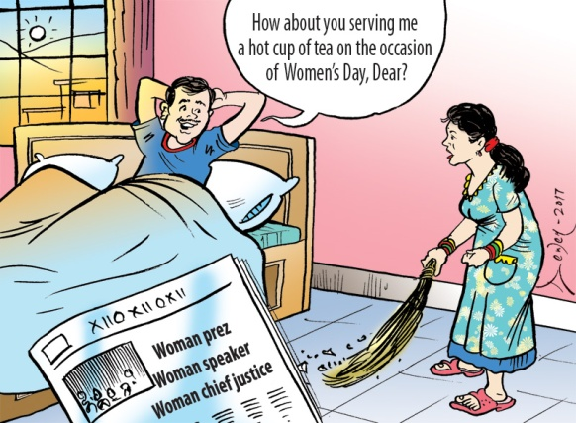

What are your reflections on this cartoon? Do you think the concept of women’s day is effective in bringing about women empowerment? Answer in about 200 words. [Text in speech bubble. Man: How about you serving me a hot cup of tea on the occasion of Women’s Day, Dear?]

6.
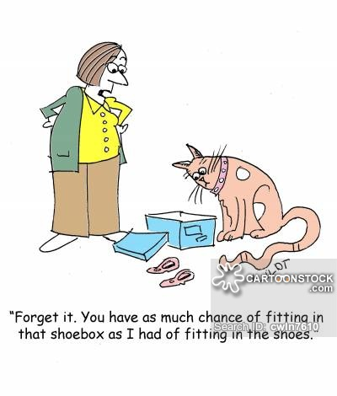

Frame a humorous short story based on the above cartoon in about 200 words. [Text in speech bubble. Lady: Forget it. You have as much chance of fitting in that shoebox as I had of fitting in the shoes.]

