ST. JOSEPH’S COLLEGE (AUTONOMOUS), BANGALORE-27
B.Sc - GENERAL ENGLISH – IV SEMESTER
SEMESTER EXAMINATION: APRIL 2018
GE 412– General English (Special paper for PSA)
Time- 2 1/2 hrs |  |  | Max Marks-70
This paper contains 5 printed pages and three parts

INSTRUCTIONS
- This paper is meant for B.Sc students who have opted for the PSA Special Course
- The paper contains THREE sections and SIX printed pages
- Answer all sections
- You will lose marks for exceeding the suggested word-limits
- You are allowed to use a dictionary during the examination
- Please indicate PSA-SPL COURSE clearly on your answer-booklet

I. Read the following two essays and answer the questions that follow.

Science, antiscience, and environmental decision making

Unfortunately, environmental decision making in too many cases is no longer rooted in scientific facts and findings but rather is heavily influenced by value judgments, political concerns, emotions, and naïve calls for simple solutions, inadequate for a complex world.
It is particularly worrying that scientific findings are, these days, attacked almost routinely by politicians and special interest groups, who propose alternative descriptions of reality or even reject science outright (Otto 2016). This antiscience movement relies on “alternative facts” that are presented as valid science but fall outside the rigors of the scientific method and the peer-review process (Martinez-Conde and Macknik 2017). Instead, alternative facts are generated by cherry-picking data, distorting the findings of published peer-reviewed studies, concocting unfounded theories, and publishing papers or books that merely mimic peer-reviewed publications. The resulting alternative facts are often in sharp contrast to factual evidence. These alternative facts increasingly pollute the body of scientific information used for tackling challenges in environmental and public health management (e.g., McGarity and Wagner 2012).
In 1995, Carl Sagan discussed the role of science in society in his classic work “The Demon-Haunted World: Science as a Candle in the Dark.” More than 20 years later, his concerns and arguments are more relevant than ever, as society faces ever more wicked environmental problems. These problems are nonlinear and complex, have an uncertain scope and scale, and have no analytical solutions. Such problems are resolved only by developing collaborative and integrative solutions. However, in the current climate of continuous concerted attacks, driven by vested economic and political interests or simple ignorance, the science that could underpin informed decision making is increasingly pushed aside, silenced, or even actively eliminated.
There are many reasons for the spread of antiscience. The Internet disseminates information at a rate unprecedented in history. However, there has been insufficient effort to educate the public in critical thinking, fact checking, intellectual commitment, and the scientific method. Paired with a lack of public access to scientific resources, a lack of understanding of uncertainty, and disconnects between risk science and risk perception, society's vulnerability to misinformation has been exploited across a broad political spectrum. This sows doubt and discredits scientific findings, resulting in widespread public cynicism and distrust of institutions and experts. Faced with an overwhelming hodgepodge of seemingly contradictory “facts” and “expert” opinions, the audience is tempted to simply pick the most soothing “facts” available.
For example, in the last decade, certain governments of Canada, Australia, and the United States (US) have sought to discredit the scientific underpinnings of environmental decision making. In Canada, the previous government (2006–2015) eliminated investigation of the environmental impacts of persistent organic pollutants and silenced government scientists. Fortunately, the present Canadian government has reversed this trend. Its most recent budget (March 2017) even provides incentives to attract scientists from other countries such as Australia, where environmental programs have been deeply cut, resulting in an exodus of talent. In the United States, research on climate change was actively discouraged by the White House from 2001 to 2009. This trend was reversed by the subsequent government but has been emphatically reinstated by the current administration. The current proposed US budget (March 2017) eliminates research on climate change and proposes deep cuts in spending for all science-based components of the government concerned with environmental issues, including climate change and human health. Scientific societies such as the Society of Environmental Toxicology and Chemistry, the American Association for the Advancement of Science, and many other groups and individuals are increasingly alarmed by the very real damage that governmental budget cuts would have on science-based environmental assessment and management.
Rising nationalism and isolationism pose serious threats. Environmental and human health problems do not observe national borders. Therefore, scientific endeavours to solve those problems must be international to be effective. Increasing restrictions to immigration, international travel, and collaboration further inhibit the discovery of new science and the solutions to wicked, global problems. Further, we have a moral obligation to support students and colleagues who are subject to systematic harassment because of their gender, religion, nationality, or profession.
The Earth's climate system is in upheaval; habitat change, invasive species, harmful algal blooms, eutrophication, and chemical pollution jeopardize ecosystems on a global scale. Exposure to, for example, fine particulates and endocrine disruptors jeopardizes human health and is costing health care systems billions of dollars annually. Denial will not change these facts and, more worryingly, will squander precious time and resources needed to protect public health and slow irreversible climate change and global biodiversity loss.
In view of the issues at stake, we cannot simply buckle down. We cannot placate ourselves by generating more data and focusing on scientific publications, academic teaching, and discussions within the comfort of business as usual. Although we may feel more comfortable developing new models or spending time in the laboratory, we must become better at arguing the wider implications of our work. Unfortunately such outreach efforts are time consuming and intellectually demanding and are insufficiently rewarded in academic and other institutions. This is especially problematic for young scientists early in their careers. Scientific outreach and civic participation must be better taught and incentivized.
(Source journal: Integrated Environmental Assessment and Management, Volume 13, Issue 4, July 2017)

Science and Religion - the Aftermath of the Schism
The schism between science and religion, in the 17th century, was a necessary step in the advancement of human knowledge, because rigid adherence and dogma were undoubtedly halting progress. Science has continued, over the centuries, to uncover vast areas of knowledge and answer pressing questions, for the undoubted benefit of humanity. There is little doubt that science has improved the quality of human life, but the focus is now shifting to whether this progress needs a counterweight.
Technological advances are unrecognizably, and irreversibly, changing human culture. The question is now about whether humanity, and morals, are lying forgotten on the road of discovery. Many scientists, whilst brilliant in their field, are often guilty of not looking at the wider implications of their research, and become fixated on the result. They become caught up in their elegant theories, and innovative experiments, without asking whether they should be pursuing the line of research.
Ethical questions are an integral part of the scientific process, and should always be built into the steps of the scientific research process. Currently, there is little consensus on who or what determines these ethics, and self-regulation is not working. Politicians make laws, but their judgment is suspect and subject to ulterior motives. For example, the environmental mess is due to politicians cynically selecting research that gives them the answers they want, not what is beneficial for humanity. The strategies of politicians are built around the election cycle, and are not conducive to laying down solid foundations for future generations.
Science has always faced questions about ethics and morality, during the experimental design process, and also in determining how the results are used. The Tuskegee Syphilis Experiment, where sufferers of the disease were denied treatment, in order to provide a control group, was very unethical and bordered upon murder. The exposure of servicemen to the unknown health effects of radiation was extremely immoral.
Modern science does display a better sense of internal morality. Mental suffering is now regarded as unethical and something like the Asch experiment, where subjects were subjected to intense emotional effects, would not be permitted in modern science. Science is now governed by strict protocol, and layers of legislation, dictating procedure and protecting the rights of the individual. For example, in a medical test where a placebo control group is used, if the medicine appears to be helping, the experiment is terminated and all patients are given the drug. These protocols are admirable, but are rarely used in a wider, external sense. The problems arise when we look at wider ethical concerns, governing the whole of humanity. Here we appear to be stuck in a mentality of ‘Scientists know best.’
Whether an individual subscribes to concerns about stem cell research, Hadron particle colliders, or genetic manipulation, these are areas that affect the whole of humanity, and should be governed by collective responsibility. In the same way that philosophy underlies the basic reasoning process governing the structure and validity of scientific research, religion should play a greater part in ethics. When using, lazily, the term religion, this should also encompass humanists and atheists, who can, and often do, express valid opinions based around a strong moral code.
This is not about fear of the unknown, but an insurmountable barrier across which there is little discussion. The lack of room for compromise is a breeding ground for extremism and intolerance, at both sides of the spectrum. If scientists were more willing to address the genuinely ethical concerns, would the Intelligent Design argument have been allowed to fester for so long?
Religious fanatics spouting off narrow-minded and distorted views of the world are extremely dangerous, but so are scientists refusing to accept the possibility of a creator. Atheism is perfectly acceptable, but it is important not to fall into the same trap of believing that it is the only viable belief. Ethical concerns are not solely the province of religion and those with or without faith have the right to express their views upon the subject, as long as they are reasoned, and well thought out.
Esteemed scientists stating that 'people who believe in God are idiots' are as intolerant as religious leaders ranting that those who do not subscribe to their restricted view of the world are evil, and deserve death and eternal damnation. For too long, there has been little overlap between the two fields, and this contributes to extremism. The path surely lies somewhere in the middle, where religious bodies are able to question ethics, without being shouted down, and scientists are allowed to establish their theories without attacks from those who believe in the literal truth of ancient texts. Science and religion have not always occupied mutually exclusive fields. The Age of Islam, from the 8th century to the 13th century, saw a period of great scientific advancement, sponsored by the controlling Theocracy.
Unfortunately, the aftermath of the schism, and the accusations of blasphemy caused by the theory of evolution and natural selection left scars, which need to be healed. This worked both ways, with great scientists such as George Carver Washington mocked by the scientific community for their religious beliefs. The Intelligent Design debate is widening this rift, and religious extremists are striving to maintain distance between science and religion. Despite the view being held only by a vocal minority, the debate is capturing the public consciousness, and masking any constructive dialogue and discussion.
Despite the fringes of science and religion causing difficulties, there are signs that the uneasy co-existence is thawing. Many scientists are happy to proclaim their religious beliefs, and many religious organizations support real science, rather than trying to use it to support narrow beliefs. Once the course of debate switches, and religions are allowed to air ethical concerns, humanity will be able to improve and develop at an even greater rate.
(Source: ‘When Science Meets Religion’ by Martyn Shuttleworth at explorable.com)

I. A. Answer the following questions in about 200 words each: (4x15 = 60)
- On the basis of the first article, what criteria would you use to characterize those who are anti-science? Do you think environmental scientists are unnecessarily apprehensive about the power and influence of those who deny global warming? Give reasons.
- How does the second article defend its assertion of a middle ground between science and religion? Does this sound credible to you? Why/why not?
- Do you think it is possible for politics and religion to join forces against the progress of science? Support your response with examples from reading this semester and your knowledge of current affairs both nationally and internationally.
- What according to you are the steps India must take in order to harness scientific knowledge to the mission of sustainable development?

II. Use the following cartoons as points of reference for a reflective essay of about 150 words on the theme of this paper: (10 marks)

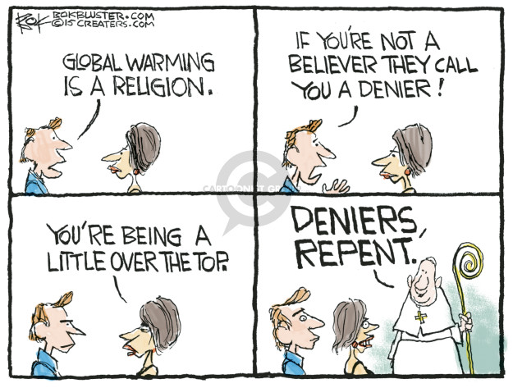

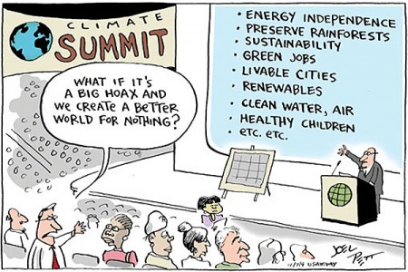
GE-412-A-18

