Register Number:
DATE: 16-04-2018 ( 9AM )

ST. JOSEPH’S COLLEGE (AUTONOMOUS), BANGALORE-27
BA(VISUAL COMMUNICATION)– IV SEMESTER
END SEMESTER EXAMINATION: APRIL 2018

VC 4217:WRITING FOR MEDIA

Time – 2 1/2 hrs Max Marks-70

This paper contains twoprinted pages and three parts

- Answer any FIVE of the following question in 100 words. (5X5 = 25 marks)

1. Write a short note on the following:
a. Teaser
b. Tag
c. Boilerplate
d. Institutional Copy
e. Command Headline
2. What is a layout? Discuss the purpose of a layout in advertisements.
3. Discuss the four basic format elements used to construct long copy ads.
4. What is the difference between PR and Advertising. Discuss with relevant examples.
5. Discuss the importance of a Press Release.

6. What is the difference between blogging and micro blogging sites?

- Answer any THREE of the following questions in about 300 words. (3X10 = 30 marks)
7.Discuss the seven types of layout in creating an ad.
8. Write copy for the following print ads.Specify the product and provide an explanation.

VC 4217-B-18
a. 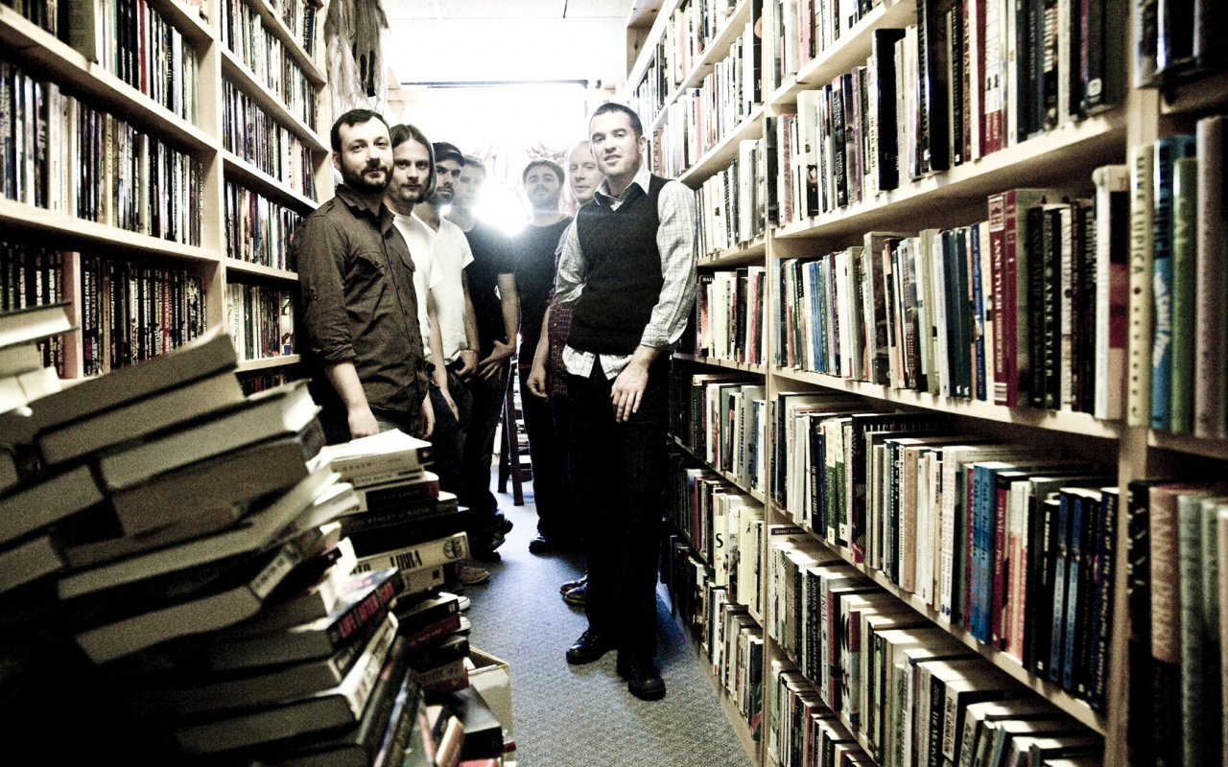
b.
c.
10. Write a blog for the launch of the ad campaign ‘#MomBeAGirlAgain’ of Amazon in the market.

11. Write a press release for
Calling all film enthusiasts! Block buster actor, Andy Serkis, is hosting exclusive audience sessions at one of London’s hottest film industry hangouts, the Soho hotel, next week (8 December 2007) in aid of children’s charity Barnardo’s.

- Answer the following question. (1X15 = 15 marks)

12.Write a radio script for a 60 seconds PSA on body shaming.

