Register Number:
DATE: 17 -04-2018 (1PM)
ST. JOSEPH’S COLLEGE (AUTONOMOUS), BENGALURU-27
M.Sc. BOTANY – II SEMESTER
SEMESTER EXAMINATION: APRIL 2018
BO 8415: Biostatistics and Bioinformatics

Time: 2 ½ hrs. Max. Marks: 70

This question paper has TWO printed pages and TWO parts
Answer Part-A and Part-B in separate Main Answer Books.
Students are allowed to use calculators.

PART-A: BIOINFROMATICS (Answer in separate Main Answer Books)

A. Write on any FIVE of the following 5 x 2= 10
1. Meanings for the Genomatix syntax codes- descr, sym
2. Orthologous genes
3. Identify the logo and write its importance
4. UniProt KB
5. HTML
6. Orphan drugs
7. Identify the sequence format with 2 reasons;
LOCUS AB000263368 bp mRNA linearPRI 05-FEB-1999 DEFINITION Homo sapiens mRNA for prepro cortistatin like peptide, complete cds.ACCESSION AB000263 ORIGIN
1 acaagatgcc attgtccccc ggcctcctgc tgctgctgct ctccggggcc acggccaccg
61 ctgccctgcc cctggagggt ggccccaccg gccgagacag cgagcatatg caggaagcgg……………………..//

B. Write critical notes on any THREE of the following 3 x 5=15
8. Pairwise sequence alignment
9. PubMed and its uses
10. Tertiary structure of proteins
11. Molecular visualization using tools
C. Give a comprehensive account of any ONE of the following 1x 10=10
12. Nucleotide sequence databases
13. Networking and Programming languages

P.T.O
Page 1 of 2

PART-B: BIOSTATISTICS (Answer in separate Main Answer Books)

A. Explain or define any FIVE of the following 5 x 2= 10
1. Mahalanobis
2. Randomization
3. Chi-square test
4. Variance
5. Identify the diagram and mention the uses
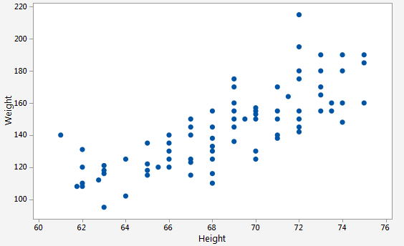
6. Median class
7. Identify the type of Kurtosis with reasons
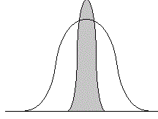
B. Write critical notes on any THREE of the following 3 x 5=15
8. Sampling methods (any three) and their applications in research
9. The data collected to study the yield in case of an experimental Mango crop is given below. Calculate the Median.

No. of fruits/Plant | Below- 5 | 5-20 | 20-30 | 30-40 | 40-50 | 50-60 | 60-70 | Above 70
No of plant | 11 | 34 | 178 | 249 | 136 | 90 | 70 | 14

10. Concepts and rules of hypothesis testing
11. ANOVA
C. Give a comprehensive account of any ONE of the following 1x 10=10
13. The data collected to study the infection in Pisum sativa crop is given below. Calculate the Mode by both the methods and write a note.
No. of infected leaves/plant | 0-5 | 5-10 | 10-15 | 15-20 | 20-25 | 25-30 | 30-35 | 35-40 | 40-45
No of plant | 02 | 16 | 78 | 149 | 301 | 130 | 102 | 70 | 23
14. Give an account of correlation and regression with suitable examples.
Page 2 BO-8415-A-18

