ST. JOSEPH’S COLLEGE (AUTONOMOUS), BENGALURU-27.
M.Sc MICROBIOLOGY - II SEMESTER
SEMESTER EXAMINATION- APRIL 2018
MB8216 - IMMUNOLOGY

Time: 2 1/2hrs Max Marks: 70

This question paper has 2 printed pages and 4 parts

I. Answer any Five of the following 5 x 3 =15

- What are collectins and compliments, and what is their function?

- List three reactive oxygen intermediates in phagocytosis.

3. Why are gelatin and polystyrene not immunogenic?

- Who were the scientists who first reported the identification of two Recombination
activating genes and their functions?

5. Name three mediators of a hypersensitive reaction.

6. Write a note on Graves’ disease?

7. Define: Leukemia, carcinoma, and sarcoma.

II. Answer any Five of the following 5 x 5 =25

8. Tabulate the comparisons of active and passive immunity.

9. Write a note on the classification of dendritic cells and their function giving examples.

10. Explain compliment fixation test.

11. Describe with an example immunotoxin as a therapeutic tool.

12. What are the host immune responses to bacterial infection and bacterial evasion
mechanisms?

13. What factors must be kept in mind while designing vaccines for active immunization?

14. Draw a schematic pathway of the compliment system which is dependent on antibody.

III. Answer any Two of the following 2x10=20

15. Give a detailed account of a secretory antibody and an antibody involved in
hypersensitive reactions.

16. Explain the mechanism of antigen processing and presentation by the cytosolic pathway.

17. Tabulate the properties and function of cytokines.

IV. Answer the following 1 x10=10

18. What response can be observed during the body’s reaction to a simple thing like a
thorn in the flesh?
a) Name the response. 1
b) Explain its mechanism 9

MB-8216 B-18

M.Sc II Semester MB-8216 B-18

Scheme of Evaluation APRIL -2018

I. Answer any Five of the following 5 x 3 =15

- Selectins Integrins, Mucins, Immunoglobulin like molecules.any three each -I mark

- Super oxide anion 0₂^{-,} OH , H₂O₂ , ClO⁻any three -1 mark each

- Gelatin is a protein which is highly unstable -1.5where as polystyrene is not susceptible in tissue and cannot be broken down into antigenic peptides.-1.5

- The scientists are David Schatz, Marjorie Oettinger and David Baltimore2-RAG I AND RAG -II are required for V-(D)-J rearrangement.-1

- The tree mediators- Heparin,Serotonin, Epinephrine, Leukotrenes,Prostoglandins,
Platelet activating factor etc- any one each one mark

6. Graves disease is an auto immune disease mediated by stimulating the production of
autoantibodies to the receptor TSH-1.Binding of these autoantibodies to the receptor
mimics the normal action of TSH,activating adenylate cyclase and resulting in the
production of the thyroid hormone.-1
Unlike TSH autoantibodies are not regulated ,and consequently they are
overstimulated leading to excess production of the hormone-1

7.Leukaemia –malignant tumors of the hemopoietic cells of the bone marrow-1
Carcinoma-tumor that arise from the endoermal, or ectodermal tisues, such as skin or
the epithelial lining of the internal organs and glands-eg colon, breast, prostrate etc-1
Sarcoma- which arise from mesodermal connective tissues, such as fat,cartilage and
bone-1

II. Answer any Five of the following 5 x 5 =25

8.
Active Immunity | Passive Immunity
Produced actively by hosts immune system | Received passively, not active host participation
Induced by infection or by immunogens | Ready made antibodies transferred
Immunity effective only after a long lag period | Immediate immunity
Immunological memory present | No memory
Booster effect on subsequent dose | Subsequent dose less effective
Negative phase may occur | No negative phase
Not applicable in immunodeficient | Applicable in immunodeficient
Effective protection. | Less effective-transient
Any 5 points each one mark

9. Hematopoeitic stem cell gives rise to a myeloid progenitor in the presence of a specific
CSF namely GMCSF AND IL3. -1 The myeloid further differentiates to give rise to a ne
Which gives rise to a cells with long extensions resembling the dendrites of a neuron
Andis called DC-1. It can be classified into circulating and fixed DC-. Such as
Langerhans- Dc found in the skin and mucous secretion
Interstitial DC found in the kidney ,liver, heart etc
Interdigitating DC – found in the THymic medulla.
Circulating DC in the blood and those in the lymph are called –Veildcel.
All the above function as Antigen Presenting cells.
Folicular Dendritic cells which are found in the Lympnode do not function as APC as
they do not express class II MHC-4

10. Compliment Fixation test. Explanation- 5
This tests helps identify the antigen in a serum. It involves II STEPS.
First requires-1. Antigen 2, serum if it has circulating antibodies to the antigen
tested ,3. Compliment proteins obtained from Guinea pig antiserum.
II -is referred to the indicator system- 1. Sheep RBC 2. Antibody to sheep RBC
called amboreceptor.
1. In step one which is incubated with the serum and compliment. If serum contains antibody. Antigen and antibody bind. Once this takes place the compliment binds. Indicating the compliment is fixed. When the sheep Rbc and antibody to sheep RBC areadded.There is no hemolysis. Which is a positive test.-contain antibody and is incubated with antigen . The compliment is free. When the indicator system components are added. Compliment is free as the sheep RBC will bind to the antibody and compliment binds, causing the RBC to lysis .Henc e hemolysis is a negative test. When the serum does not

11. Toxins used to prepare immunotoxins include ricin, Shigella toxin, and diphtheria toxin. Each toxin contains an inhibitorytoxin chain (red) and a binding component (yellow). To makean immunotoxin, the binding component of the toxin is replacedwith a monoclonal antibody (blue). (b) Diphtheria toxin binds to acell-membrane receptor (left) and a diphtheria-immunotoxin bindsto a tumor-associated antigen (right). In either case, the toxin is internalizedin an endosome. The toxin chain is then released into thecytoplasm, where it inhibits protein synthesis by catalyzing the inactivationof elongation factor 2 (EF-2).

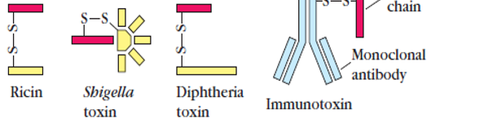

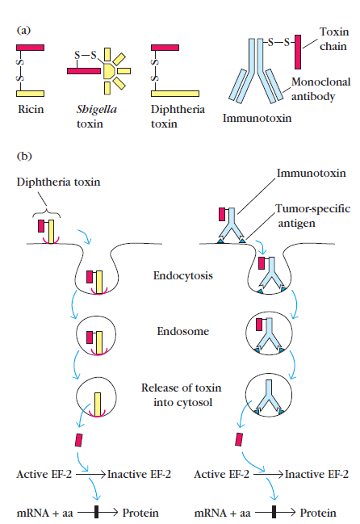
. 12.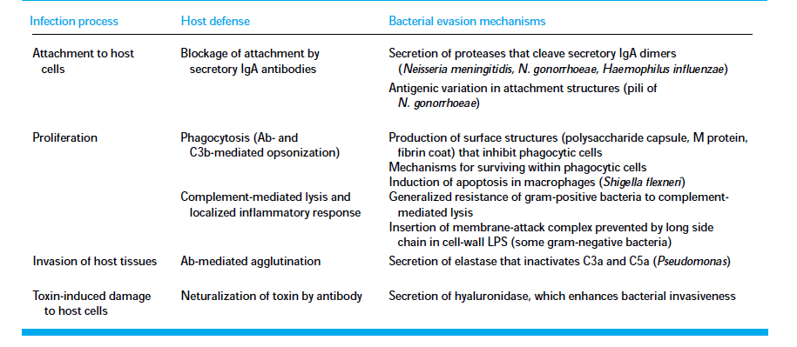

13.Knowledge of the differences in epitopesrecognized by T cells and B cells has enabled
immunologiststo begin to design vaccine candidates to maximizeactivation of both arms of the immune system.-1
AsFirst and foremost, the development of an immunevvresponse does not necessarily mean that a state ofprotective immunity has been achieved.What is often critical
is which branch of the immune system is activated, andtherefore vaccine designers must recognize the importantdifferences between activation of the humoral and the cellmediated
branches. -1
A second factor is the development ofimmunologic memory. For example, a vaccine that induces aprotective primary response may fail to induce the formation
of memory cells, leaving the host unprotected after the primaryresponse to the vaccine subsides. -1
The role of memory cells in immunity depends, in part,on the incubation period of the pathogen. In the case ofinfluenza virus, which has a very short incubation period (1
or 2 days), disease symptoms are already under way by thetime memory cells are activated. Effective protection againstinfluenza therefore depends on maintaining high levels ofneutralizing antibody by repeated immunizations; those athighest risk are immunized each year.-1
For pathogens with alonger incubation period, maintaining detectable neutralizing
antibody at the time of infection is not necessary. Thepoliovirus, for example, requires more than 3 days to begin toinfect the central nervous system. An incubation period of
this length gives the memory B cells time to respond byproducing high levels of serum antibody. Thus, the vaccinefor polio is designed to induce high levels of immunologic
memory.-1
.
14. Schematic pathway of classical pathway-

III. Answer any Two of the following 2x10=20

15
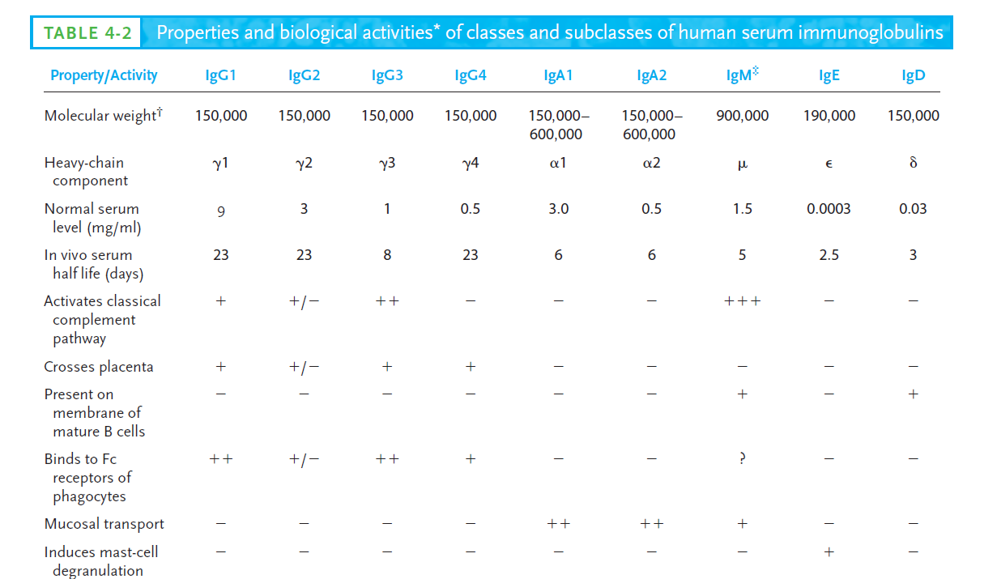.

16. Generation of antigenic peptide–class I MHC complexesin the cytosolic pathway. TAP, a heterodimeranchored in the membrane of the rough endoplasmic
reticulum (RER). The two chains are encoded by TAP1 and TAP2. The cytosolic
domain in each TAP subunit contains an ATP-binding site, and
peptide transport depends on the hydrolysis of ATP. (b) In the cytosol,
association of LMP2, LMP7, and LMP10 (black spheres) with a proteasome
changes its catalytic specificity to favor production of peptides that
bind to class I MHC molecules. Within the RER membrane, a newly synthesized
class I _ chain associates with calnexin until _2-microglobulin
binds to the _ chain. The class I _ chain/_2-microglobulin heterodimer
then binds to calreticulin and the TAP-associated protein tapasin. When
a peptide delivered by TAP is bound to the class I molecule, folding of
MHC class I is complete and it is released from the RER and transported
through the Golgi to the surface of the cell.

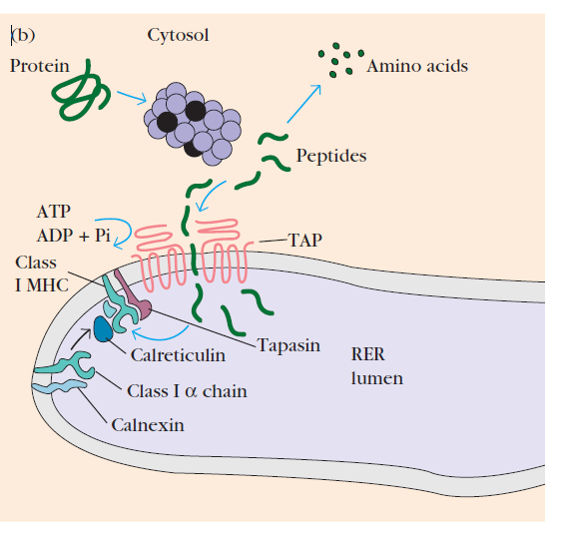
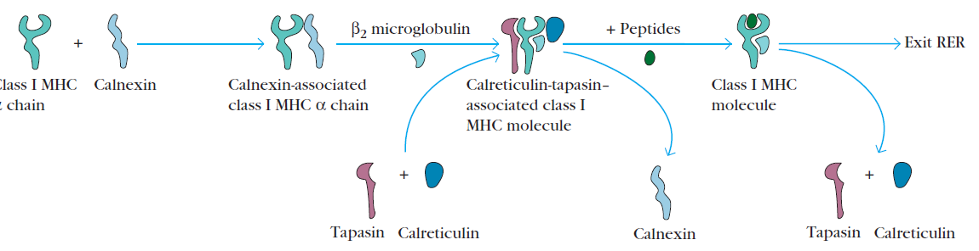
Intracellular proteins are degraded into short peptides by a cytosolic
proteolytic system present in all cells. Those proteinstargeted for proteolysis often have a small protein, calledubiquitin, attached to them (Ubiquitin-protein
conjugates can be degraded by a multifunctional proteasecomplex called a proteasome. Each proteasome is a large(26S), cylindrical particle consisting of four rings of protein
subunits with a central channel of diameter 10–50 Å.A proteasome can cleave peptide bonds between 2 or 3different amino acid combinations in an ATP-dependent
process Degradation of ubiquitin-proteincomplexes is thought to occur within the central hollow ofthe proteasome.
Cytosolic proteolytic system for degradation of intracellularproteins. (a) Proteins to be degraded are often covalentlylinked to a small protein called ubiquitin. In this reaction, which requiresATP, a ubiquinating enzyme complex links several ubiquitinmolecules to a lysine-amino group near the amino terminus of theprotein. (b) Degradation of ubiquitin-protein complexes occurswithin the central channel of proteasomes, generating a variety ofpeptides. Proteasomes are large cylindrical particles whose subunitscatalyze cleavage of peptide bonds.. Thetransporter protein, designated TAP (for transporter associated
with antigen processing) is a membrane-spanningheterodimer consisting of two proteins: TAP1 and TAP2In addition to their multiple transmembranesegments, the TAP1 and TAP2 proteins each have a domainprojecting into the lumen of the RER, and an ATP-binding
domain that projects into the cytosol. Both TAP1 and TAP2belong to the family of ATP-binding cassette proteins foundin the membranes of many cells, including bacteria; these
proteins mediate ATP-dependent transport of amino acids,sugars, ions, and peptides.
Peptides generated in the cytosol by the proteasome aretranslocated by TAP into the RER by a process that requiresthe hydrolysis of ATP TAP has the highestaffinity for peptides containing 8–10 amino acids, which isthe optimal peptide length for class I MHC binding. In addition,TAP appears to favor peptides with hydrophobic or basiccarboxyl-terminal amino acids, the preferred anchorresidues for class I MHC molecules. (Like other proteins, the _ chain and _2-microglobulincomponents of the class I MHC molecule are synthesized
on polysomes along the rough endoplasmic reticulum. Assemblyof these components into a stable class I MHCmolecular complex that can exit the RER requires thepresence of a peptide in the binding groove of the class Imolecule. The assembly process involves several steps andincludes the participation of molecular chaperones, whichfacilitate the folding of polypeptides. The first molecularchaperone involved in class I MHC assembly is calnexin, a
resident membrane protein of the endoplasmic reticulum.Calnexin associates with the free class I _ chain and promotesits folding. When _2-microglobulin binds to the _chain, calnexin is released and the class I molecule associateswith the chaperone calreticulin and with tapasin.Tapasin (TAP-associated protein) brings the TAP transporterinto proximity with the class I molecule andallows it to acquire an antigenic peptide). Thephysical association of the _ chain–_2-microglobulin heterodimer with the TAP protein) promotespeptide capture by the class I molecule before the peptidesare exposed to the luminal environment of the RER.
Peptides not bound by class I molecules are rapidly degraded.As a consequence of peptide binding, the class I molecule displaysincreased stability and can dissociate from calreticulin
and tapasin, exit from the RER, and proceed to the cell surfacevia the Golgi. An additional chaperone protein, ERp57,has been observed in association with calnexin and calreticulin
complexes.
17. p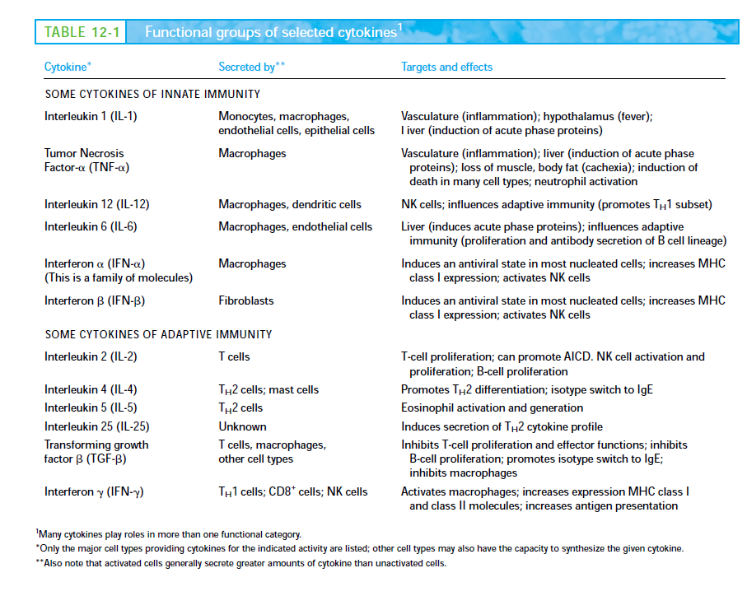

IV. Answer the following 1 x10=10

18.a) Inflammatory response.-1
b) bumping ,Rolling, activation and firm attachment of phagocytotic cells
Trans Endothelial migration and movement to the site of infection followed by
phagocytosis. CAMS , TNF alpha activates endothelial cells to produce E and P
selectins. IL-circulates in the blood and stimulates the hypothalamus of the brain to
induce anorexia,fever and somnolence.
,IL-6-, activates the liver to produce acute phase proteins Chemokine receptor is
activated by IL-8 produced by endothelial cells that activates G-coupled proteins on
the phagocytotic cells and brings a conformation change of the integrins and
immunoglobulins and helps in transendoothelial migration.

