ST. JOSEPH’S COLLEGE (AUTONOMOUS), BANGALORE-27
CBCS - IV SEMESTER
SEMESTER EXAMINATION: APRIL 2018
MTOE 4116: Quantitative Methods for Competitive Examination
Time- 1 1/2 hrs |  |  | Max Marks-35
This paper contains FOUR printed pages
Instruction: Scientific Calculators are not allowed

(For supplementary candidates)
Do not write the register number on the question paper
Please attach the question paper along with the answer script.

Answer any SEVEN questions from the following. (7x5=35)

- a) Simplify : ${27}^{\frac{2}{3}}$
b) What is the quotient when (x⁻¹ - 1) is divided by (x - 1)?
c) If 2^{x - 1} + 2^{x + 1} = 1280, then find the value of x. (1+2+2)
- a) Arrange the fractions 5/8, 7/12, 13/16, 16/29 and 3/4 in increasing order.
b) If $\frac{a}{b}=\frac{3}{4}$ and 8a+5b=22, then find the value of a.
c) if $\frac{x}{4}-x-\frac{3}{6}=1$,then find the value of x. (1+2+2)
- Arjun and Sajal are friends. Each has some money. If Arjun gives Rs. 30 to Sajal, then Sajal will have twice the money left with Arjun. But, if Sajal gives Rs. 10 to Arjun, then Arjun will have thrice as much as is left with Sajal. How much money does each have?
(5)
- Find
- The fourth proportional to 2, 8, 14.
- The third proportional to 8 and 16.
- The mean proportional between 0.07 and 0.16.
- A mixture contains alcohol and water in the ratio 4 : 3. If 5 litres of water is added to the mixture, the ratio becomes 4: 5. Find the quantity of alcohol in the given mixture.
(1+1+1+2)
- a) In an examination , 30% of total students failed in Hindi , 40% failed in English and
30% in both . Find the percentage of those who passed in both subjects.
b) During one year, the population of town increased by 5% . If the total population is
9975 at the end of the second year , then what was the population size in the
beginning of the first year ? (3+2)

- a) If the diagonal of a rectangle is 17 cm long and its perimeter is 46 cm, find the area
of the rectangle.
b) The inner circumference of a circular race track 14 m wide is 440 m. Find the
radius of the outer circle.
c) Find the measure of angle A in the figure below.
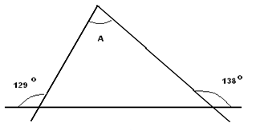 (2+2+1)

7 a) Three solid cubes of sides 1 cm, 6 cm and 8 cm are melted to form a new
cube. Find the surface area of the cube so formed.
b) Find the volume and surface area of a sphere of radius 10.5 cm (3+2)

- In a school the periodical examination are held every second month. In a session during April 2001 – March 2002, a student of Class IX appeared for each of the periodical exams. The aggregate marks obtained by him in each periodical exam are represented in the line-graph given below. Study the graph and answer the questions based on it.

MARKS OBTAINED BY A STUDENT IN SIX PERIODICAL EXAMS HELD IN
EVERY TWO MONTHS DURING THE YEAR IN THE SESSION 2001-02
Maximum Total Marks In each Periodical Exam = 500
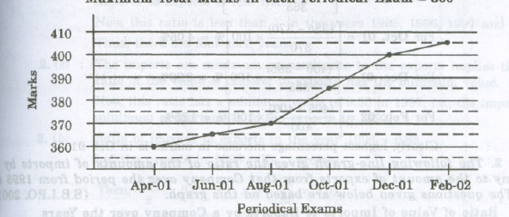
- The total number of marks obtained in Feb 2002 is what percent of the total marks obtained in April 2001?
- What are the average marks obtained by the student in all the periodical exams
during the session.
- What is the percentage of marks obtained by the student in the periodical exams of Aug 2001 and Oct 2001 taken together?
- In which periodical exam there is a fall in percentage of marks as compared to the previous periodical exam?
- In which periodical exam did the student obtain the highest percentage increase in marks over the previous periodical exams? (5)

- The bar-graph provided below gives the sales of books (in thousand numbers) from six branches of a publishing company during two consecutive years 2000 and 2001. Answer the questions based on this bar-graph:

Sales of books (in thousand numbers) from six branches-B1,B2,B3,B4,B5 and B6 of a
publishing company in 2000 and 2001

- Total sales of branches B1,B3 and B5 together for both the years (in thousand numbers) is:
- Total sales of branch B6 for both the years is what percent of the total sales of branch B3 for both the years?
- What is the average sale of all the branches (in thousand numbers) for the year 2000?
- What is the ratio of the total sales of branch B2 for both the years to the total sales of branch B4 for both years ?
- What percent of the average sales of the branches B1,B2 and B3 in 2001 is the average sales of branches B1,B3 and B6 in 2000? (5)

- The following pie-charts show the distribution of students of graduate and post graduate levels in seven different institutes -M,N,P,Q,R,S and T in a town.

DISTRIBUTION OF STUDENTS AT GRADUATE AND POST-GRADUATE LEVELS IN
SEVEN INSTITUTES-M,N,P,Q,R,S AND T.

Total number of students of Total number of students of
graduate level : 27300 post graduate level : 24700

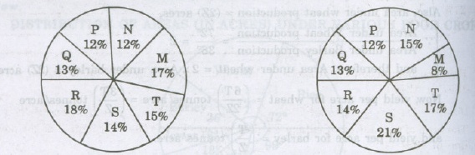

- How many students of institutes M and S are studying at graduate level?
- What is the total number of students studying at post -graduate level from institutes N and P ?
- What is the total number of graduate and post-graduate level students in institute R?
- What is the ratio between the number of students studying at post graduate and graduate levels respectively from institute S?
- What is the ratio between the number of students studying post graduate level from institute S and the number of students studying at graduate level from institute Q?
(5)

