DATE: 13-04-2018

ST. JOSEPH’S COLLEGE (AUTONOMOUS), BANGALORE-27
B.Sc. ELECTRONICS – II SEMESTER
SEMESTER EXAMINATION: APRIL 2018

EL 215: Amplifiers and Oscillators
(For supplementary candidates)
Do not write the register number on the question paper
Please attach the question paper along with the answer script.

Time-2 ½ hrs Max Marks-70
This paper contains three printed pages and three parts
PART – A
ANSWER ANY FIVE OF THE FOLLOWING 5X8=40 Marks

- a) Define cascade and cascode type of multistage amplifiers.
b) With necessary circuit diagram explain and derive the expression for voltage gain
of direct coupled multistage amplifier. (2+6)

- a) With the help of circuit diagram explain the working of Class-A single ended
transformer coupled amplifier and drive the overall efficiency.
b) Give any three difference between voltage and power amplifier. (5+3)

3. a) Explain Barkhusen criteria for oscillation.
b) Define Multivibrators. Explain the working of Astable multivibrator using transistor
and derive the expression for transistor off time. (2+6)

4. a) Explain all necessary steps to fabricate a diode.
b) Explain the working of Schmitt trigger and draw its input and output waveform.
(4+4)

5. a) Define differential amplifier. Mention different configurations of differential
amplifier.
b) With the help of circuit diagrams derive the expression for voltage gain of dual
input balanced output differential amplifier. (2+6)

6. a) Explain the block diagram of operational amplifiers.
b) Derive the expression for voltage gain of voltage series feedback amplifier. (3+5)

7. a) With the help of circuit diagram derive the expression for voltage gain of first order
low pass Butterworth filter and draw its frequency response.
b) Draw the circuit diagram of inverting comparator, and draw its output waveform.
(5+3)

PART – B
ANSWER ANY FIVE OF THE FOLLOWING 5x4=20 Marks
8. A radio receiver uses a two stage RC coupled amplifier as shown in figure. Determine
the values of voltage gain of each stage and overall voltage gain, also express the
overall voltage gain in decibels.
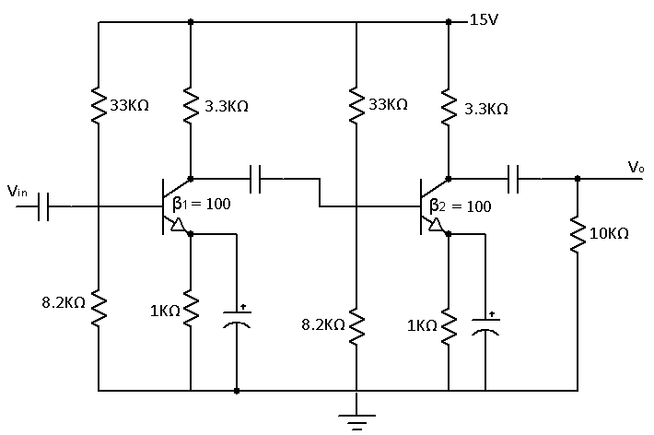

9. A class-B output stage has an efficiency of 60%. If the maximum collector dissipation
of each transistor is 2.5W. Calculate the d.c input power and a.c output power.

10. An RC phase shift oscillator makes use of an amplifier with open loop gain equal to
200000 and three RC sections with R = 10KΩ, C = 0.1µF. Calculate frequency of
oscillation and feedback fraction.

11. Determine the minimum and maximum frequency for the given circuit.
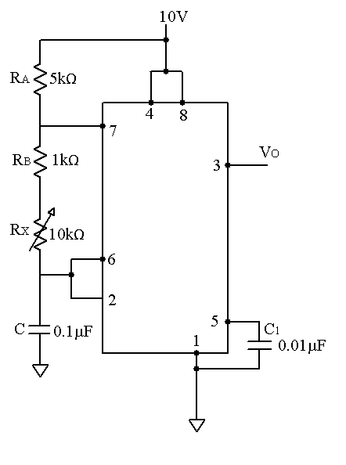

12. The following specifications are given for the dual input balanced output differential
amplifier of figure. R_{c} = 2.2kΩ, R_{E} = 4.7kΩ, R_{in1} = R_{in2} = 50Ω, +V_{cc} = 10V,
-V_{EE} = -10V, β_{dc} = β_{ac} = 100 and V_{BE} = 0.715V.
Determine a) I_{cQ} and V_{ceQ}
b) Voltage gain
c) V₀ for (V_{in1} = 50mV, V_{in2} = 20mV peak to peak at 1 KHz respectively).

13. For the inverting amplifier of figure shown. R₁ = 470Ω, R_{F} = 4.7KΩ, A = 2x10⁵,
R_{i} = 2MΩ, R₀ = 75Ω and f₀ = 5Hz. Calculate A_{F}, R_{iF}, R_{oF}, f_{F}.
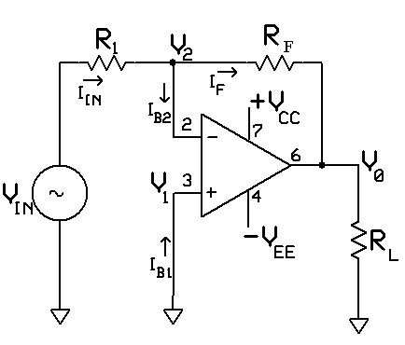

14. For a First order high pass filter determine the value of C and pass band gain.
Givn F_{L} = 1kHz, R = 15.9KΩ, R_{F} = R₁ = 10kΩ and draw the circuit diagram and
frequency response.

PART – C

ANSWER ANY FIVE OF THE FOLLOWING 5x2=10 Marks
15. Why power amplifier is also called as large signal amplifier.
16. Why we need single tuned or double tuned voltage amplifier.
17. Which multivibrator is also called as flip-flop? Give its application.
18. What is its output voltage and current range of LM 317 voltage regulator?
19. What is the problem associated with ideal differentiator circuit? How we can
overcome the same.
20. What is a level shifting circuit? Explain.
21. What is the difference between ideal and practical filters?

