Registered number:
DATE: 13 -04-2018 (1 PM)
Registered number:
DATE: 13 -04-2018 (1 PM)

ST. JOSEPH’S COLLEGE (AUTONOMOUS), BENGALURU-27
B.Sc. BIOTECHNOLOGY– II SEMESTER
SEMESTER EXAMINATION: APRIL 2018
BT 215 : Kinetics, Metabolism and Applied Microbiology

Time- 2 ½ hrs Max Marks-70
This paper contains TWO printed pages and THREE parts

- Explain/Define any TEN of the following 2x10=20
- Define mycotoxins with an example.
- What are adherence factors?
- Name two bacterial strains which colonise human tooth.
- What are enteric bacteria?
- What is glycogenin?
- State the role of aspirin.
- Name the defective enzyme and symptoms of Phenlyketonuria.
- Name the defective enzyme and symptoms of Her’s disease.
- Mathematically show that Km = [S] when Vo = Vmax/2
- Define energy coupling and give an example of coupled reactions.
- If you are measuring the effect of temperature on the rate of an enzyme-catalyzed reaction and you plot reaction rate against temperature, which of the graphs in the figure below would you expect your plot to resemble? Explain why temperature has this effect.

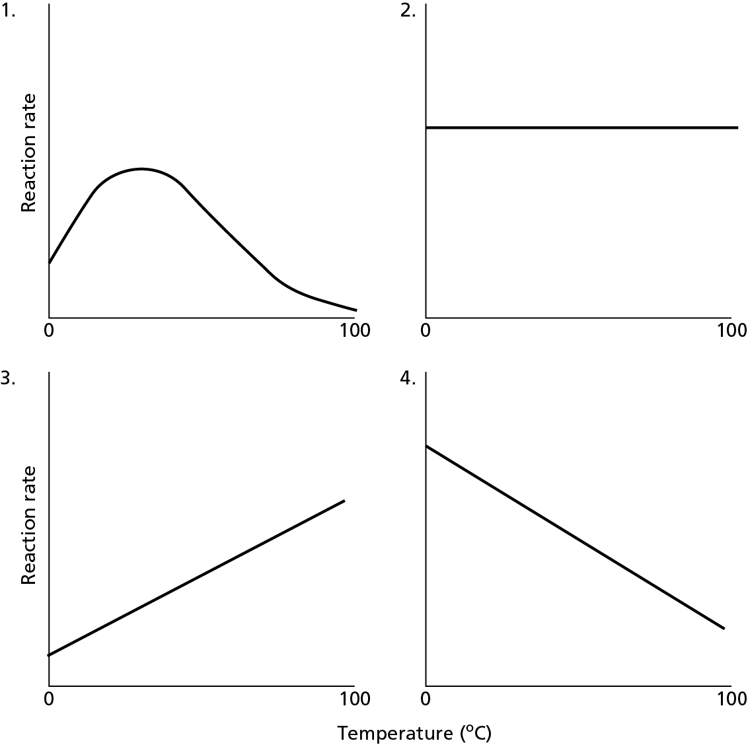
- What are the different types of signals cells receive? Give examples.

BT-215-A-17

- Write short notes on any FIVE of the following 6x5=30
- Explain Transdeamination.
- Explain the reactions of beta oxidation proper.
- Explain the role of Rhizobium sp in fixing nitrogen.
- Explain the pathogenicity of streptococci.
- Discuss any three important molecular biology studies that support epidemiological data, suggesting the spread of HIV strains.
- What are the different types of enzyme inhibition? Draw typical Line weaver Burk plots for these types of enzyme inhibition.
- Describe the three major classes of membrane receptors.
- Answer the following 10x2=20
- Explain in detail the process of glycolysis.
Or
[S], µM | Vo, µM/min
2 | 2.9
3 | 3.8
4 | 4.4
5 | 5.0
6 | 5.4
7 | 5.8
8 | 6.2
9 | 6.4
10 | 6.7
- You measure the kinetics of an enzyme E as a function of substrate concentration as shown in the table. The enzyme concentration is maintained constant at a level of 1 µM (=10⁻⁶ M). Draw a Lineweaver-Burk plot and determine Vmax, Km from the graph.

- Explain the role of bacteria in biomining.
Or
- Discuss the chemical properties and preservation techniques of food.

