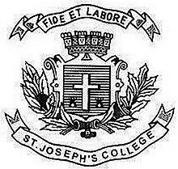
Register No:
Date: 12-4-19

ST. JOSEPH’S COLLEGE (AUTONOMOUS), BANGALORE-27
BVOC FILMMAKING/ ANIMATION - II SEMESTER
SEMESTER EXAMINATION: APRIL 2019
VO 2218 Communication Skills II

Time: 2 ½ Hrs Maximum Marks:70

This question paper has ONE printed page and THREE parts

- Answer any FOUR in not more than 100 words each. (4x5 = 20)
- Bio-diversity
- Earth Day
- Dr.Harshavardan
- Western Ghats
- Ettinahole Project
- Estuaries
- Answer any TWO questions in about 200 words each. (2x 10= 20)
- Write an environmental report for a leading newspaper in India on the issue of Road widening in the city of Bengaluru.
- Briefly expalin the principles of Rio Summit 1992.
- Explore the ecological profile of India.

- Answer any TWO of the following questions in about 400 words: (2 x 15 = 30)
- What are the salient features of Environment Protection Act?
- Design and plan for an environment related media campaign on any relevant issue in India. Explain your strategies.
- Enumerate on what is the role of media in environment protection?

***********

VO_2218_A_19

