Register Number:
DATE:

ST JOSEPH’S COLLEGE (AUTONOMOUS), BENGALURU - 560027
BVOC FILMMAKING/ ANIMATION – II SEMESTER
SEMESTER EXAMINATION – APRIL 2019
VO 2218 – COMMUNICATION SKILLS II

Time: 2 ½ hours Maximum Marks: 70

This paper consists of TWO printed pages and TWO parts

- Answer any SIX of the following in about 150 words each. (6 x 5 = 30)
- What is Ecology? Explain
- Write a short note on the United Nations’ outlook with the environment.
- Elucidate on the major types of pollution that we face in Bengaluru city on a daily basis.
- Read the following article and define the term that closely associates with it. Highlight the major problems that we are facing due to this.
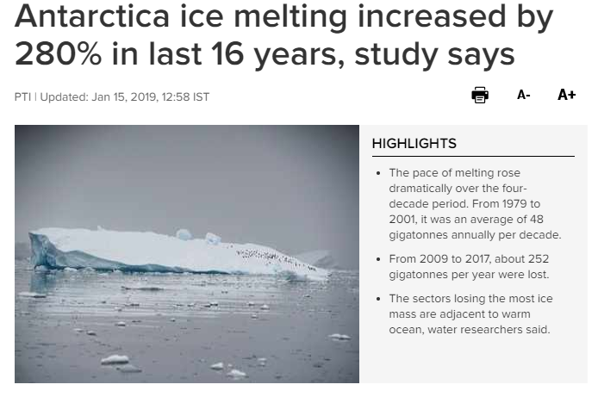
- Articulate any three recent climatic disasters as a result of ‘man-made needs or developments’ that have proved to be hazardous and dangerous to the ecosystem and have caused a huge loss to human settlements.
- Write a short note on the Environment Protection Act
- Delhi’s air quality was negatively termed as ‘severe’ for a very long time, now. What are your observations of the current events associated with Delhi? What are the reasons for the quality of air to turn out as ‘severe’?

- Answer any FOUR of the following. Follow instructions as required. (4 x 10 = 40)
- Create a neat visually appealing illustration either a memeor an infographic with the following theme - Global Warming. The illustration should be accompanied with a description of 100 words.
- Deforestation has been one of the main causes for lack of clean and fresh air. Script a 30 second TV advertisement or radio advertisement in English making public aware of the same. (Word limit is based on the ad)
- What are ecological sensitive zones? Name the ones pertaining to our country. (200 words)
- Highlight FIVE strong reasons as to how art has evolved as an instrument for change. How is art striving to do the same for the environment? Explain with valid examples.(200 words)
- Societal involvement is necessary for change. We’ve witnessed Marathons, Ad campaigns, word of mouth awareness, celebrity endorsements and more, on saving the environment. Create a creative strategy for a campaign of your own elucidating the importance of saving water. The plan should consist of the following details. (No word limit)

Title: (E.g. a name for a Marathon; a campaign)

Objective: (State a clear objective that seems to be suitable for your campaign in one sentence)

No of Days/ hours: (up to one week or one month)

Media platforms used: (E.g.: TV/ Radio/ Social Media/ Print)

Budget: (suitable funds/ sponsors) approximate amount to run the campaign

Venue: (if required)

Content: (E.g.: taglines, posts, illustrations etc)

VO 2218_B

