Register Number:
DATE:

ST. JOSEPH’S COLLEGE (AUTONOMOUS), BENGALURU-27
M.Sc. BIG DATA ANALYTICS – II SEMESTER
SEMESTER EXAMINATION: APRIL 2017
BDA 2116: Foundation of Data Science

Time 2.5 Hours Maximum Marks 70
This Question Paper Contains TWO Printed Paper And ONE Part

Answer Any Seven questions 7 x10 = 70

- Using Dijkstra's Algorithm find the shortest path.

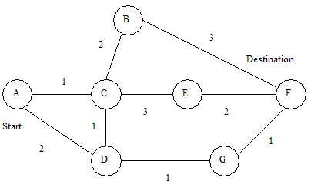
- Using Kruskal's Algorithm find the Minimum Spanning Tree from A to G .

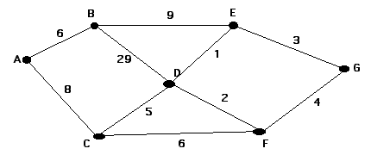

- a) Explain properties of High dimensional space.

b) What isChebyshev’s inequality? Prove Chebyshev’s inequality. (5+5)

- a) State and prove law of large number.

b) What do you mean by giant Component? (7+3)

- a) Explain similarity function S(Q,D).

b) Explain Erdo and Renyi’sG(n,p) model on random graph. (5+5)

- Write and explain the algorithm for finding SVD using Power method. (10)
- What do you mean by reflection principle? Explain with suitable example.

(10)
- Write short notes of the following
- Random walk
- Long lead
- Change of sign (4+4+2)

- Explain the frequency moment of data stream. (10)

