Register Number:
DATE: 17-04-2017
ST. JOSEPH’S COLLEGE (AUTONOMOUS), BENGALURU-27
M.Sc CHEMISTRY – II SEMESTER
SEMESTER EXAMINATION, APRIL 2017
CH-8315- Physical Chemistry
Time: 2 ½ hours Max.Marks: 70
This question paper contains two pages and three parts A, B and C

PART-A
Answer any SIX of the following : 6 x 2 =12 marks
- Obtain the expression for variation of fugacity with pressure at constant temperature.
- Derive Raoult’s law from the concept of chemical potential.
- State the postulates of statistical thermodynamics.
- For the simultaneous coupled flows of two solutes, give the linear phenomenological relation.
- Give the expression for the total number of collisions between two molecules A and B and explain terms in it.
- Define the chain length of a reaction.
- Explain with an example the influence of solvation of reactants on the activity coefficient of the activated complex.
- For the hydrolysis of an organic acid the rate constant was found to be 1.2 x 10⁻³ mol⁻¹dm³s⁻¹ at 100°C. Calculate the equilibrium constant for the formation the activated complex.

PART-B
Answer any FOUR of the following : 4 x 12 = 48 marks
- (a) Derive Gibbs Duhem Margules equation starting from the concept of chemical potential. Prove that in a binary solution if the solvent obeys Raoult’s law then dissolved gas obeys Henry’s law.
(b) Obtain expressions for ΔG_{mix} and ΔS_{mix} for a non ideal binary liquid mixture. (6+6)
- (a) Define “partial molal volume”. Explain the principle, procedure and calculations involved in the determination of partial molal volume of NaCl in aqueous solution.
(b) What is the need for the concept of ensembles? Represent different types of ensembles by a suitable diagram. (6+6)
- (a) Derive Maxwell Boltzman statistics for a system of non degenerate energy levels.
(b) Calculate the translational contribution to the standard free energy of oxygen. (8+4)
- (a) How do you study the kinetics of fast reactions by flow techniques?
(b) Discuss the kinetics of chain polymerization. (5+7)
- (a) Mention the limitations of (i) Lindemann's theory and (ii) Hinshelwood's theory of unimolecular reactions.
(b) Ethane decomposes into ethylene and hydrogen according to the following mechanism:
$$C_{2}H_{6} \underset{→}{k_{1}} {2 CH}_{3}^{*}$$
$${CH}_{3}^{*} + C_{2}H_{6} \underset{→}{k_{2}} {CH}_{4} + C_{2}H_{5}^{*}$$
$${ C}_{2}H_{5}^{*} \underset{→}{k_{3}} C_{2}H_{4} +H^{*}$$
$$C_{2}H_{6} + H^{*} \underset{→}{k_{4}} H_{2} + C_{2}H_{5}^{*}$$
$$C_{2}H_{5}^{*} +H^{*} \underset{→}{k_{5}} C_{2}H_{6}$$
Find the expression for the concentration of the hydrogen radical.

CH-8315-A-17

-2-

(c) The following figure indicates the addition of HBr to 1,3-Butadiene at 45°C. Identify kinetic and thermodynamic transition states and write the structures of products P-1 and P-2.
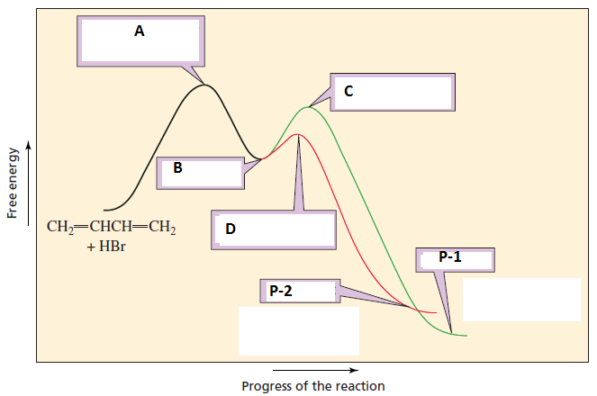 (6+3+3)

- (a) Discuss the entropy production in chemical reactions.
(b) Explain briefly RRK theory of unimolecular reactions. (8+4)

PART-C

Answer any TWO of the following questions. 2x5 = 10 marks

- The densities of water and ethanol are 997 and 789 kgm⁻³ respectively. The partial molar volumes water and ethanol are 17.8 and 55.2 dm³mole⁻¹at the mole fraction of ethanol = 0.2. Calculate the volume of the pure components required to prepare 100g of the solution of the same composition.
- In a rotational spectrum of HBr the maximum intensity was observed for J = 4 to J = 5 transition at spacings of 16.92 cm⁻¹. Calculate the temperature of the experiment.
- Predict the effect of increasing (a) dielectric constant and (b) ionic strength on the rates of the following reactions:
(i) CH₃Br + H₂O → CH₃OH + H⁺ + Br⁻
(ii) BrCH₂COO⁻ + S₂O₃²⁻ → ⁻S₂O₃CH₃COO⁻ + Br⁻
(iii) [Co(NH₃)₅Cl]²⁺ + OH⁻ → [Co(NH₃)₅OH]²⁺ + Cl⁻
(iv) (C₂H₅)₃N + C₂H₅I → (C₂H₅)₄N⁺ I⁻
(v) CH₃COOC₂H₅ + OH⁻ → CH₃COO⁻ C₂H₅OH

xxxxxxxxxxx

