Register Number:
DATE: 10-04-2017
ST. JOSEPH’S COLLEGE (AUTONOMOUS), BENGALURU-27
B.Sc. CHEMISTRY- VI SEMESTER
SEMESTER EXAMINATION – APRIL 2017
CH 6112 – Inorganic Chemistry
Time: 3 hours Maximum Marks: 100
This question paper has three printed pages and three parts
Element | Sc | Ti | V | Cr | Mn | Fe | Co | Ni | Cu | Zn
At.number | 21 | 22 | 23 | 24 | 25 | 26 | 27 | 28 | 29 | 30

PART A
Answer any TEN of the following: 2 × 10 = 20 marks
- Which of the following ions will give a coloured aqueous solution and why?: Ti³⁺, Cu⁺.
- The magnetic moment values of transition metal compounds are calculated using
spin-only formula. Why?
- Many transition metals and their compounds show catalytic properties. Give reason.
- What are ambidentate ligands? Give an example.
- Draw the structure of the octahedral complex, [Cu(en)₃]²⁺.
- Give (i) the oxidation state of the central metal ion and (ii) the coordination number of the complex, [Ni(EDTA)]⁻.
- Calculate the EAN of Cr in K₃ [Cr(C₂O₄)₃].
- What is hapticity? Give an example for a trihapto ligand.
- Write the formula of Wilkinson’s catalyst. What is its use?
- Mention any two roles of Mg²⁺ in biological systems.
- Draw the partial structure of haem.
- Why do actinides show variable oxidation states?

PART B
Answer any TEN of the following: 6 ×10 = 60 marks
- Give the important postulates of Werner’s thory of coodination compounds. How does Werner’s theory account for the non- ionic nature of CoCl₃.3NH₃?
- a) Write the IUPAC names of the following complexes:

i) [PtCl(NH₃)₄(NO₂)]SO₄
ii) [Co(en)₃]₂(SO₄)₃

CH-6112-A-17

iii) NH₄[Cr(NCS)₄(NH₃)₂]
b) Write the formulae of the following complexes:
i) Calcium hexacyanidoferrate(II)
ii) μ-amido-μ-nitrito-κNoctaamminedicobalt(III) nitrate
iii) Tetraammineaquabromidocobalt(III) nitrate
- Illustrate the following types of isomerism in coordination compounds with an example each: (a) ionization isomerism (b) geometrical isomerism.
- Ni(CO)₄ is diamagnetic. Predict is geometry using valence bond theory. Give any two limitations of valence bond theory.
- What are the basic postulates of crystal field thoery? With proper explanation for the metal- ligand interactions draw the d- orbital splitting pattern in an octahedral ligand field.
- Draw the electron distributions in t_{2g} and e_{g} orbitals of (i) high spin and (ii) low spin octahedral Co(II) complexes. Calculate (i) crystal field stabilization energy and (ii) magnetic moments in each case.
- Give the structures of the following organometallic compounds and compute their valence electron counts: (i) Co₂(CO)₈ (ii) K[PtCl₃(C₂H₄)].
- Discuss the bonding in transition metal carbonyls. Explain the synergic effect in metal carbonyl bonding.
- a) Give the classification of organometallic compounds according to the metal- carbon bond type. Give an example for each type.
b) What is lanthanide contraction? Zr and Hf have almost identical chemical properties. Give an explanation based on lanthanide contraction. (3+3)
- Give the chemical composiion of monazite sand. Discuss the extraction of lighter and heavier lanthanide sulphates from monazite sand.
- Discuss the following properties of lanthanides: (i) magnetic properties (ii) colour (iii) complex formation.
- What is cooperativity effect in haemoglobin? Discuss its mechanism.
- A Latimer diagram of O₂ is given below:
Write the ionic equations for all the three reduction half reactions in the diagram. From the diagram with proper explanation predict whether H₂O₂ undergoes disproportionation.

PART C
Answer any FOUR of the following: 5 × 4 = 20 marks
- There are five complex ions that can be prepared from a trivalent metal ion M³⁺ using both ‘en’ and Br⁻ ligands. Draw their structures.
- a) Amongst the two, [Co(NO₂)₆]⁴⁻ ion and [Co(NO₂)₆]³⁻ ion, which would absorb light of longer wavelength in the visible region and why?
b) A complex of Fe²⁺ is diamagnetic. With proper reasoning predict whether it is octahedral or tetrahedral. (2½ + 2½)

- a) [Ir(H₂O)₆]²⁺ and [IrF₆]³⁻ possess approximately the same 10Dq values . Give an explanation.
b) Why does NH₃ form complexes whereas the isoelectronic species CH₄ does not? (3+2)
- The following is the Latimer diagram of Mn in basic solution. Construct a Frost diagram of Mn in basic solution.
- Answer the following questions based on the Pourbaix diagram of iron given below:
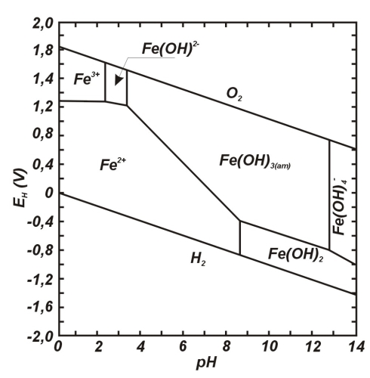
- Identify the iron species that exists at highly reducing conditions at low pH.
- Identify the iron species that are involved in (i) pure acid-base equilibrium and (ii) pure redox equilibrium. Give the chemical equations corresponding to both these equilibria. (1+4)

