ST. JOSEPH’S COLLEGE (AUTONOMOUS), BANGALORE – 27
ADVANCED JOURNALISM – VI SEMESTER EJP
SEMESTER EXAMINATION: APRIL 2017
JN6113: Advanced Journalism

Time- 2^{1/2} hrs Max Marks- 70

Instructions:

- This paper has TWO SECTIONS and FOUR printed pages.
- This paper is for the VI Semester Journalism students who have opted for the Arts & Culture Elective.
- You are allowed to use a dictionary.
- You will lose marks for exceeding the suggested word-limits.
- This paper contains SIX pages and THREE sections

- Read the following article

Media Landscape and the Making of an Unconventional Journalist: Monobina Gupta

Five days a week at 9 PM, Ravish Kumar begins his news programme, Prime Time, on NDTV India with “namashkaar, main Ravish Kumar…” At the same time when English news channel anchors scramble over each other for ratings, putting on display wild (often unsubstantial) discussions on the day’s events, Prime Time – in style and news content – strikes a very different note.
Ravish starts his programme with a 5-minute introduction, which is its unique selling point and also one of the highlights of the show. Packaging the topic of debate with a well-researched perspective, Ravish speaks in lucid, eloquent Hindi, interspersed with subtle and witty asides. Meticulously, he references the news reports, analyses, blog posts and opinion pieces he has swotted over during the day. In his mindful reference to every author whose work he has accessed through both mainstream and social media, Ravish has created a new media morality. The cutthroat universe of corporate media is more dedicated to grabbing information first rather than acknowledging sources or granting space to insights generated by others.
“Firstpost.com is our rival but whenever I take any news or analysis from the website, I acknowledge it. You could say this is NDTV India’s inherent culture. English channels don’t have that system. But they can have it if they want to. I do that consciously. I want viewers (a lot of them are students) to follow up these references,” Ravish told me.
His viewers – at least a good many of them – keep in touch with him: “I have built up these contacts over the last ten years of reporting. I used to leave my contact numbers where ever I went”. He talks about how he began his journalistic stint sorting out mail at NDTV. He was passionate about reporting and finally started on the journey that brought him to his present position. His programme Ravish Ki Report became one of the most talked about and popular ones to move away from conventional reporting. The ordinary lives of ordinary people – sex workers at G B Road, Kapashera garment factory workers – found prominent place on that show. Lutyens’ journalism focussed on the lives of powerful people, politicians, MPs, ministers, never interested Ravish. The lives of others did. And he made this his brand.
“When I take the Metro people just come up to me and chat. They do not always compliment me. Sometimes I am also at the receiving end of gaalis. I listen to their complaints,” he tells me.
Listening is important, especially for TV anchors who are so often accused of loving their own voices. “Sometimes in the midst of my programme a judge would SMS me: ‘you are wrong. You don’t understand the legality of this issue.’ Imagine my consternation being taken to task in the middle of my programme!”
Among the many ironies of Prime Time, the one that strikes you most is that its success runs against the grain of popular media wisdom. Sustained propaganda would have us believe that viewers and readers of Hindi language media prefer lowbrow entertainment peddled as news; that Hindi speaking consumers of news do not want information so much as entertainment. Market pundits have painstakingly drilled this falsehood into the minds of proprietors, editors and viewers at large.
...
Images of admiring fans mobbing popular TV celebrities in public places – even those not enamoured of the media – are hardly unusual. Ravish, no doubt, occupies a seat at the high table of TV luminaries. But his novelty lies in the unmaking of the conventional brand image of a media icon and the making of an unconventional one. Ravish happens to be a star with cerebral appeal; an anchor with an ear to the ground. His personality is critical to the crafting of Prime Time and building it as a unique brand.
Looking at how the 2014 general elections played out on Prime Time is instructive in this regard. TV reportage of the event, especially of the showdown between Arvind Kejriwal and Narendra Modi in Banaras was generic and followed a set template: all the celebrity anchors of the televisual world descended on Banaras’ fabled ghats where they conducted discussions which moved from land to the waters of the Ganga. Collecting the city’s notables and the hoi poloi, anchors weighed the pros and cons of the Modi vs. Kejriwal fight; they picked dry the binary between religiosity and development. The themes discussed nearly always intoned each other, and those being interviewed hopped from channel to channel, moving from boat to boat, finding little to say that was new or interesting. These endless, protracted arguments served to veil the true depthlessness of the spectacle on display. A lot of time was spent in disseminating very little information. This is the vacuum Ravish Kumar filled.
Rather than join his colleagues on the ghats, he reached areas which usually escape the glare of TV cameras. The inhabitants of Katari village on the outskirts of Banaras haven’t visited the ghats for years. Their gruelling existential routine leaves them with no time to visit the place that, for most, is synonymous with the city itself. Chhedi Lal, a dalit villager, told Ravish about the persistence of caste in his locality. “Discrimination, though less, still continues. There are still some people in the village who keep separate vessels for Dalits. Upper castes still don’t eat with us.” Have politicians visited the village? “No, nobody comes here. Not Modi, not anybody else.”
During his election coverage, Ravish foregrounded the bewildering paradoxes of Indian politics and society. His show was a guidebook for how to report from the ground, evading opinion-makers and delving into the fabric of everyday life. It is this approach that sets Prime Time apart on a regular basis. What is novel about the programme is its motivation to probe deeper than the top layer.
This motivation was on display more recently when, on the occasion of Prime Minister Narendra Modi’s glitzy interaction with students on Teacher’s Day, Ravish did something different from most. As most prime time news programmes filled viewers’ homes with debate, discussion and distraction, Ravish spent an hour chronicling the ritual and reception of the speech in a government school in Delhi. His hour long interaction with teachers and students showed how the speech had been received very differently in places where English news channels didn’t bother to venture. Instead of enthralled masses, Prime Time beamed visuals of bored kids and disciplinarian teachers.
If a narrative in this vein seems too celebratory, we would do well to remember that Ravish is the product of particular histories – specifically his own as well as that of Hindi language journalism in India. Both these histories have to be acknowledged in understanding the niche Prime Time has carved out for itself.
...
Ravish’s personal journey is complemented by the larger arc of Hindi journalism, an indispensable frame for decoding the success of programmes like Prime Time. During the 1960s, Hindi journalism came into its own as mature, reflective as well as ‘newsy.’ Behind its efflorescence was the invaluable contribution of five Hindi publications brought out by the Times of India group. These were Dinmaan, Dharmayug, Madhuri, Paraag and Vama. “Dinmaan, a highbrow weekly, was like The Caravan magazine of today. The magazine did very well. University and college students vied with each other to have their pieces published in that weekly. Just one published article could catapult you in the eye of fame,” says veteran Hindi language journalist Urmilesh. He narrates a personal anecdote: “I was doing my Bachelor’s in Allahabad University in 1976 when Dinmaan published my article on Vivekananda. Suddenly the whole University got to know me. Before that I was only known as a member of the Student’s Federation of India (SFI). One article in Dinmaan and lo and behold, I was suddenly the cynosure of all eyes in the University.”
In a Times of India profile, educationist and former head of the National Council of Education Research and Training (NCERT) Krishna Kumar spoke about how Dinmaan impacted his life and turned him into a ‘citizen-journalist.’ He had just been appointed lecturer in the English Department in Delhi’s Kirori Mal College. The year was 1971. Raghuvir Sahay, poet and editor of Dinmaan, was known for his democratic and open door editorial policy. Krishna Kumar recalled how every week Sahay would ask readers a question. To one such question (say “what is your school prayer?”) the magazine received four hundred responses. Sahay asked Kumar to put the responses together and write an accompanying piece. Soon Kumar’s articles became a regular feature.
Dharmayug, yet another landmark Hindi magazine, was originally published by Dalmia press just after independence in 1947. A year later, the Dalmia Group divested its stake to Bennett Coleman & Co. Ltd. Dharmayug stayed with the Times of India group and became associated with legendary figures of Hindi culture. Under the editorship of the eminent Hindi poet and author Dharmvir Bharti, the magazine reached the zenith of its popularity in 1960. “Dharamyug was a family magazine – diverse features, articles on entertainment, films, lifestyle (not in the sense lifestyle is understood today),” says Urmilesh. A poet, author and playwright of immense acclaim, Bharti radicalised the product with his thinking and ideas.
In a society where the English language continues to be an important purveyor to status and influence, vernacular language journalists deal with hierarchies erected by the English speaking elites. This dynamic is as evident in the newsroom as elsewhere in Indian society today.
In an article in The Indian Express in 2007, political scientist Yogendra Yadav wrote “Not so long ago, it was not enough to know English; it was equally important not to know any other Indian language. Failing in Hindi was a mark of honour. Being at ease with a desi language defined you out of the monolingual English-speaking power elite. This power equation has altered a bit in the last decade or so. Your station in life is still determined by how well you speak English, but knowing Hindi is no more a disqualification.”
In the field of television, Yadav rightly claimed that it was Surendra Pratap Singh (better known as SP) who bridged the chasm between Hindi and English media. SP launched Aaj Tak initially as a half an hour news bulletin on Doordarshan, and then turned it into a household name as an independent TV channel. SP’s line at the end of every broadcast, “Yeh thi khabrein Aaj Tak. Intezaar kijiye kal tak,” became his signature catchphrase. According to Yadav: “Aaj Tak was for Hindi television news what Surf was for detergents or Xerox for photocopiers.”
It was a turning point in professional Hindi journalism. When entire North India worked itself up into a tizzy over Lord Ganesha’s milk drinking miracle – contrary to the belief that Hindi channels reinforces such irrationality – SP got a scientist to provide a rational explanation in his evening bulletin. Hindi journalism seemed to have come of age. But was that just a temporary and meteoric explosion of thoughtful analysis in a field that was soon to descend into sensationalist infotainment? Today, is it even possible to make distinctions between the sensationalism of journalism in different languages? English, Hindi or Bengali, a generic formula has come to dominate news. The desire to chase after seismic-scale events (or manufacture them) has diverted attention away from the everyday: that region which Ravish repeatedly excavates.
This is where Ravish’s journalism becomes significant – as a continuation of the tradition of Hindi language print media and SP Singh’s innovative television reportage. The blending of thought, analysis and an interest in the mundane is what sets Prime Time apart. The point is less to valorise Ravish or hold him up as a singular, flawless example than it is to throw light on other possibilities that continue to remain unexplored in the landscape of contemporary media.

I .A Answer any three of the following questions in about 150 words each (3x10=30)
1. Why does the writer believe that the success of Prime Time, ‘runs against the grain of popular media wisdom.’? Do you agree with the reasons the writer cites to substantiate her claim?
2. ‘In a society where the English language continues to be an important purveyor to status and influence, vernacular language journalists deal with hierarchies erected by the English speaking elites. This dynamic is as evident in the newsroom as elsewhere in Indian society today.’ Does the hegemonizing influence of dominant news media effect how audiences are imagined? Does this dominant idea of audience influence the nature of programs?
3. The article suggest that the nature of the programming of Prime Time follows in the trajectory of Hindi print media journalism, what is your understanding of the values and news values of the Hindi language press that the writer explores in this article? Does she draw substantial argument to place the journalism of Prime Time in this milieu?
4. From your reading or consumption of news in languages other than English, do you think that editorial choices and news values differ in regional language and English language news media? Substantiate with examples.
II. Answer any one of the following questions in about 250 words (1x20=20)
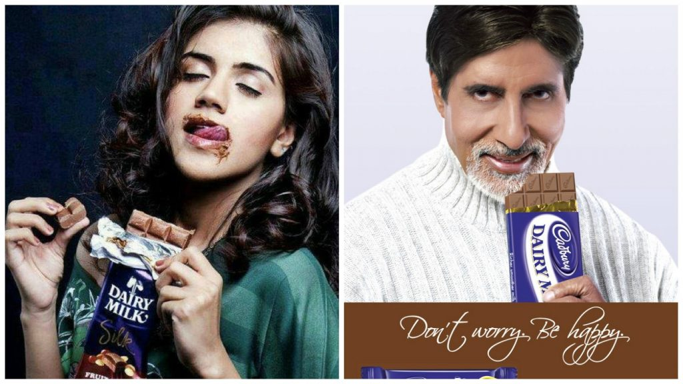

- What do these two different ads for the same product suggest about how men and women are represented in popular culture?

- Laura Mulvey, in her essay, ‘Visual Pleasure and Narrative Cinema’ suggests that the male gaze occurs when the audience is put into the perspective of a heterosexual man, and the woman is viewed through his gaze. Is this true of how women are represented (photographs, video) in news media? In particular when the news story involves women or what is perceived as ‘women’s issues?
III. Answer any ONE of the following in about 250 words (1x20=20)

- “Adorno believed that the greatest danger to democracy lay in the mass-culture apparatus of film, radio, and television. In his view, this apparatus operates in dictatorial fashion even when no dictatorship is in place: it enforces conformity, quiets dissent, mutes thought. Do you believe mass media is an ‘enforcer of conformity that quiets dissent and mutes thought’? Use examples to substantiate your answer.

- Comment on your understanding of journalists as ‘Intellectuals’.

*****

