Register Number:
DATE: 22-04-2017

ST. JOSEPH’S COLLEGE (AUTONOMOUS), BANGALORE
IV SEMESTER B.A/B.Sc Final Examinations: April 2017
General English Special Paper for NSA/EJP streams (GE 412)
Bangalore—Recording/Consuming the City

Time: 3 hours Max. Marks: 70

INSTRUCTIONS
- This question paper is for students of the NSA Special Courseon Bangalore as also for IV Sem EJP students
- This paper contains five pages and three sections
- Answer the sections according to the instructions given
- You will lose marks for exceeding the suggested word-limits
- You are allowed to use a dictionary.
- Please write the phrase BA-Bangalore or NSA-Bangalore clearly on your answer booklet.

- Examine the picture below of Shivaji Nagar from the 1950s carefully:

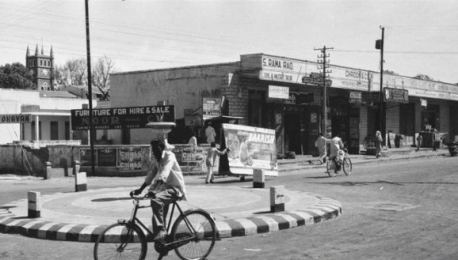

Now examine this picture below of Russel Market in Shivaji Nagar from the 1970s carefully:

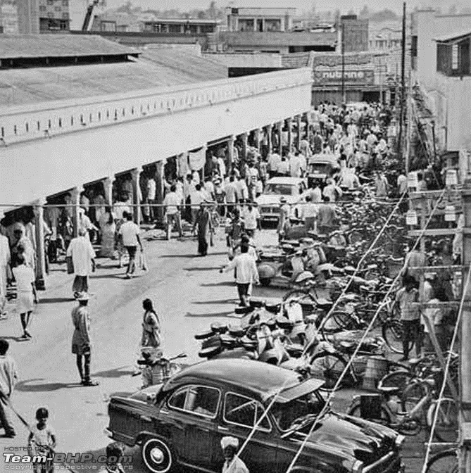

I.A. Answer ANY THREE of the following questions in about 150 words each:
(3x10=30)

- Which of the visual details in the first picture do you find most striking? Why? Similarly, which of the visual details in the second picture do you find most striking? Why?

- How would a contemporary picture of Shivaji Nagar/Russel Market be different from the above two pictures?

- If you were asked to click a current picture of Bangalore, what would it be and why?
- Have you ever visited a market place in Bangalore? What was your experience like? Compare it with a market place that you visited in another city.

- Read Anita Nair’s blog writing on Bengaluru city titled What Would Dickens Write Today?(Anita Nair is a Bangalore based author):

We do not choose the world we write about. Most often than not, we write about what is the temple of our familiar. We locate our stories in the world that we believe we have a rare understanding of. A world that we internalize to an extent that it seeps into our every breath and thought. For only then can we recreate on paper that world with almost the life force it pulses with.At first the urban landscape failed to stir me. Even the books I read were based in quiet villages and small towns. To me, they offered a harmony between man and land strewn with a wealth of sub-plots. And so, this became the landscape that I wished to set my novels in. In the books I wrote I sought to narrate the stories of people who would inhabit such a world.
And then a little over eighteen months ago, I decided to write my first true urban novel. It would be a novel dictated by the city as much as the characters. I had a choice of two cities. Chennai where I had grown up, Bengaluru where I lived. The danger of locating it in Chennai was to be swamped by nostalgia. And I wanted this to be an edgy piece of writing with no room for sentiment or memory.
In Bengaluru that has been my home for the last two decades, I sought a world that was far away from what is commonly perceived to be Bengaluru ─ The glittering cityscape of the IT companies, the orderly lives of the middle class, the joggers, the parks, the hi-rises and the international brands─. For I was certain that somewhere within Bangalore was another city that would be mine, as London had been for Dickens. In fact, as the narrator of Dickens’ Master Humphrey’s Clock suggests, I too would have to ‘draw but a little circle above the clustering housetops, …have within its space everything, with its opposite extreme and contradiction close by.’
One evening as I drove through Shivaji Nagar, I had a moment of epiphany. For twenty years, I have driven through its narrow roads strewn with shops that dealt in everything from nuts and bolts to automobile spare parts to old newspapers to meat, vegetables, fruit and flowers to clothes and shoes… My eyes had paused at the doorways here and there on the streets. No one would realize what lay behind the doors. That the narrow corridor flared into a small square courtyard and around it was a warren of two room tenements. Clotheslines would be strung in the courtyard and on a corner, would be a couple of brick stoves, so each household could make its own hot water to take to the two bathrooms that was all there was for everyone who lived there. When it rained, the road turned into a stream of fast flowing dirty brown water in which garbage floated. To open the main door of the house was dangerous then. There was no knowing what would float in. An old tyre or a single chappal or a dead bandicoot.
I had trawled the streets of Sivaji Nagar with more the curious eye of a tourist rather than the calculated gaze of a writer. But that particular evening, I knew a sense of preordination. Was it the whiff of meat cooking or the sight of a raggedy group of children nibbling at cotton candy or was it the dying sun reflected in a window pane? I thought then of Dickens writing of his London. ‘The amount of crime, starvation and nakedness or misery of every sort in the metropolis surpasses all understanding.’
Over the next few months as I made countless forays into this Dickensian world within modern metropolitan Bangalore, I glimpsed it again and again: How late in the night the Shivaji Nagar bus stand area was still simmering with activity. Of a certain excitement that resonated through the alleys and lanes. Even the vendors had their carts edged along the roads. The smell of meat cooking on charcoal mingled with the aroma of samosas being fried in giant vats of hissing oil. Chopped onions and coriander leaves, pakodas and jalebis, strings of marigold and jasmine buds, rotting garbage and cow dung. The high notes of attar. The animal scent of sweat and unwashed bodies.
Men of all sizes and shapes trawled the alleys. Some seeking a hot kebab to sink their teeth into; some seeking a laugh, a suleimani in a glass and a smoke. Men returning home from work. Policemen on the beat. Autorickshaw drivers and labourers. Whores. Eunuchs. Urchins. Beggars. Tourists. Regulars.
A composite cloud of a thousand fragrances and needs in that shadowed underbelly of the city.
So, when I chose to locate my novel in this world, I was only seeking to replicate what Dickens may have sought to write if he were alive and writing of Bangalore. An inner city that to most people didn’t even exist. ‘A black shrill city . . . a gritty city . . . a hopeless city, with no vent in the leaden canopy of its sky.’
The inner lives of characters needn’t always be located in their monologues. When every day is a struggle to survive, when to claim a shred of humanity from bestial surroundings demand more than you can give, what place then for angst or soul-searching? Sometimes the very world they inhabit has the unique ability to postulate their inner self.
Humanity, shorn of high art and culture, stripped of its veneer of education and polish, is redefined here ‘amidst this compound of sickening smells, these heaps of filth, these tumbling houses, with all their vile contents, animate and inanimate, slimly overflowing into the black road,’ Of what it is to be human – complex, vulnerable, resonating with goodness and evil – is most evident where human life has little or no value.
Dickens recognized this perhaps more than any other writer ever did.

II.A. Answer the following in about 200-250 words: (2x15=30)

- “Dickens recognized this perhaps more than any other writer ever did.” What does the writer intend by this statement? Give specific examples. Do you find yourself agreeing with the writer? Explain.

- Does this blog writing allow the younger reader to see the city differently? Support your answer with specific evidence. If you were to write a book set in Bangalore, which part of the city would you focus on and why?

- Now read this piece by S. Shyam Prasadon Bangalore’s Majestic Area.

While Namma Metro's biggest station came to life on Friday, it marked one more change to probably the most iconic area in Bengaluru. The Kempegowda Interchange could become a lifeline for city's commuters, but the place has always been more than that. As old as the city itself, the place has evolved according to the demands of time.
In 1889, when Queen Victoria's son, Prince Albert Victor, visited Bengaluru, the first thing he noticed when he alighted the royal train was the Dharmambudhi Lake. The city administration had organised a Bharatanatya performance right in the middle of the lake on a theppa (platform made on boats), to welcome him. The theppa was new to the lake. Every year, when the lake filled up, local citizens organised the theppotsava (boat festival).
For over 300 years prior to this royal British encounter, the lake was the lifeline of the city, since it was its primary source of drinking water. It was called the 'jeeva kere' (lifeline) for this reason. The city's founder, Kempegowda, is credited with building the lake as Bengaluru's primary source of water, and this continued for over 300 years till the late 19th century.
Less than 10 years after Albert's visit though, the lake was almost dead. Earlier, all the lakes in and around Bengaluru were connected to each other and this helped overflowing ones to drain into others. But by now, the connecting channels were all gone. The city began to get piped water from Hesarghatta lake, and the other lakes within the city had all lost their importance. By the beginning of the 20th century, Dharmambudhi had gone dry and it never filled up again.
During the 19th and early 20th centuries, the city was divided into British-controlled and the Mysore-controlled parts. The lake area came under the administration of the Mysore kings. In the first decade of the 20th century, the state wanted to convert the now dry lake into a park. But the municipal administration was confident of reviving the lake though this never happened.
When the freedom movement began to make its presence in Bengaluru, the dry lake began to become a political venue. Jawaharlal Nehru addressed a public meet on the lakebed in 1931. As more As more political rallies began to be organised in this place, Dharmambudhi began to be called Gandhi Sagara. This, probably, gave the surrounding area the name Gandhi Nagara, which is still in use.
After independence, the area to the south and west of the lake was named Subhash Nagara, and for decades the bus station was also called Subhash Nagara bus stand. After
independence, the dry lakebed began to be used as an exhibition ground (called Congress Exhibition for some strange reason) and temporary amusements like circuses.
When the theatre movement was at its peak, Master Hiranaiah's plays began to be staged here, and drew crowds that rivalled political rallies.
In the 1960's, a part of the lake became the bus terminal for the state road transport corporation. In the 1980's, the iconic semi-circular city bus terminal was built on the remaining portion of the lake. The oldest and closest film theatre here was Majestic. The bus terminal continues to be called Majestic by old-timers despite its official name being Kempegowda Bus Station. Gandhi Nagara and Majestic area become synonymous although the theatre does not even exist now.

III.A. Answer ANY TWO of the following in about 150 words: (2x10=20)

- In what way does this historical account of an important Bangalore landmark deliver insights into the way cities evolve? What have been the gains and losses of such an evolution?

- Would you consider Majestic as one of the important landmarks in Bangalore? What in your opinion has this account missed about the area’s development?

- “In the 1960s, a part of the lake became the bus terminal for the state road transport corporation. In the 1980s, the iconic semi-circular city bus terminal was built on the remaining portion of the lake.” Has this development been a boon to Bangalore? Do you think the development of Bangalore’s infrastructure should take priority over the preservation of its lakes? Explain.

