Register Number:
DATE : 22-04-2017
ST. JOSEPH’S COLLEGE (AUTONOMOUS), BENGALURU-27
SEMESTER EXAMINATION: APRIL 2017
B.A./B.Sc/B.Com – IV SEMESTER
GE 412: General English (Regular)

Time – 2 ½ hrs Max. Marks - 70
This paper contains 4 printed pages and 4 parts.

I. Read passages A and B and answer the questions that follow.
Passage A is an article from The News Minute and Passage B is an article from The Hindu.

Passage A

4,000 trees could be axed for housing project in Bengaluru, but how many trees are left in the city?
The city could soon turn into a concrete jungle.

One of the stories about the origins of Bengaluru’s name, has it that it derives from “benga”, a local term for pterocarpus marsupium, a species of dry and moist deciduous trees, and “ooru”, which translates to village. Ironically though, much of the modern city which boasts of its “Garden City” moniker, could soon turn into a concrete jungle.
Even as the strong protest against the proposed steel flyover in the city which could axe 812 trees is yet to die down, the Karnataka Housing Board plans to chop down 4,166 trees for a housing project in Rayasandra on Kanakpura Road. Two private developers have also sought permission to cut 730 and 806 trees for separate projects in Jakkasandra and KR Puram.
The indiscriminate felling of trees to make way for "development work" comes at a huge cost - of losing the city’s green cover and also its water bodies. Of the many functions that urban vegetation serves, a few crucial ones include moderating micro climate, absorbing CO₂, aiding percolation of water, acting as a barrier to noise pollution and even acting as “natural air-conditioners”.
The number of trees cut between 2011-14 was equivalent to wiping out Lalbagh completely, and then some more, Bangalore Mirror reported in 2014. Lalbagh has over 8,000 trees and 9,281 trees were felled for Namma Metro and road extension projects in the city. However, there's no official record of the exact number of trees in Bengaluru. Estimates range between 10 to 50 lakh, the latter claimed by the BBMP.
A 2014 study titled "Trees of Bengaluru", released by TV Ramachandra from Centre for Ecological Sciences, Indian Institute of Science, said that the city has seen an enormous growth in population in the last decade, i.e. 46.68%. While population increased from 6,537,124 (in 2001) to 9,588,910 (in 2011), population density for the same period jumped from 10,732 to 13,392. Land use analysis based on remote sensing data was used and the study found that Bengaluru had 14,78,412 trees during that period.
There has also been a 925% increase in concretisation in the past four decades. “For every seven persons there is one tree. Every day one person exhales between 540-900 grams of carbon dioxide and one hectare of trees takes in close to 8 ton of carbon dioxide. So, based on that calculation every person needs 8 trees. So you can imagine how pathetic the situation is,” Ramachandra had earlier told The News Minute.

The number of water bodies in the city have also seen a staggering decline. The city had 265 water bodies in 1962. By 2010, the figure dropped to 98. In the last four decades, vegetation has decline by 66% and water bodies by 74%.The amount of vegetation has declined from 68.27% (in 1973) to less than 25% (in 2012). Another 2015 study mentioned that greater Bengaluru is experiencing unprecedented urban growth of 4.6% in recent times.
“Temporal assessment of urban growth in Bengaluru show an intense urbanisation with 125% increase in built-up area during last four years (2010 to 2014) with decrease of vegetation cover by 62% and water bodies by 85%. These results show that the city is gradually transforming to concrete jungle with compact urban areas and retreat of vegetation and water bodies. Landscape metrics are helpful in assessing the spatial patterns of urbanization. It is observed that the city outskirts are experiencing urban sprawl,” the study concluded.
Experts have also blamed authorities for planning the city in a haphazard manner, and not giving heed to scientific advice. Stating that the unregulated growth will come at the expense of green cover along
with higher pollution by 2020, TV Ramachandra told Bangalore Mirror, "This is bound to make the city greenhouse gas-rich, water-scarce, non-resilient and unliveable, depriving the city dwellers of the basic constitutional rights - the right to clean air, water and environment.”

Passage B

Neighbourhoods divided over steel flyover
The divide over the proposed steel flyover is evident even along its alignment. Though most neighbourhoods along the route of the steel flyover on Ballari Road remain opposed to the project, the neighbourhoods located at the end point, at Esteem Mall junction, are strongly batting for it.
Even as the State government has been arguing that the steel flyover is required to segregate the airport traffic, which will give respite to areas along the alignment, several RWAs in Abshot Layout, Sanjay Nagar, R.T. Nagar, Jayamahal, Sadashivanagar, Vasanth Nagar, Malleswaram, Hebbal have been opposing the project and some of their representatives even participated in last weekend's human chain protest.
Nevertheless, residents in Sahakar Nagar, Kempapura, Vidyaranyapura, Shivaram Karanth Nagar, Amrutahalli – all areas beyond the Hebbal flyover – are strongly batting for the steel flyover. A. Sivarama Setty, Secretary, Sahakar Nagar Residents’ Welfare Association (RWA), argued that the steel flyover is necessary to ease traffic. “Nobody is talking of the environmental damage, fuel wastage and travel time as a result of the traffic congestion,” he argued. N. Devaraj, president of Kempapura RWA, said the flyover could solve the problems plaguing Kempapura junction. “People are losing their lives or getting injured in accidents. None of those protesting against the steel flyover are from north Bengaluru. Our opinions need to take precedence,” he argued.
But the neighbourhoods along the alignment make a different argument. Ramesh C Dutt, of Sanjay Nagar RWA, while conceding that the flyover will reduce travel time from the CBD, said its cost was too dear. “We will be served better if the government opts for a Namma Metro line along the corridor,” he argued. Metro connectivity is a theme writ large across several neighbourhoods along the alignment. T. Vidyadhar, convenor of Forward Hebbal, a federation of over 20 RWAs in the area, said that all RWAs had collectively decided to oppose the project. “We will be forced to pay toll to reach our homes or endure hour long delays on the road below,” he argued.
Sadashivanagar RWA passed a resolution on Friday opposing the steel flyover. Vivek Shah of the RWA said that their area is the biggest victim of short-sighted infrastructure intervention, like the magic box, and believes the steel flyover would be a blunder. Hanumanth Reddy of Jayamahal RWA and Raju Dugar of Vasanth Nagar RWA said residents are also concerned about the up and down ramps into their areas, which they said would only add to the congestion and mess in residential areas. “They are only shifting the congestion from Ballari Road to our areas,” said Mr. Reddy.

Santosh Lal of Abshot Layout RWA is worried about losing the biggest green space in their area — the golf course. Citizens For Bengaluru, who are protesting against the steel flyover, on Friday sought an appointment with Governor Rudabhai Vajubhai Vala to brief him about their concerns.
I. Answer any THREE of the following questions in about 500 words each. (3x10=30)
- Would you agree that the cutting of trees for the housing board project and the steel flyover is indiscriminate? Examine both government and private ventures that necessitate it, keeping in mind the numerous construction sites across the city, and explain with reasons justifying your viewpoint.
- What is your understanding of the word “development”, with respect to urban spaces? Who does this development benefit? Are there parties that are adversely affected by development?
- Are the housing board projects and the steel flyover unnecessary constructions, given the unprecedented growth of population in Bengaluru? Why/why not?
- Is the shift of Bengaluru from a green city to a concrete jungle primarily a media creation? Respond, based on your experience of residing in Bengaluru.

II. Analyze the following cartoon and answer the questions that follow. (2x5=10)
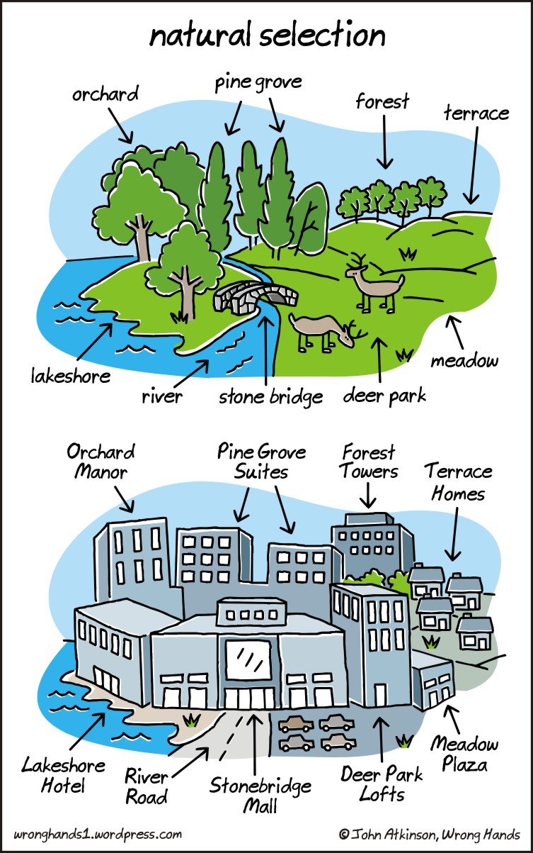

- What commentary does the cartoon offer on changing urban landscapes? Does it resonate with the situation in Bengaluru?
- Does the cartoon exaggerate, reflect or anticipate a certain reality? Are there any positive aspects to this reality?

III. Read the poem “A Brook In The City” by Robert Frost and answer the question that follows

The farmhouse lingers, though averse to square
With the new city street it has to wear
A number in. But what about the brook
That held the house as in an elbow-crook?
I ask as one who knew the brook, its strength
And impulse, having dipped a finger length
And made it leap my knuckle, having tossed
A flower to try its currents where they crossed.
The meadow grass could be cemented down
From growing under pavements of a town;
The apple trees be sent to hearth-stone flame.
Is water wood to serve a brook the same?
How else dispose of an immortal force
No longer needed? Staunch it at its source
With cinder loads dumped down? The brook was thrown
Deep in a sewer dungeon under stone
In fetid darkness still to live and run --
And all for nothing it had ever done
Except forget to go in fear perhaps.
No one would know except for ancient maps
That such a brook ran water. But I wonder
If from its being kept forever under,
The thoughts may not have risen that so keep
This new-built city from both work and sleep.

- The poem seems to suggest that the urbanized new world can be created only through the destruction of the ‘natural’ world, with no possibility of a sustainable, equitable solution. Do you agree with this viewpoint? Why/Why not? Use the poem to supplement your answer. (10)

IV. The poem, the cartoon and the articles reflect a bias against economic growth and urban development, a sense of nostalgia for a “natural” landscape and bitterness towards newer urban spaces. This is indicative of an unwillingness to embrace modernity and growth.

Respond to this statement in agreement or disagreement and use the texts to validate your response. (20)

