Register Number:
DATE: 22-04-2017
ST. JOSEPH’S COLLEGE (AUTONOMOUS), BENGALURU-27
End Semester Examination – April 2017
IV Semester BCA/BVC-General English (GE 412)
Media, Culture & Technology
Time: 2 ½ hours Max. Marks: 70
INSTRUCTIONS:
- This booklet contains TWO question papers for the sections MCT-A and MCT-B
- The MCT-A paper contains THREE pages and TWO sections
- The MCT-B paper contains THREE pages and TWO sections
- Answer questions according to the section you have been assigned to.
- Please mention the section (MCT- A or B)on the front page of your answer script.
- You will lose marks for exceeding the suggested word-limits.
- You are allowed to use a dictionary.

MCT ‘A’- ONLINE LIVES IN WEB 2.0

I. Read this article titled ‘How the Internet Changed the Way we Read’ by Jackson Bliss from The Daily Dot:
As a professor of literature, rhetoric, and writing at the University of California at Irvine, I've discovered that one of the biggest lies about American culture (propagated even by college students) is that Americans don’t read.
The truth is that most of us read continuously in a perpetual stream of incestuous words, but instead of reading novels, book reviews, or newspapers like we used to in the ancient régime, we now read text messages, social media, and bite-sized entries about our protean cultural history on Wikipedia.
In the great epistemic galaxy of words, we have become both reading junkies and also professional text skimmers. Reading has become a clumsy science, which is why we keep fudging the lab results. But in diagnosing our own textual attention deficit disorder (ADD), who can blame us for skimming? We’re inundated by so much opinion posing as information, much of it the same material with permutating and exponential commentary. Skimming is practically a defense mechanism against the avalanche of info-opinion that has collectively hijacked narrative, reportage, and good analysis.
We now skim everything, it seems, to find evidence for our own belief system. We read to comment on reality. Reading has become a relentless exercise in self-validation, which is why we get impatient when writers don’t come out and simply tell us what they’re arguing. Which reminds me: What the hell am I arguing? With the advent of microblogging platforms, Twitter activism, self-publishing companies, professional trolling, everyone has a microphone now and yet no one actually listens to each other anymore. And this is literally because we’re too busy reading. And when we leave comments on an online article, it’s usually an argument we already agree with or one we completely reject before we’ve read the first paragraph. In the age of hyper-information, it’s practically impossible not to be blinded by our own confirmation bias. It’s hard not to be infatuated with Twitter shitstorms either, especially when we’re not the target.
E-novels, once the theater of the mind for experimental writers, are now mainstream things that look like long-winded websites. Their chapters bleed into the same cultural space on our screen as grocery lists, weather forecasts, calendar reminders, and email messages. What’s the real difference between reading a blog post online by an eloquent blowhard and reading one chapter of a Jonathan

Franzen novel? We can literally swipe from one text to another on our Kindle without realizing we changed platforms. What’s the real difference between skimming an informed political critique on a political junkie Tumblr account and reading a focused tirade on the Washington Post’s blog written by putative experts?
That same blog post will get reposted on other news sites and the same news article will get reposted on other blogs interchangeably. Content—whether thought-provoking, regurgitated, or analytically superficial, impeccably researched, politically doctrinaire, or grammatically atrocious—now occupies the same cultural space, the same screen space, and the same mental space in the public imagination. After awhile, we just stop keeping track of what’s legitimately good because it takes too much energy to separate the crème from the foam.
One silver lining is that the technological democratization of social media has effectively deconstructed the one-sided power of the Big Bad Media in general and influential writing in particular, which in theory makes this era freer and more decentralized than ever. One downside to technological democratization is that it hasn’t lead to a thriving marketplace of ideas, but a greater retreat into the Platonic cave of self-identification with the shadow world. We have never needed a safer and quieter place to collect our thoughts from the collective din of couch quarterbacking than we do now, which is why it’s so easy to preemptively categorize the articles we read before we actually read them to save ourselves the heartache and the controversy.
The abundance of texts in this zeitgeist creates a tunnel effect of amnesia. We now have access to so much information that we actually forget the specific nuances of what we read, where we read them, and who wrote them. We forget what’s available all the time because we live in an age of hyperabundant textuality. Now, when we’re lost, we’re just one click away from the answer. Even the line separating what we know and what we don’t know is blurry.
It is precisely because we now consume writing from the moment we wake until the moment we crash—most of it mundane, redundant, speculative, badly researched, partisan, and emojian—that we no longer have the same appetite (or time) for literary fiction, serious think pieces, or top-shelf journalism anymore, even though they’re all readily available. If an article on the Daily Dot shows up on page 3 of a Google search, it might as well not exist at all. The New York Times article we half-read on our iPhone while standing up in the Los Angeles Metro ends up blurring with the 500 modified retweets about that same article on Twitter. Authors aren’t privileged anymore because everyone writes commentary somewhere and everyone’s commentary shows up some place. Only the platform and the means of production have changed.
Someday, the Centers for Disease Control will create a whole new branch of research dedicated to studying the infectious disease of cultural memes. Our continuous consumption of text is intricately linked to our continuous forgetting, our continuous reinfection, and our continuous thumbs up/thumbs down approach to reality, which is why we keep reading late into the night, looking for the next place to leave a comment someone has already made somewhere. Whether we like it or not, we’re all victims and perpetrators of this commentary fractal. There seems to be no way out except deeper inside the sinkhole or to go cold turkey from the sound of our own voices.
I.A. Answer the questionsthe follow in about 150 words: (5x10=50)
- What do you think the writer means by the phrase ‘info-opinion’? Explain with examples from your experience of reading online.
- The writer seems to hint that hyper information leads to amnesia. Do you agree with such a claim? Justify your stance.

- What do you think the writer means by ‘our continuous thumbs up/thumbs down approach to reality’? Is this approach unique to communication online or has it pervaded real life communication?
- Do you think ‘skimming’ as opposed to deep reading is as bad as the writer makes it out to be? Explain, drawing examples from your reading and class discussions.
- Discuss your own reading habits. Does the medium affect how you read and how much you retain? Explain using examples.
II. Examine the cartoon and answer the question that follows in about 150 words: (2x10=20)
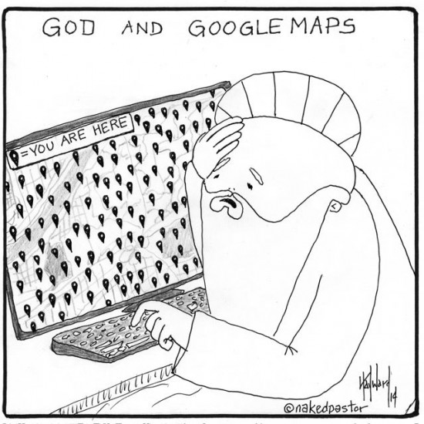
- What idea is the cartoonist trying to convey? Do you find the cartoon humorous? Give reasons for your choice.
- Do you think using Google maps is a better alternative to asking for directions? Give reasons for your choice.
__________________________________________________________________________

MCT ‘B’ –IMAGES AS TEXTS

I. Read this article by Yan Wu from storybench.org:
The harrowing cartoon images in Ca$h Cow, a series about a Tanzania girl who was abducted and then raped and beaten every day for eleven months represent a new genre of comics journalism, also known as graphic journalism.
Marc Ellison, a senior data journalist for the BBC based in Scotland, is the creator of this online multimedia narrative, which he calls a “graphic novel V2.0.” By using comic representations, Ellison says it enables him to tell the characters’ stories while potentially protecting their identities. What’s more, for an increasingly tech-savvy, tablet-oriented generation, using the graphic novel medium makes the story more appealing to Western audiences and helps draw attention to Uganda.
Ellison’s “graphic novel V2.0” is a form of graphic journalism. This hybrid combines illustrations, photographs, video and audio, among other forms of media. Ellison’s story allows users to ‘interact’ with the characters by clicking on the video icons to reveal more background information and quotes.
There are many reasons why Ellison was drawn to comic journalism. Before he became a journalist, he was a computer programmer interested in using different platforms to communicate with audiences. Since 2011, Ellison has been working on and off in Uganda, reporting about the reintegration challenges that female child soldiers face there. He has published a few traditional multimedia pieces, with photos and videos, but he’s since tried to push the envelope.While reporting Ca$h Cow, he thought a graphic novel might be a visually powerful way of telling those kinds of stories, and he wanted to create a more immersive, interactive version for the Internet.
Exploring comic journalism, Ellison understands there is the risk of exaggerating or sensationalizing a story by telling it through drawings and not real pictures or videos.
“With reporting using graphic novels, there comes great responsibility. But I think there is the same level of ethics in reporting via comic book as reporting for print, TV or radio,” Ellison said. “I include photo and video in my comics; it’s really multimedia and the illustrations are used to plug the narrative gaps. Obviously, when the girl was abducted on a motorbike, I was not there to witness that, so I imposed the illustration on top of the picture of the family’s home.” (See the image below)
Some people may criticize the idea of using comics in journalism because their perception of comic books is tales about unrealistic superheroes. That is partly the reason why Ellison puts photos and videos to break up the illustrations and to constantly remind people that these terrible things did really happen to these young girls. “The mixture is really powerful when you click the video to actually see the girl talking about her experience after you see a few pages of illustrations. It grants the illustration a sense of reality in a way the authentic article would not,” Ellison said.
He also wrote long articles that accompanied the comic stories. But he thought that “the people who read the graphic novels did not even read half of the article.” He said, “Human beings are really captured by visual images, so the benefit of the graphic novel is that it evokes a more immediate reaction in a way that a long article simply cannot.”
To Ellison, the creative thinking starts before every trip and every interview.“Before I began my journey, I had already started mentally story-boarding things that I wanted to capture,” he explained. “For example, with Ca$h Cow, I knew in my head that there are certain kinds of photos I want to get, some of which would be background photos so the artists could draw up on it, like the compound where Grace was abducted from. I have a checklist of the types of the photos I may want to get.”
As for the scripts, he always starts writing when he comes from the field. He was too busy with his “one-man-show” when he was in the field to write — he did the research, interviewed various kinds of people, and shot photos and videos, all by himself. But the most important reason is, the interviews contain too much information and are emotionally powerful. He needs time to figure out how to tell the story in a sensitive way.
Ellison did the programming work for each graphic novel by himself. He used html, javascript, and an open source javascript library called skrollr, which allows users to animate html elements.It was all custom-coded and lightweight. Ellison also made sure that the loading of images was “lazy loading” so people with slow Internet connections could access it. “It’s important to me that not only people in the UK or the United States see the stories, I want people from Uganda or Tanzania to read it too.”
Recalling the process, Ellison said, “It’s quite physically and mentally exhausting because the topics are about horrible human rights problems. But all the effort pays off.For example, when Ca$h Cow came out, I received quite a few emails from people who wanted to know how to help the girl, how to donate money to the NGO. When Safe House came out, I was contacted by a number of NGOs who asked if it is OK to use it as an educational tool in Tanzania. When you get feedback like that, it makes the effort worthwhile.”

I.A. Answer the questions that followin about 150 words: (5x10=50)
- Comment on Marc Ellison’semployment of mixed media in comics journalism.
- What do you think the writer means by the phrase ‘narrative gaps’? Explain based on your understanding of the comic form and class discussions.
- Ellison claims that “Human beings are really captured by visual images, so the benefit of the graphic novel is that it evokes a more immediate reaction in a way that a long article simply cannot.” Do you agree with this statement? Justify your stance.
- In the preface of his anthology ‘Journalism’, notedcomics journalist Joe Sacco writes: “Aren’t drawings by their very nature subjective? The answer to question is yes…” And he adds: “The comics medium is adamant and forces me to make choices. In my vision that is part of the message.”
Do you think the use of subjectivevisual story telling makes the journalistic medium less objective? Justify your stance.
5.Do you think graphic textbooks would have helped you understand a concept clearly or a subject better in school? Explain based on your learning experience.

II.A.Closely examine the comic below and answer the questions that follow:
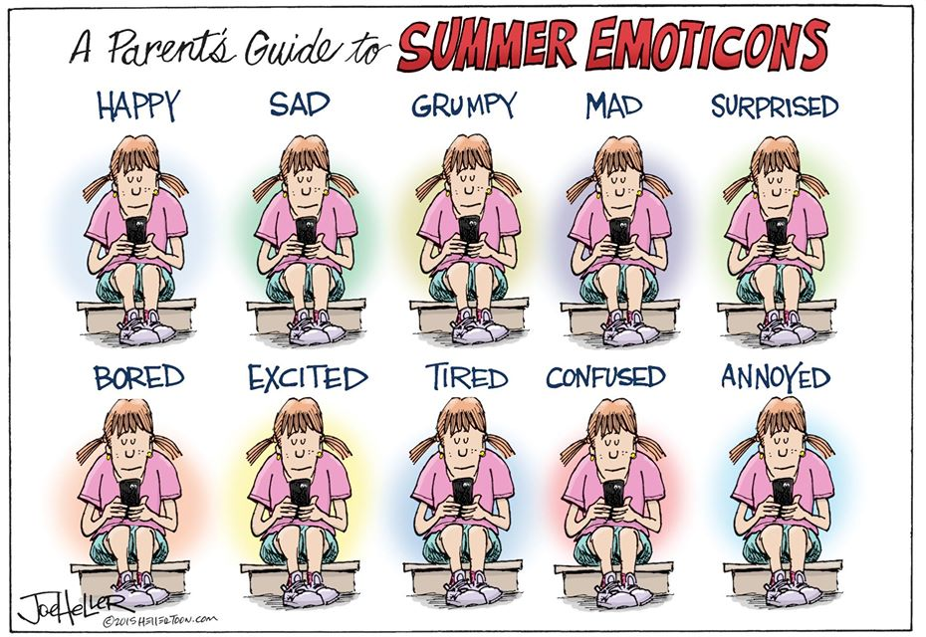

II.B. Answer the questions that followin about 150 words: (2x10=20)
1. What do you think is the message the cartoonist is trying to convey? Do you find the cartoon humorous? Give reasons for your choice.
2. Discuss your use of emoticons in day to day communication. If you were given an opportunity to add an emoticon to Whatsapp, what would it be and why?

__________________________________________________________________

