Register Number:
DATE:
ST. JOSEPH’S COLLEGE (AUTONOMOUS), BANGALORE
Fourth Semester BCA/BVC End Semester Examination- April 2017
General English (GE412) - Media, Culture & Technology

Time: 2 ½ Hours Max. Marks: 70

INSTRUCTIONS
Answer questions according to the section you have been assigned to. Please mention the section on the front page of your answer scripts.
You will lose marks for exceeding the suggested word-limits
You are allowed to use a dictionary.
THIS BOOKLET HAS SIX PRINTED PAGES

FOR MCT ‘A’- ONLINE LIVES ON WEB 2.0
I Read this article about the Internet of Things:
The Internet of Things revolves around increased machine-to-machine communication; it’s built on cloud computing and networks of data-gathering sensors; it’s mobile, virtual, and instantaneous connection; and they say it’s going to make everything in our lives from streetlights to seaports “smart.”
The Internet of Things really comes together with the connection of sensors and machines. That is to say, the real value that the Internet of Things creates is at the intersection of gathering data and leveraging it. All the information gathered by all the sensors in the world isn’t worth very much if there isn’t an infrastructure in place to analyze it in real time. Cloud-based applications are the key to using leveraged data. The Internet of Things doesn’t function without cloud-based applications to interpret and transmit the data coming from all these sensors. The cloud is what enables the apps to go to work for you anytime, anywhere.
Where it’s most common, in Britain at least, is home heating and energy use – partially because the government is pushing energy companies to roll out smart meters (although it has been questioned whether it can be delivered on schedule). They have clever functions that let you turn on heating remotely, set it to turn down the temperature if it’s a sunny day, or even turn off when there’s no-one home. Some can tell the latter with motion-sensing cameras, or simply by seeing that your smartphone (and therefore you) has left the premises.
IoT is more than smart homes and connected appliances, however. It scales up to include smart cities – think of connected traffic signals that monitor utility use, or smart bins that signal when they need to be emptied – and industry, with connected sensors for everything from tracking parts to monitoring crops.
A thing, in the Internet of Things, can be a person with a heart monitor implant, a farm animal with a biochip transponder, an automobile that has built-in sensors to alert the driver when tire pressure is low -- or any other natural or man-made object that can be assigned an IP address and provided with the ability to transfer data over a network.
IoT has evolved from the convergence of wireless technologies, micro-electromechanical systems (MEMS), microservices and the internet. The convergence has helped tear down the silo walls between operational technology (OT) and information technology (IT), allowing unstructured machine-generated data to be analyzed for insights that will drive improvements.
This all depends on your industry: manufacturing is perhaps the furthest ahead in terms of IoT, as it’s useful for organising tools, machines and people, and tracking where they are. Farmers have also been turning to connected sensors to monitor both crops and cattle, in the hopes of boosting production, efficiency and tracking the health of their herds.
The examples are endless, and all we can predict is that connected devices will likely creep into most businesses, just the way computers and the web have. When the efficiencies are with tools or plants, it’s easy to appreciate the potential benefit, but when it’s office workers who are being squeezed for more productivity, it could take on a bit of a dystopian shade: imagine your security access card being used to track where you are in the building, so your boss can tot up how much time you’re spending in the kitchen making tea.
On the flip side, a smart tea maker that knows just when you’re in need of a cuppa could be very handy indeed.
The difference of privacy in the context of the Internet of Things, as compared to privacy on the internet is the shifting notion of identity ownership. Despite what we may think, we don’t own our data. Ownership of data is complex, the rules transcend ownership as we think of physical objects. In the Internet of Things, notions of privacy, identity ownership, product ownership, consent, consumer agency, our ability to manipulate and control the very objects we ‘own,’ among numerous other behavioral templates transform.
I A Answer the following questions in about 120-150 words: [5x10=50]
- In the context of technology, how do you understand the term ‘smart’? Explain how you gathered the meaning of this word.
- Drawing on your personal experience, explore if there is a relationship between owning a smartphone and feeling a sense of empowerment.
- What are the author’s views about The Internet of Things?
- Based on what you read, do you think the Internet of Things is a feasible idea in a country like India? Provide reasons to support your opinions.
- How would you differentiate between the internet and the Internet of Things? Your response may be based on your reading, discussions and personal experience.
II Carefully examine the visual below and read the note that follows:
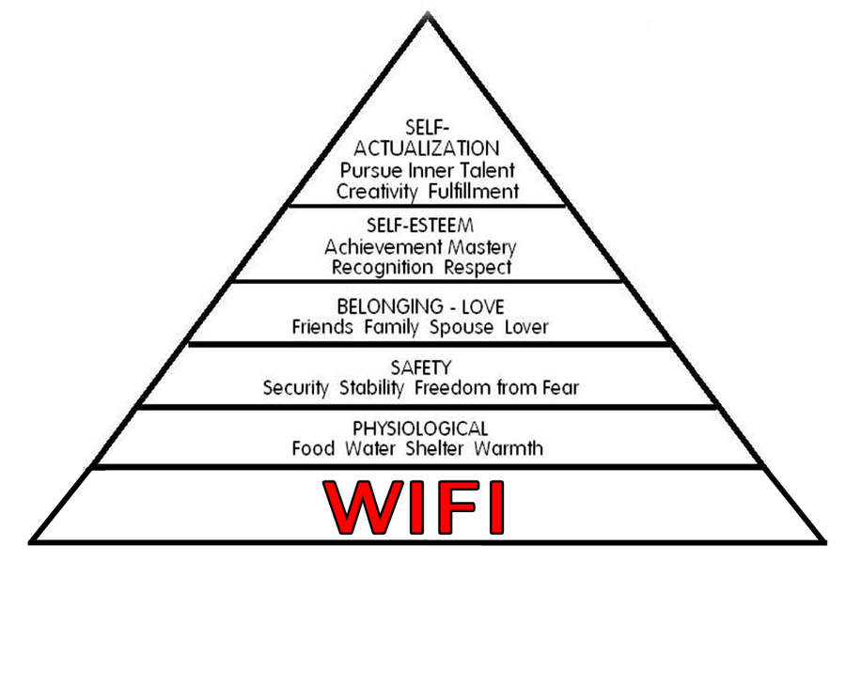
Note: The above visual is a representation of Abraham Maslow’s hierarchy of needs. - often portrayed in the shape of a pyramid with the largest, most fundamental levels of needs at the bottom and the need for self-actualization and self-transcendence at the top. The most fundamental and basic four layers of the pyramid contain what Maslow called "deficiency needs”: esteem, friendship and love, security, and physical needs. If these "deficiency needs" are not met – with the exception of the most fundamental (physiological) need – there may not be a physical indication, but the individual will feel anxious and tense. The original representation has only five levels of needs- starting with the ‘psychological’ and moving upwards. A popular meme has an extra level added- Wi-Fi.
II A Respond to the following questions in 120-150 words: [2x10=20]
- What comment about the revised ranking of human needs is the meme above making?
- Over the four semesters of your MCT course, explain what you have learnt about the interconnections among the ideas of media, culture and technology.
-------------

FOR MCT ‘B’- IMAGES AS TEXTS
I A Read this article about Curating in the Digital Age
It seems nowadays that any aspect of collecting and displaying tangible or intangible material culture is labelled as curating: shopkeepers curate their wares; DJs curate their musical selections; magazine editors curate media stories; and hipsters curate their coffee tables.
This association is not surprising. The development of increasingly interactive software such as Web 2.0 has led to a rapid rise in new technologies aimed at connecting people and information in ways that were previously unimaginable. In particular the internet has become a space in which people can collect, store and most importantly share vast quantities of information.
In a 2009 article in the New York Times, journalist Alex Williams commented on the growing trend in American consumer culture of labelling oneself a curator. “The word ‘curate’,’’ he observed, “has become a fashionable code word among the aesthetically minded, who seem to paste it onto any activity that involves culling and selecting”. Williams dated the origins of the popular adoption of the term ‘curating’ to a decade earlier; noting the strong association between the uptake and the rise of the internet.
This association is not surprising. The development of increasingly interactive software such as Web 2.0 has led to a rapid rise in new technologies aimed at connecting people and information in ways that were previously unimaginable. In particular the internet has become a space in which people can collect, store and most importantly share vast quantities of information.
This information is often about objects. According to sociologist Jyri Engeström, the most successful social network sites on the internet (such as Pinterest, Flickr, Houzz etc), use discrete objects, rather than educational content or interpersonal relationships, as the basis for social interaction. So objects become the node for inter-personal communication. In these and other sites, internet users can find, collate and display multiple images of objects on the same page, which can in turn be connected at the press of a button to other related sources of information in the form of text, commentary or more images.
These sites are often seen as the opportunity to virtually curate mini-exhibitions, as well as to create mood boards or sites of virtual consumption. The idea of curating as selective aesthetic editing is also popular in online market places such as Etsy where numerous sellers offer ‘curated’ selections from home wares, to prints, to (my personal favorite) a curated selection of cat toys. In all of these exercises there is an emphasis on the idea of connoisseurship.
Audiences can now visit museum websites through which they can easily access information about current and past exhibitions, public programs, and online collections. In many cases visitors can also contribute to general discussion forums and collections provenance data through various means such as ‘tagging’; commenting on blogs; message boards; and virtual ‘talk back’ walls. Again, however, this represents a change in how visitors access museums but not a fundamental shift in what they can access. In the past, museum visitors were still encouraged to access and comment upon the collections; it’s just that doing so took a lot more time and effort.
A recent innovation did not attempt to harness public authorship, but rather enhanced individual visitor connections to museum collections by harnessing new GPS technologies. The Streetmuseum was a free app program created by the Museum of London to bring geotagged historical street views to hand held or portable mobile devices.
The program allowed user to undertake a self-guided tour of London. After programing in their route, users could then point their device at various significant sites along the way. Looking through their viewfinder they would see a 3D historic photograph overlayed on the live site – allowing user not only to see what the area looked like in the past but also to capture an image of the overlay.
While many of the available tagging apps simply allow for the opportunity of adding more white noise, allowing viewers to add commentary, pics, links to a particular geo tagged site but with no particular focus, the Streetmuseum had a well-defined purpose to encourage their audience to get out and explore London; to share their archival photograph collection with a broader audience; and to teach people more about London’s unique history.
“My interest in technology is in its relationship with culture and its effects on society, and in many cases that can be communicated in things other than code.” (O'Dwyer 2012)
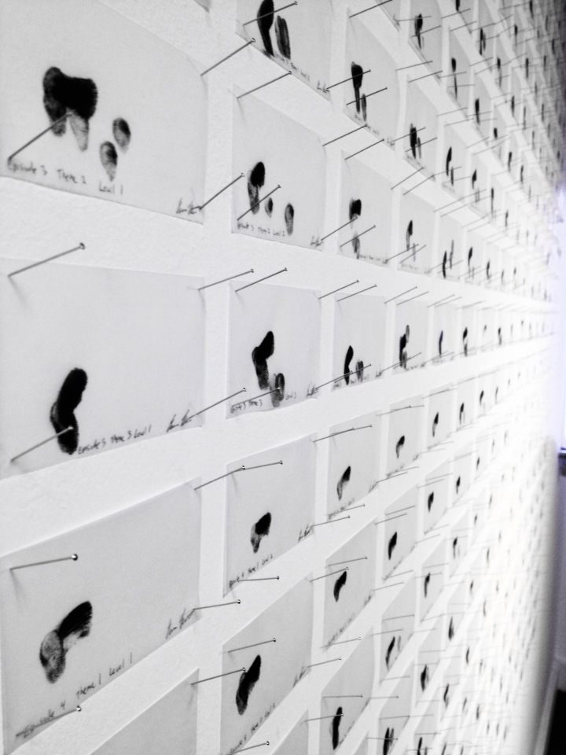
Angry Birds All Levels (2012) is the telling title of Evan Roth's last work, consisting of 300 sheets of tracing paper and black ink attached to the wall in a grid with small nails. According to the Science Gallery website, it is “a visualization of every finger swipe needed to complete the popular mobile game of the same name. The gestures are visualized on sheets of paper the same size as the iPhone the game was originally created for. Angry Birds is part of a larger series that Roth has been working on over the last year called Multi-Touch Paintings. These compositions are created by performing simple routine tasks on multi-touch handheld computing devices [ranging from unlocking the device to checking Twitter] with inked fingers. The series is a comment on computing and identity, but also creates an archive of this moment in history when we have started to manipulate pixels directly through gestures that we were unfamiliar with just over 5 years ago.” Even if it is on show in a science museum, nobody would ever say it belongs there.
In such works, technology is part of the creative process and one of the issues at stake (but not the only one). In both cases, technology does not feature in the gallery, not out of convenience or for marketing reasons, but because this is what works best for the artwork itself.
I A Answer the following questions in about 120-150 words: [5x10=50]
- Based on what you understand of the word ‘curate’ and based on your earlier knowledge of Web 2.0, do you think the internet curates information? Substantiate your answer.
- Paragraph 6 of the article displaces the word ‘curate’ from its usual context of ‘art and expertise’ and applies it to (virtual) marketplaces. What do you make if this new usage of the word?
- Paragraph 7 of the above article enumerates how the interaction with exhibits in museums has changed, with museum websites being set up. Compare this description with your experience of scanning museum websites for your blogposts.
- After examining the visual and description for Angry Birds All Levels, what opinions are you able to form about digital art? What insights do you think such pieces would generate about a sense of cultural history?
- “My interest in technology is in its relationship with culture and its effects on society”. Using the ideas in the article and other examples, demonstrate what you learnt about the interactions among media, culture and technology over the four semesters of your course.
II Carefully examine the meme given below and read the note that follows:
Note: A meme is "an idea, behaviour, or style that spreads from person to person within a culture". A meme acts as a unit for carrying cultural ideas, symbols, or practices that can be transmitted from one mind to another through writing, speech, gestures, rituals, or other imitable phenomena with a mimicked theme. Supporters of the concept regard memes as cultural analogues to genes in that they self-replicate, mutate, and respond to selective pressures. A field of study called mimetics arose in the 1990s to explore the concepts and transmission of memes in terms of an evolutionary model. Memes, analogously to genes, vary in their aptitude to replicate; successful memes remain and spread, whereas unfit ones stall and are forgotten. Thus memes that prove more effective at replicating and surviving are selected in the meme pool. An "Internet meme" is a concept that spreads rapidly from person to person via the Internet, largely through Internet-based E-mailing, blogs, forums, image boards like 4chan, social networking sites like Facebook, Instagram or Twitter, instant messaging, and video hosting services like YouTube and Twitch.tv. In 2013 Richard Dawkins characterized an Internet meme as one deliberately altered by human creativity, distinguished from Dawkins's original idea involving mutation by random change and a form of Darwinian selection.
II A Respond to the following questions in 120-150 words: [2x10=20]
- Do you agree with the parallels drawn between genes and memes? Do you think there is a necessity to distinguish between cultural memes and internet memes, as Dawkins did?
- Examine the meme supplied above, as a digitally produced form of cultural expression. According to you, what cultural purposes do internet memes serve?
-----------------

