ST.JOSEPH’S COLLEGE (AUTONOMOUS), BANGALORE-27
OPEN ELECTIVE : IV SEMESTER
SEMESTER EXAMINATION- APRIL 2017
ZO-OE-4116- A Journey into Animal World and Human Life

Time: 1 1/2hrs Maximum marks: 35
This question paper has 2 printed pages and 3 parts
I. Answer the following questions. Each question carries 1 mark 10X1=10
1. Zoo is an example of in-situ conservation (True or False)

2. What first aid needs to be given to a person in case of a heart attack?

3. List any two preventive measures to minimise Human-elephant conflict.

4. Which blood group is called the Universal donor?
5. Name a disease transmitted by mosquito and caused by a worm?
6. Protozoans are……
a. Multicellular b. Unicellular c. Vertebrates d. Sponges

7. Name the type of signal used to communicate
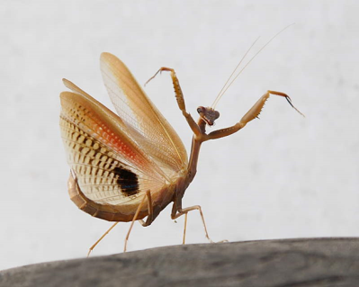 | 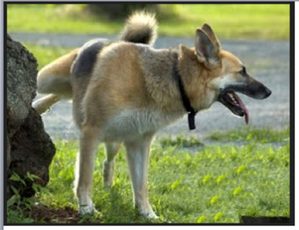

8. Give any two reasons why vermicompost should be used.
9. Name the following: a). Eastern coast of India b). An endangered animal
10. Molluscans are the second largest phylum. True / False?

II. Answer any 5 of the following 5X 2 =10
11. What is thrombosis?

12. Answer the questions based on the figure given below
- Name the type of dance? b. Why are they performed?
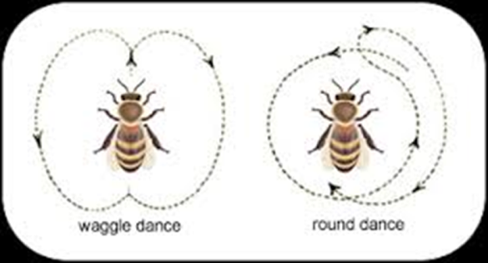

13. Match the following (2)
P | Bleeders disease | I | Parkinsons
Q | Paa | II | Cri-du-chat Syndrome
R | Mohamad Ali | III | Progeria
S | Cat cry | IV | Haemophilia

14. What are the economic uses of insects?
15. Write a short note on tuberculosis.
16. Preventive measures of AIDS.

III. Answer any 3 of the following 3X5=15
17. Write a short note on hepatitis.
18. What is brain tumour? Write a note on the preventive measures and treatment involved.
19. Write a short note on human digestive system.
20. Write the definition of Eugenics, and state tow positives and negatives of eugenics.

