2-06-2017

ST. JOSEPH’S COLLEGE (AUTONOMOUS), BANGALORE
Second Semester BA/ BSc/ BCom
SPECIAL SUPPLEMENTARY EXAMINATION: MAY 2017
GE 214 - General English

Time: 2 ½ Hours Max. Marks: 70
ATTACH THE QUESTION PAPER WITH THE ANSWER SCRIPT

INSTRUCTIONS
- This booklet contains three themes. You may answer any ONE of them.
- Indicate your stream and theme clearly on the front page of your answer booklet.
- Answer all sections under the theme you have chosen. Do not choose sections at random from different themes.
- You will lose marks for exceeding word limits.
- You are allowed to use a dictionary, during the examination.

THIS PAPER HAS 10 PRINTED PAGES
THEME 1
I Read this article entitled Twitter Fiction Reveals the Power of Very, Very Short Stories
“For Sale: Baby shoes, never worn." So goes Ernest Hemingway's famous six-word story, which, in spite of being perfectly compact, manages to paint a complete picture of thwarted desire and elicit strong feelings from the reader (unless said reader is heartless). It would've been the perfect candidate for this year's #TwitterFiction Festival.

Author Robert Swartwood, who edited an anthology of "hint fiction," or stories weighing in at 25 words or fewer, is a champion of tweet-length works. He told The Huffington Post, "A story should do four basic things: obviously it should tell a story; it should be entertaining; it should be thought-provoking; and, if done well enough, it should invoke an emotional response. And if a writer can do that with a story that's 140 characters or less, even better!"

So, brevity isn't the only qualifier for a narrative told online. In fact, most Twitter fiction stories are composed of several tweets, and so are characterized not only by pithiness, but also the social nature of the form. Neil Gaiman's Hearts, Keys and Puppetry, for example, has a unique byline: it was authored not only by him, but also "the Twitterverse." Urged to tack sentences onto Gaiman's bombastic first line of a fairy tale, readers hashtagged their way to a complete story.

Neil Gaiman
✔@neilhimself
Sam was brushing her hair when the girl in the mirror put down the hairbrush, smiled & said, "We don't love you anymore."
Though both reading and writing are traditionally solitary acts, participants in this year's #TwitterFiction Festival will employ tactics similar to Gaiman's; If I Stay author Gayle Foreman asked followers to tweet a sentence she could use as a jumping-off point. She'll craft her performance around an entry of her choice, making for a less collaborative but still technically crowd-sourced experience.
Anna North, author of The Life and Death of Sophie Stark, will be offering both previously published flash fiction stories and crowd-sourced works. She likens the latter to performance, where “even if there’s just laughing, there’s feedback from the audience."

The cooperative nature of Twitter fiction isn’t the only thing that appeals to her; she says its inherent brevity allows writers to use flash fiction to tackle esoteric topics that might not be worthy of entire novels. One such topic she's devoted many super short stories to is polar exploration. "I started to write about a polar explorer who was doing these bizarre things, like doing surgery on himself," she told The Huffington Post.A successful Twitter fiction story, she added, achieves a tone that's absurd, powerful, "and also maybe a little bit funny."

New Yorker Fiction
✔@NYerFiction
People rarely look the way you expect them to, even when you’ve seen pictures.

Jennifer Egan's short story "Black Box" ticks each of these boxes. It wasn't written in real-time, but was revealed in 140-character (or less!) spurts, beginning with the tweet above. Her Twitter fiction isn't just easy-to-digest writing; according to North, Egan's work in the medium offers something traditional stories don't have. She "plays with chronology," North asserts. "With the idea of these updates that could add up to be a whole." It doesn't hurt that the story was constructed from witty sentences that work as one liners, such as, "It is technically impossible for a man to look better in a Speedo than in swim trunks," and, "A hundred feet of blue-black Mediterranean will allow you ample time to deliver a strong self-lecture."
Though humor is key in the Twitterverse, it can be too easy to recede to stories propelled only by their ability to induce a chuckle. Which might not be such a bad thing, as Amelia Gray, author of the flash fiction collection Gutshot, demonstrates with her take on Hemingway's notorious story:
Amelia Gray
✔@grayamelia
For Sale: baby shoes, worn a lot. Please buy these old-ass baby shoes

I A Answer the questions that follow in 120-150words: [5x10=50]
- The article begins by supplying the Hemingway short story and ends with a retelling of that story by Amelia Gary. Compare the two in terms of the effect each produced on you. The two are reproduced here for your reference: 1) “For Sale: Baby shoes, never worn." 2) “For Sale: baby shoes, worn a lot. Please buy these old-ass baby shoes”.
- The second paragraph of the article enumerates author Robert Swartwood’s list of ‘things a short story should do’. Examine this list and express your satisfaction/dissatisfaction with it by stating reasons. You may present such a list of your own.
- Based on the sampling of twitter fiction from the article you read, do you think such extremely short fiction gives a sense of closure? Do you or do you not like open-ended stories? Give evidence in support of your opinion.
- Attempt an original story in 140 characters or retell an existing story (you could consider film plots too) in 140 characters. Also write about the challenges you faced in the process.
- Based on what you read about twitter fiction,do you thinkthere’s any genre that lends itself easily to be written in 140 characters? (genre: a style, especially in the arts, that involves a particular set of characteristics- for example: action, horror, comedy).

II Now read this BBC News Articles 'How I accidentally became a poet through Twitter'
Brian Bilston has been dubbed the "unofficial poet laureate of Twitter", but he stumbled into writing poetry on social media. Here he explains the power of online verse.
It started with a tweet. I never thought it would come to this.I'm not even sure it was a poem. More of a play on words, each one carefully selected to fit into the 140-character constraint of a tweet.
It went:
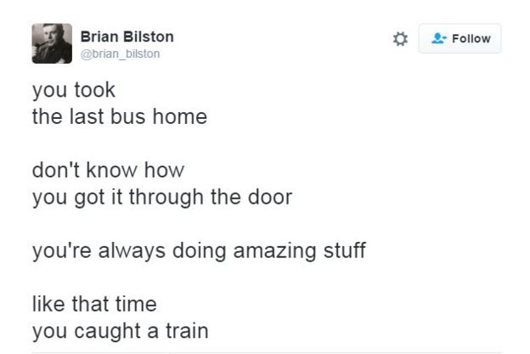
But something else had begun to bloom in the background - I had started to talk to strangers on Twitter (some of whom were very strange) and read about the things that interested them or made them laugh or annoyed or sad or angry.
And almost nothing, it seemed, made Twitter angrier than bad grammar. For every badly spelt, poorly constructed tweet, there were a hundred unreconstructed grammar pedants leaping in to point out the mistakes.So I started writing poems about these heinous crimes, the misapplication of a semi-colon, the rule about i before e, and of course, that most controversial of all the punctuation marks, the Oxford comma - and even gently mocked the grammar enforcers themselves:
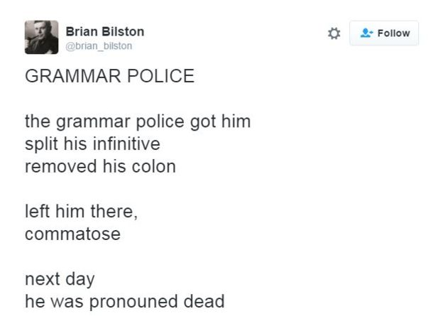
I began to experiment with the visual aspects of poetry, when I wrote a poem in the shape of a Christmas tree. The poem itself was about how I had neglected to water my words, and I illustrated this by having words spread out around the base of the poem, like pine needles scattered over a carpet.
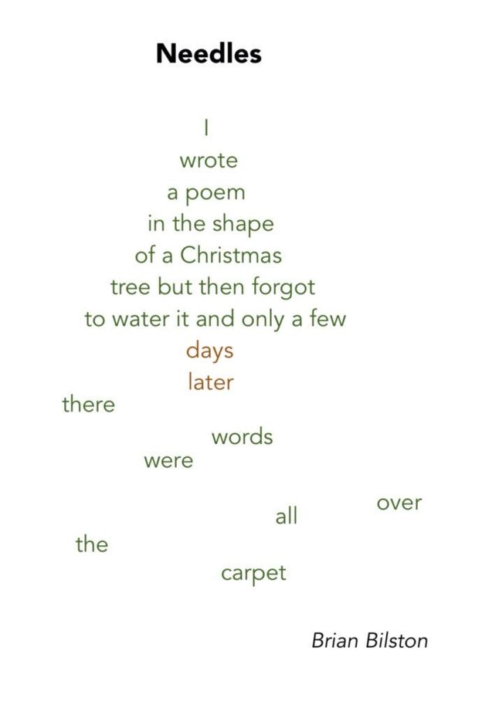

II A Respond to the following questions in about 120-150 words: [2x10=20]
- Describe your relationship with poetry. Have the terms of this relationship changed recently either because of English classes or as a result of encountering the samples of twitter poetry you just read?
- Typography is the visual component of the written word. When you looked at the poem Needles, how did the arrangement of the words on the page contribute to your experience of reading the poem?

THEME 2
I Read the following article entitled Fitted:
The American television program PBS Newshour aired a news story on self-tracking on 28 September 2013. The reporter begins with an interview with Bob Troia, an enthusiastic self-tracker who measures his sleep patterns, pulse, blood pressure, blood glucose, cognitive performance, heart rate, sweat levels, skin temperature and stress levels using a range of devices including his iPhone and wearable computing technologies. In the interview Troia says that he does all this as part of attempting to achieve a healthy, enjoyable and productive life: ‘Personally, like, my goal is to basically be – an optimal human being in every aspect of my life.’
Some further quotes from this news story included the following from another keen self-tracker: David Pogue, technology columnist for The New York Times.
‘You want to be your best self. You want to put your best foot forward.’
‘It’s absolutely narcissism. Or more healthfully, ego. It’s studying yourself as an interesting topic in ways that you couldn’t study yourself before, I mean this is just giving you self-awareness into previously invisible aspects of your life.’
From the interviews with self-trackers quoted in this brief news report, a number of discourses that give meaning to self-tracking cultures are apparent. These include those about selfhood: the importance of self-awareness and self-improvement (the attempt to be ‘an optimal human being’ and ‘your best self’) and also the role played by self-interest (‘studying yourself as an interesting topic’).
While there is constant reference among members of the Quantified Self movement to the ‘Quantified Self community’, this community largely refers to sharing personal data with each other, or learning from others’ data or self-tracking or data visualisation methods so that one’s own data project may be improved. According to the Quantified Self Institute, a research body that is part of the Hanze University of Applied Sciences in the Netherlands, self-tracking ‘is a functionally “selfish” activity, which is a result of a personal motivation. “Me and my data”, that is the point of the Quantified Self’ (de Groot, 2014).
There is a large literature on the ways in which self-identity is enacted via digital technologies. However little attention has been paid to the ways in which the specific types of hardware and software that are used as part of contemporary self-tracking cultures draw on, reproduce, and in some cases reconfigure concepts of selfhood.
Gary Wolf, a journalist and co-founder of the Quantified Self movement, argues that the combination of the proliferation of small, cheap sensors, portable computing and the emergence of social media is bringing about profound shifts that are laying the groundwork for self-quantification to enter the mainstream. He says the same early adopters who turned computers from scientific data-gathering machines into the core tools of our personal lives are the same species as the self-quantifying pioneers who are pushing personal data tracking as a logical and inevitable next step in human development.
Tied into the proliferation of sensors is the rise of the “quantified self” movement. In 2007, Wired Magazine editors Gary Wolf and Kevin Kelly coined the term “quantified self” to refer to the use of new digital technologies to record and compile data on the most intimate aspects of one’s personal life--from physical and mental performance to foods consumed and even blood oxygen levels. From Silicon Valley’s tech-oriented early adopters, the “quantified self” idea has since spread to a much broader audience interested in health and wellness.
If you wear a fitness tracker, log all your calories or scrutinise you sleep, you could be caught up in the cult of wellness. Here’s why many of us feel that being ‘good’ is no longer good enough. Your timeline is probably filled with posts from fellow fitties, uploading stats from their latest run or sharing instagram pics of their green smoothie. Or maybe you tweeted a sweaty selfie after the gym today. But while being healthy is good for us, experts now say it can also trigger feelings of guilt, anxiety and obsessive behaviour. If you think this constant body monitoring and looking after yourself is the most positive thing you can do, authors Carl Cederstrom and Andre Spicer beg to differ. In their new book The Wellness Syndrome, Cederstrom and Spicer argue this obsession with individual wellness does not lead to a well society.
I A Based on your reading, answer the questions that follow in 120-150 words: [5x10=50]
- What do you think is the tone used by the narrative towards self-tracking? (The tone expresses the writer's attitude toward or feelings about the subject matter- in this case, self-tracking).
- Do you agree with the writer’s choice to use ‘Narcissism’ (excessive interest in or admiration of oneself and one's physical appearance), ‘self-awareness and ‘ego’ as synonyms? Provide reasons for your response.
- “There is a large literature on the ways in which self-identity is enacted via digital technologies.” While the above article uses fitness trackers as an example, can you think of other examples (like the selfie or the profile picture) to examine how self-identities are enacted via digital technologies?
- The article mentions the involvement of ‘quantified self’ individual in a ‘quantified self’ community. In what ways do you think the idea of self-identity is influenced by sharing personal fitness data with others?
- How does the meme given below correlate the ideas of self-tracking and the wellness syndrome? Does the meme have the same tone as the article?

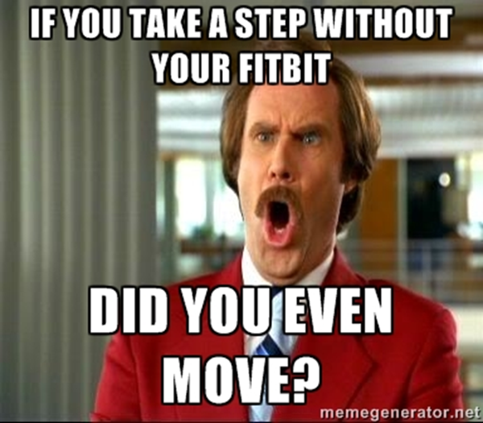

II Now read this note on Narcissus:
Narcissus, in Greek mythology, is the son of the river god Cephissus and the nymph Liriope. He was distinguished for his beauty. Narcissus’s mother was told by the blind seer Tiresias that he would have a long life, provided he never recognized himself. However, his rejection of the love of the nymph Echo or (in an earlier version) of the young man Ameinias drew upon him the vengeance of the gods. He fell in love with his own reflection in the waters of a spring and pined away (or killed himself); the flower that bears his name sprang up where he died.
The story may have derived from the ancient Greek superstition that it was unlucky or even fatal to see one’s own reflection. Narcissus was a very popular subject in Roman art. In Freudian psychiatry and psychoanalysis, the term narcissism denotes an excessive degree of self-esteem or self-involvement, a condition that is usually a form of emotional immaturity.
II A Answer the following questions in 120-150words: [2x10=20]
- Assess the manner in which the article about fitness trackers employs references to the myth of Narcissus.
- Myths are (usually ancient) stories that explain origins of cultural practices. Do you think ancient myths are culturally important to modern societies? Explain with examples.

THEME 3
I Carefully read the following set of notes:
The Ballad
Centuries-old in practice, the composition of ballads began in the European folk tradition, in many cases accompanied by musical instruments. Ballads were not originally transcribed, but rather preserved orally for generations, passed along through recitation. Their subject matter dealt with religious themes, love, tragedy, domestic crimes, and sometimes even political propaganda.
A typical ballad is a plot-driven song, with one or more characters hurriedly unfurling events leading to a dramatic conclusion. At best, a ballad does not tell the reader what’s happening, but rather shows the reader what’s happening, describing each crucial moment in the trail of events. It conveys a sense of urgency.
The Southern Murder Ballads:
As creepy as the term sounds, we've likely all heard, and even sung along with, a murder ballad. For centuries, murder ballads have served as a way for people to memorialize shocking or titillating events.
Folk murder ballads date back to the mid-17th century, and many originated in England and Scotland. The words of those earliest ballads were typically printed on broadsheets and served as "the equivalent of supermarket tabloids, providing news of strange and shocking events, many of highly dubious authenticity," according to the book "Savage Pastimes: A Cultural History of Violent Entertainment," by Harold Schecter.The lyrics of murder ballads create narratives of crimes, some true and some fictional.
Bob Dylan’s Ballad of Donald White
Bob Dylan was inspired to write this song when a programme about crime and capital punishment called 'A Volcano Named White' — was broadcast. The then twenty-four-year-old Donald White (who was, appropriately, black) was filmed on Death Row talking about how his cries for help were ignored until he finally went and killed someone, and now he was waiting to be executed.

My name is Donald White, you see
I stand before you all
I was judged by you a murderer
And the hangman's knot must fall
I will die upon the gallows pole
When the moon is shining clear
And these are my final words
That you will ever hear

I left my home in Kansas
When I was very young
I landed in the old Northwest
Seattle, Washington
Although I'd a-traveled many miles
I never made a friend
For I could never get along in life
With people that I met

If I had some education
To give me a decent start
I might have been a doctor or
A master in the arts
But I used my hands for stealing
When I was very young
And they locked me down in jailhouse cells
That's how my life begun

Oh, the inmates and the prisoners
I found they were my kind
And it was there inside the bars
I found my peace of mind
But the jails they were too crowded
Institutions overflowed
So they turned me loose to walk upon
Life's hurried tangled road

And there's danger on the ocean
Where the salt sea waves split high
And there's danger on the battlefield
Where the shells of bullets fly
And there's danger in this open world
Where men strive to be free
And for me the greatest danger
Was in society

So I asked them to send me back
To the institution home
But they said they were too crowded
For me they had no room
I got down on my knees and begged
'Oh, please put me away,'
But they would not listen to my plea
Or nothing I would say

And so it was on Christmas eve
In the year of '59
It was on that night I killed a man
I did not try to hide
The jury found me guilty
And I won't disagree
For I knew that it would happen
If I wasn't put away

And I'm glad I've had no parents
To care for me or cry
For now they will never know
The horrible death I die
And I'm also glad I've had no friends
To see me in disgrace
For they'll never see that hangman's hood
Wrap around my face

Farewell unto the old north woods
Of which I used to roam
Farewell unto the crowded bars
Of which've been my home
Farewell to all you people
Who think the worst of me
I guess you'll feel much better when
I'm on that hanging tree

But there's just one question
Before they kill me dead
I'm wondering just how much
To you I really said
Concerning all the boys that come
Down a road like me
Are they enemies or victims
Of your society?

I A Based on your reading, answer the questions that follow in 120-150 words: [5x10=50]
- Imagery draws on the five senses, namely the details of taste, touch, sight, smell, and sound. Imagery can also pertain to details about movement or a sense of a body in motion (kinesthetic imagery) or the emotions or sensations of a person, such as fear or hunger. Pick out such images in the ballad that provide this sensory experience to you.
- What (or whose) perspective (first/third) is the ballad/narrative in? How does this affect your reading of the events in the narrative?
- Examine lines 37-44 (danger on the ocean……was in society). Look up the word ‘irony’. What is the irony that these lines express?
- Identify the attitude of the ballad towards the ideas of crime and punishment. Do you find yourself sympathising with Donald White even though he is a murderer?
- Explain if your reading of the ballad allows you to place it in the genre of the southern murder ballads. (Refer to the note given in the passage).
II Read the following article about singer Bob Dylan:
Folk rock singer-songwriter Bob Dylan was born Robert Allen Zimmerman on May 24, 1941, in Duluth, Minnesota, to parents Abram and Beatrice Zimmerman. He and his younger brother David were raised in the community of Hibbing, where he graduated from Hibbing High School in 1959. Driven by the influences of early rock stars like Elvis Presley, Jerry Lee Lewis and Little Richard (whom he used to imitate on the piano at high school dances), the young Dylan formed his own bands, including the Golden Chords, as well as a group he fronted under the pseudonym Elston Gunn. While attending the University of Minnesota in Minneapolis, he began performing folk and country songs at local cafés, taking the name "Bob Dillon."
In 1965, Dylan scandalized many of his folkie fans by recording the half-acoustic, half-electric album Bringing It All Back Home, backed by a nine-piece band. On July 25, 1965, he was famously booed at the Newport Folk Festival when he performed electrically for the first time.Over the course of the next three decades, Dylan continued to reinvent himself.
His rise to fame was granted by his allegiance to the Civil Rights Movement, which provided him both topics and motifs to write songs about, but also an audience to perform for. His careful, youthful and wise song crafting style has spawned early protest songs like “Blowin’ in the Wind”, “The Times, They Are A-Changin'”, “A Hard Rain’s Gonna Fall”, and “Masters of War” – which became anthems of the Civil Rights Movementand, on the long run, laid the foundation of Dylan’s international superstardom. What made Dylan stand out from the other representatives of the folk movement was the universality of the lyrics: he did not sing about a certain instance of injustice (well, not until later in his career), but has used Woody Guthrie’s mantra of wisdom to turn issues like nuclear warfare, freedom of the individual and infringement human rights into large-scale, old-yet-still-contemporary problems. Moreover, even though his second album (“The Freewheelin’ Bob Dylan”) contains songs such as “Talkin’ World War III Blues”, that humorously describe a post-apocalyptic world that suffered nuclear annihilation, fingers are never pointed in order to designate a person’s or an entity’s guilt. Dylan satirizes actions and events that are in the human nature and have either occurred or are very likely to occur. Thus his purpose becomes that of creating a sense of awareness towards what can happen unless “they (cannon balls, nuclear weapons, abuses towards other human beings) are forever banned”.
In addition to winning Grammy, Academy and Golden Globe awards, Dylan received the Presidential Medal of Freedom from President Barack Obama in 2012. On October 13, 2016, the legendary singer-songwriter also received the Nobel Prize in Literature, the first time the honor was bestowed on a musician. He became the first American to receive the honor since novelist Toni Morrison in 1993, and was lauded by the Swedish Academy "for having created new poetic expressions within the great American song tradition."
II A Provide responses to these questions in 120-150words: [2x10=20]
- In your opinion, is the above article a biographical outline of Bob Dylan’s life so far, or is it mere trivia (incohesive bits of information)? Substantiate your opinion. What kind of details would have made that passage more interesting for you to read?
- Pick one personality whose life story you would like to narrativize either as a biography or as a bio-pic. Explain the extent to which trivia would play a role in your narrative.

-----------------------

