ST. JOSEPH’S COLLEGE (AUTONOMOUS), BANGALORE-27
B.A. JOURNALISM – II SEMESTER EXAMINATION:APRIL 2019
JN 213 - Journalism & Creative Writing

Supplementary Candidates Only.
Attach the question paper with the answer booklet

Time- 2^{1/2} hrs Max Marks- 70

Instructions:
1. You are allowed to use a dictionary.
2. This question paper has FOUR sections & FOUR printed sheets.
3. You will lose marks for exceeding the word limit. Provide word-counts after every piece of writing you attempt in this paper.

- Here is an article published in The News Minute. Read it carefully and answer the questions that follow.
Heart warming story of a dog who walked 600 km to keep a Sabarimala pilgrim company.
Megha Varier
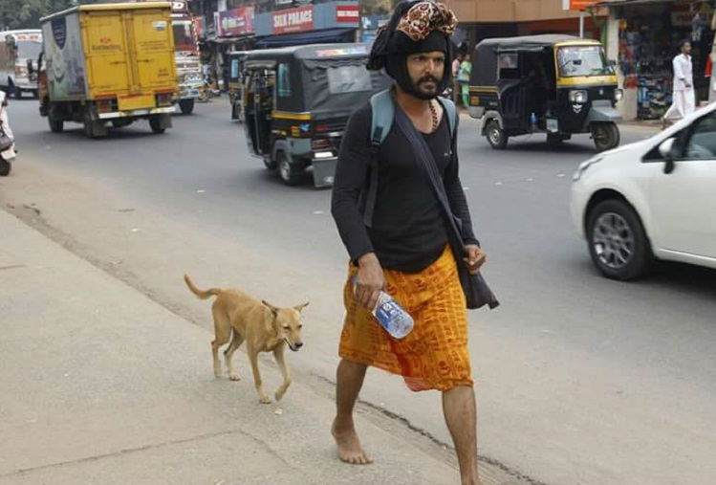
Naveen first saw Malu on December 8, on the second day of his nearly 700km pilgrimage by foot from the Mookambika temple in Kollur, Udupi to the Sabarimala shrine in Pathanamthitta. Naveen had no way of knowing then that he had found a friend of a lifetime, who would stay by his side through thick and thin.
Back then Malu was just a stray dog that was curious about a bearded man walking along the road.
It took Naveen, a 38-year-old hailing from Kozhikode in Kerala, 17 days to make the journey of more than 600 km by foot. And incredibly, Malu was with him almost every step of the way. And when he made his return journey on December 23, Malu came back home with him, seated right next to him in a KSRTC bus.
An employee at the Kerala State Electricity Board, Naveen began his journey on the morning of December 7. At first, he was worried about several stray dogs that approached him, especially in the morning hours, and invariably shood them off. But something about Malu set this dog apart from others.
Determined companion
“It was after nearly 80 kilometers or so, that I noticed her. She walked towards me from the opposite direction and stopped when she reached right in front of me. I did try shooing her off many times, but she would just not go,” Naveen tells The News Minute.
Malu had a mind of her own. For the first few days, she would maintain a distance of about 20 metres from Naveen and walk ahead of him.
“She would regularly stop and look back at me, probably to make sure I was still following her. After a few days, she began to walk behind me, constantly sniffing at my feet. I let her stay,” Naveen fondly recalls.
The journey earned her a name, a black belt and mudra mala around her neck, and a family. Malu is short for "Malikappuram", a term used to address female Sabarimala devotees.
Did Naveen know what Malu was capable of? Not at first, he admits.
“After we crossed Kozhikode, I was positive that she would not leave my side. She is a very persistent and clever dog. She would patiently wait for me when I went off to have food or take a bath. She would safely guard my thirumudikettu (bag of articles for worship) and sleep beside me at night,” Naveen says.
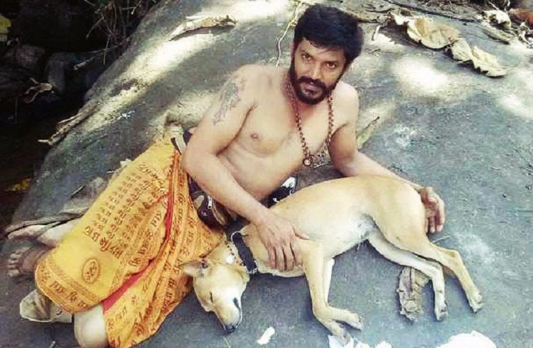
(Photo clicked by Mathrubhumi)
Naveen’s voice fills with wonder when he recalls the time Malu acted as his “alarm” to wake him up on time. Naveen used to walk an average of 50km a day, starting off at 3am and walking till he could reach a temple that would serve as his resting place for the night.
“My phone’s display had stopped working and I had overslept that morning. She tugged at my mundu, and repeatedly barked at me so that I wake up,” Naveen says.
At Sabarimala
Naveen had the shock of his life when he lost Malu for a few hours at Pamba near the shrine. However, as she had on previous days led Naveen, Malu had gone ahead of him once again.
"She was waiting near the steps that lead to the shrine. For the next one-and-a-half days, Malu waited there for my return. A few of the devotees who had accompanied me from Kozhikode called me on my phone to tell me that Malu was standing near the steps, sniffing at every man who passed by. She jumped on me the moment she spotted me in the crowd," Naveen says.
Journey back home
It was an employee at the KSRTC bus stand in Pamba who suggested that Naveen meet the special officer to make arrangements to take Malu along with him.
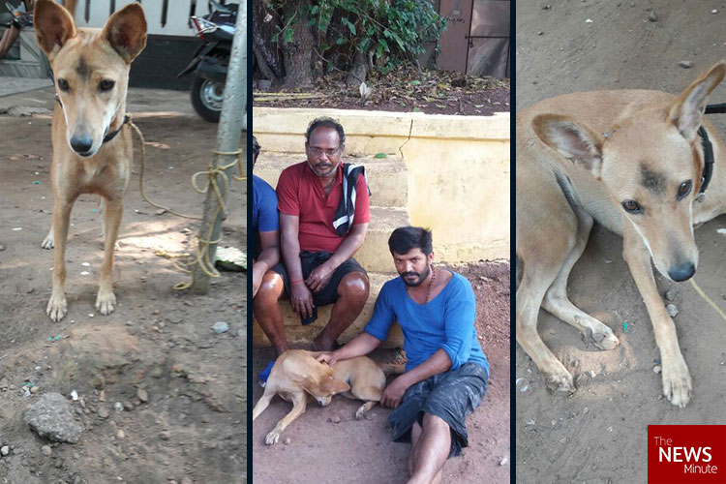
"The special officer was glad to hear our story and readily agreed to let her on the bus. I bought a ticket for Rs 460 for Malu and she fell asleep the moment we boarded. She did not wake up until we reached home late in the night," Naveen recounts.
Now, Malu has made herself at home in a large cardboard box in Naveen's house in Beypore. And proudly wears a brown-beaded necklace around her neck to remind herself and those around her of her incredible journey.

- Answer the following questions 150 words. (3x10=30)

- If you had to pick ANY ONE of the above three pictures to go with the piece, which would that be? Why? Provide a caption for the picture you choose.
- What aspects of the story would have been most challenging to write about? What would you change about the writing?

- Do you think the writer is amused by the story? Why? How is it visible?

- Respond to ANY TWO of the following topics in about FIVE sentences each: (2x5=10)
- Taimur
- Vardah
- Aleppo
- Trinamool-Bandi

- Read the following sentences and correct errors in the choice of words, punctuation and grammar, if any. Write down the correct form in a full sentence. Explain what the error is in each case in about two sentences each. If you find no mistakes, put down the phrase No Error against the relevant number. (5x4=20)

- The CBI is finding out, the unregulated financial investment schemes that were run by Rose Valley; a Bengal conglomerate with interests in real estate and entertainment.
- Following the expiry of Chief Minister Jayalalithaa Dalit leader Thirumavalavan insisted that the vacuum was in the AIADMK rather than in the wider state.
- For these remarks: both politicians have been summoned for an explanation by the National Commission for Women. Are they living in the 12th century? said, an outraged Lalitha Kumaramangalam - who heads the women's rights body.
- PM Modi today offered worship at the famous hill shrine of Lord Venkateswara at nearby Tirumala. He was accorded a customary welcome amid chanting of Vedic hymns by the high priests; who escorted him to the sanctum sanctorum along with top temple functionaries from the main entrance.
- According to resources in the Lodha -Committee, the administrators to be picked by senior advocate: Gopal Subramanium and Anil Divan, will run the cricket affairs in the country until things are in the place for a new set of office-bearer’s to take over.

IV. Respond to ANY ONE of the prompts given below in about 200 words: (10 marks)
- The shape and sound of my enemy’s name.
- Red burgers are round because…

****
JN-213-A-17

