Register Number:
DATE:8-3-2022

ST. JOSEPH’S COLLEGE (AUTONOMOUS), BANGALORE-27
M.A Advertising and Public Relations – III SEMESTER
SEMESTER EXAMINATION: OCTOBER 2021
(Examination conducted in February-March 2022)
APR ADS 9319: Account Management

Time: 2 ½ hrs. Max Marks: 70

This paper contains FIVE printed pages and THREE parts
This exam is meant to test your understanding of the entire course and your ability to apply that learning in practice. Remember to take a stand, state your point of view clearly and support it. Those sitting on the fence, unable to decide, and providing arguments for both sides of the issue will not find the going easy. Don’t waste time. Get stuck in immediately. All the best.

- Answer any TWO of the questions to follow, in 200–250 words each. (2x15 = 30 marks)

- What is the main role of a good Account Management professional? Describe in detail, in your own words. Apart from maintaining robust relationships with the Client, developing strong marcomms and manging financials, name five aspects of an Agency’s function that will suffer if she/he does not do a good job and explain why.

- One repercussion of the pandemic in marcomms is the increasing focus on meeting sales targets, sometimes at the cost of looking long-term and building a brand. The relationship between Agency and Client is becoming more transactional. Is the commonly accepted and celebrated role of Account Management relevant today? Support your answer with logic.

- Brand Equity is a potent tool. It can be used to fully understand what a brand is, what it does, how it impacts the consumer’s life and plan all marcomms activities. Your Client has a successful brand. It’s been around for a few decades, has a strong share of market and is growing well, year-on-year. The Client is clear about its positioning, and all marcomms activities convey that very well. Consumer research plays back strong affinity to the brand. Would you advise this Client to define an Equity Pyramid for the brand anyway? Why / why not? Supply a convincing answer based on your understanding of Brand Equity, and logic.

- Some Clients work with small creative shops, not large Agencies. They believe that such small teams will give them more priority and respond quicker. In addition, these Clients believe they know enough about marcomms to deal with the creative teams directly. If you were asked to convince one such Client to work with a qualified and experienced Account Management professional, how would you do it?

II. Answer any ONE of the questions to follow, in 350 - 400 words. (25 marks)

- “Agencies win new business due to great creative work, and lose accounts due to poor Client Management” is the belief among several Agencies. This puts undue stress on the Account Management team who sometimes might feel pressured into doing whatever the Client wants, only to keep him with the Agency. As an Account Management professional, how would you convince everyone at the Agency that holding on to a Client is everyone’s responsibility, and that keeping the relationship healthy is Account Management’s responsibility. Please supply at least five reasons backed by impeccable logic.

- The Agency is facing a hiring freeze during the pandemic. The Account Management / Client Servicing department is short-staffed and needs more people. Without that increase, the Agency risks losing Clients. However, the Agency cannot afford to hire all the staff it needs (a combination of Account Planners, Account Management professionals and Client Servicing people). You’ve been asked for your opinion on how you would prioritise hiring between these three functions. What would you advise?

- Your Client has asked for your help in inducting a new ABM (Assistant Brand Manager) into the ways of the Agency and how marcomms is developed. Apart from the usual introduction to different departments, and the mystique of Creative, your Client has asked that you describe to the new ABM what it is that the Account Management professional does, apart from briefing creative work etc. Specifically, the Client wants the ABM to understand how the marketing team and the Account Management team ought to work together. Prepare an outline of five areas you would cover with some explanation of why these five are the ones you’ve chosen.

- Study the case, and the three-ad print campaign below. Based on your analysis of the case and the ad campaign, attempt either question 8 or question 9. Note that all the information you are likely to need is in the case itself. If you feel something is ambiguous or missing, make reasonable assumptions, and state them clearly. Remember that common sense trumps everything. (20 marks)

DUKE’S BREAD

Duke’s Bread (DB) was a maverick bakery. Recognising that man has consumed and will always consume bread, the bakery focused on baking and selling a variety of loaves, from around the world.

Mrs. & Mr. Duke opened the bakery a few years back. Mr. Duke gave up his job as a visiting faculty at a local University to pursue a long-held passion: Baking Bread. The couple put everything into their bakery, including their life’s savings.

They reasoned that most of the bread available at stores nearby were not made from wholesome ingredients or in a healthy way. Their approach changed all that. Work at the bakery started well before dawn, as Mrs. Duke measured out the ingredients required to make the loaves that Mr. Duke had selected the previous evening. By sunrise, the first loaves were getting ready to serve / sell.

The bakery opened at 0800, and the bread was usually sold out by 1100. This popularity of DB was due to the simplicity of ingredients: whole grain, sometimes wheat, pure butter, sea salt, and live yeast. That’s all, though Mrs. Duke usually added a few dollops of loving care into each loaf.

The result never disappointed and everyone who bought DB bread swore by it. A few customers would stop by and share a loaf with Mr. Duke (who seemed to never stop eating) over a cup of coffee. Soon the couple believed they were probably on to something big.

Their product idea was fuelled by passion, but was based on wisdom that flew in the face of conventional and accepted nutritional logic. Young consumers increasingly felt that bread was all carbs and only empty calories. The Dukes laughed it off, saying there was nothing unhealthy in or about DB. It was nutritious, tasty and popular.

The only unhealthy aspect about consuming bread was the lifestyle of modern youth, they felt. “They need to get off their backsides and do something”, Mr. Duke would boom. He did have a point, as there were any number of healthy senior citizens who had not stopped eating bread – provided it was prepared correctly.

The Dukes decided they needed professional help to popularise bread consumption, and with it DB. Mr. Duke was nursing ambitions of expanding the business – perhaps more stores or a franchise operation. So, they called in your Agency.

“We’ve got a great product. What we need now is brilliant creative”, Mr. Duke said to you after the brief. You knew the gauntlet had been thrown and that the Agency would have to rise to the challenge. You had your own doubts, though. People had become used to a certain healthy lifestyle, and regular (daily) consumption of bread wasn’t part of it. Will the tasty DB and the charm of the couple be enough to swing votes? That was the biggest challenge you felt.

Some of the questions in your mind as you race back to the office:
- Should you be targeting heavy bread users, or light ones? Why?
- Who would care or worry about the quality of ingredients? Why?
- When would they be eating bread? Only mealtimes or snacking as well?
- Should you look for conversions from non-bread consumer, (who don’t eat bread at all), or marginal / occasional consumers (with whom eating bread would be more of a habit)? Why?
- It’s acknowledged that eating too much bread is not a healthy habit. So, how should you be talking about quality of ingredients, freshness of the loaves, taste etc.? Should you not be providing reassurance on health instead?
- Should you take DB into the homes of more consumers homes or try entering restaurants, coffee-shops and fast-food outlets instead?

Back at the office you issue a brief to the creative, who surprise you with a three-ad print campaign. You find it bold, simple, and focused. All the ingredients of great creative. You’re convinced and enthusiastically say that you’re ready to present the campaign to your Client.

- The Brief to Creative
Prepare the brief to creative that might have led to this three-ad print campaign. This must follow the four-question briefing format introduced to you. Bear in mind the crucial ingredients of any robust creative brief:

- A deep understanding to the target consumer.
- Clarity on what they are thinking now about the category or brand, and what we want them to think after they see the communications.
- A clear and simple articulation of the benefit.
- The message that will create the switching their thought.
- A focused and clear definition of the communications task.

OR

- Preparation for Client Meeting.
Assume you’re the Account Manager on this brand and you’re leading the Agency’s presentation of this three-ad print campaign to the Client. Please think through how you will conduct that meeting and provide the following:

- An outline of how you will present the strategic approach and the communications to the Client. Remember that the Client will want to know what strategic decisions you took, and why you took them.
- An outline of all the concerns and doubts the Client might have on seeing this campaign and how you would address them.
- An outline of what you would recommend as measurements to determine how well the campaign is working and to it is meeting the objectives set for it.

(Disclaimer: This print campaign from Dukes Bread exists. The case presented above is entirely fictional, meant only to serve as a test of understanding of key concepts in marcomms.)

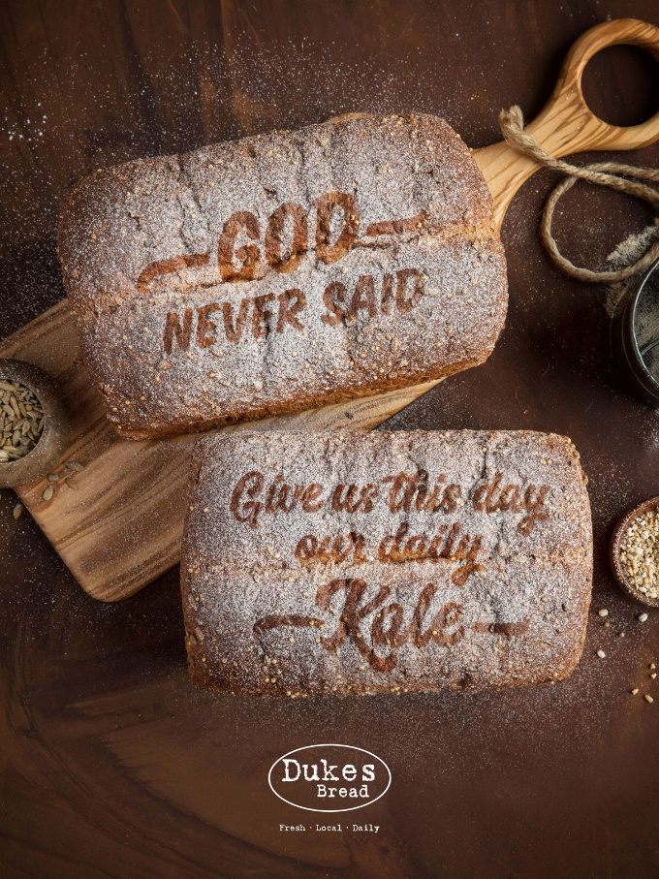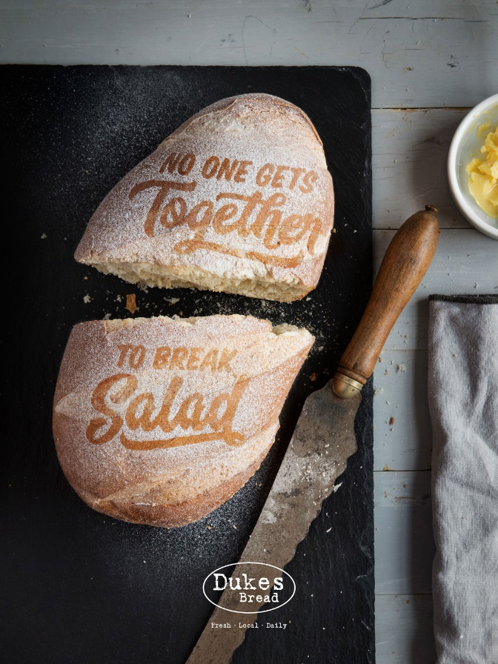

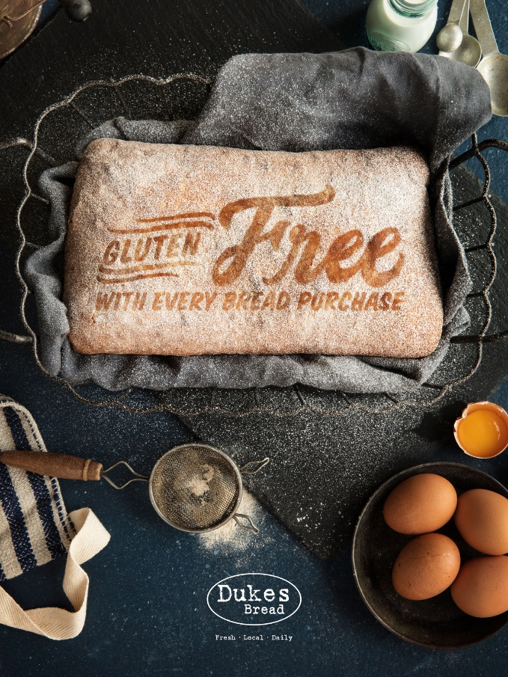
Each ad in this campaign has a different headline, “written” onto the flour dusting on the loaf of bread.
From top left, the lines read:
“God never said ‘Give us this day our daily Kale’”
“No one gets together to break salad”
“Gluten Free with every bread purchase”
The baseline says:
“Dukes Bread. Fresh. Local. Daily.”
That’s all there is. No explanatory texts, disclaimers or body copy.

******
APR ADS9319_A

