Reg No

Date:

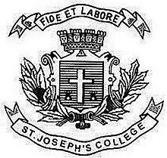
ST. JOSEPH’S COLLEGE (AUTONOMOUS), BANGALORE-27
PG OPEN ELECTIVE - III SEMESTER
SEMESTER EXAMINATION: OCTOBER 2021
(Examination conducted in January-March2022)
CS OE 9518 – Web Technologies
Time- 1 1/2 hrs Max Marks-35
This paper contains ONE printed page
I.ANSWER ALL THE QUESTIONS(2*5=10)
1.Define World Wide Web.
2. What is an HTML Frame ? What is its Purpose?
3.Mention different JavaScript objects.
4. Give the syntax for <img> and <a>
5. Write a note of Selectors in CSS.

II.ANSWER ANY FIVE (5*5=25)
6.Write the purpose of the following Web Technology languages
  - A)Html
  - B) CSS
  - C)JavaScript
7.Write an Html Program to create a Personal Information using HTML Formatting tags..
8.Create a HTML Web Page to display your Family Information using HTML TABLES with important TABLE attributes
9.Explain about Web Browsers
10.Explain the difference between Ordered List and Un Ordered List with an example
11.Write a JavaScript program to Implement Dialogue Boxes.
12.Explain about Java script arrays.

