Date:2-03-2022
Registration number:

ST. JOSEPH’S COLLEGE (AUTONOMOUS), BENGALURU-27
Msc Computer Science - I SEMESTER
SEMESTER EXAMINATION: OCTOBER 2021
(Examination conducted in January-March 2021)
CS 7221 - Theory of Computation

Time- 2 ½ hrs Max Marks-70
This question paper contains three parts and four printed pages
Part A
Answer all the following questions (15*1=15)

- The set of all strings over the alphabet S = {a, b} (including e) is denoted by
- (a+b)*
- (a+b)⁺
- a+b+
- a*b*
- Finite automata is defined as
- Abstract Machine
- Real machine
- Imaginary Machine
- None of the following
- If L1 and L2 are context free language and R a regular set, then which one of the languages below is not necessarily a context free language?
- L₁ L₂
- L₁ ∩ L₂
- L₁ ∩ R
- L₁ ∪ L₂
- All the regular languages can have one or more of the following descriptions:
i) DFA ii) NFA iii) e-NFA iv) Regular Expressions
Which of the following are correct?
a. i, ii, iv
b. i, ii, iii
c. i, iv
d. i, ii, iii, iv
- Which among these is a UNIT production?
a. Aa
b. Aza
c. AB
d. ABa
- Which of the following is an application of Finite Automata?
a) Compiler Design
b) Grammar Parsers
c) Text Search
d) All of the mentioned
- The finite automata is called NFA when there exists ______ for a specific input from current state to next state.
- Single path
- Multiple paths
- Only two paths
- None
- The transition a Push down automaton makes is additionally dependent upon the:
a. stack
b. input tape
c. terminals
d. none of the mentioned
- A language accepted by Deterministic Push down automata is closed under which of the following?
a. Complement
b. Union
c. All of the mentioned
d. None of the mentioned
- An ambiguous grammar can be obtained through
a. Only Leftmost derivative
b. Only Rightmost derivative
c. Both
d. None
- The language accepted by a Push down Automata:
- Type 0
- Type 1
- Type 2
- Type 3
- Which of the following can accept even palindrome over {a,b}
a. Push down Automata
b. Turing machine
c. NDFA
d. All of the mentioned
- Regular expression to consider strings of any number of A’s and B’s ending with AB is
a. (A+B)*
b. AB
c. AB(A+B)*
d. (A+B)*AB
- Consider a grammar: G = ({x, y), {s, x, y}, p, s)
where elements of parse:
S--> x y
S -->y x
x--> x z
x--> x
y--> y
z--> z
The language L generated by G most accurately is called
- Chomsky type 0
- Chomsky type 1
- Chomsky type 2
- Chomsky type 3
- Identify the Left Recursive Grammar among this
a. A->Ba/T
b. A->a
c. A->epsilon
d. all of the above

PART B
Answer all the five questions. In each question answer either the first or the second part (5*5=25)

- a. Convert the given NFA to its equivalent DFA
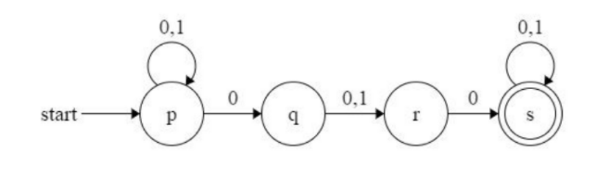
OR

b. Write a DFA to accept strings of a’s and b’s with even number of a’s and b’s.
- a. Draw a DFA from the following regular expression (0+1)*(00+11) (0+1)*
OR
b. Define regular expression and also write the regular expressions for the following
languages:
i) L= { w ϵ { a,b } * | w has exactly one pair of consecutive a's }.
ii) Set of all strings not ending in substring 'ab' over Σ = { a,b }.
- a. Eliminate Left Recursion from the given Grammar
A->Aa/B/C
T->T+B/T*X/L/M
OR
b. Convert the following grammar into GNF
S AB1 | 0
A 00A | B
B 1A1
B CA | b
C AB | a
- a. Explain Instantaneous Description for a corresponding PDA with an Example.
OR
b. What is the general purpose of the STACK in PDA. Explain any transitions of a PDA with respect to the changes in the STACK.

- a. Obtain a Turing Machine to accept the language L={0^{n}1^{n} | n>=1}
OR
b. Given a string w, design a Turing Machine that generates the string ww where w Ɛ a⁺

PART C
Answer any three of the following questions (3*10=30)
- a. How to convert NFA with epsilon to without epsilon?
b. Convert the given NFA with epsilon to NFA without epsilon. [4+6]
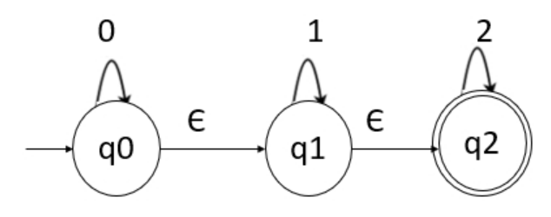
- a. What is context free grammar? [3+7]
b. Construct a regular grammar for the following FA.
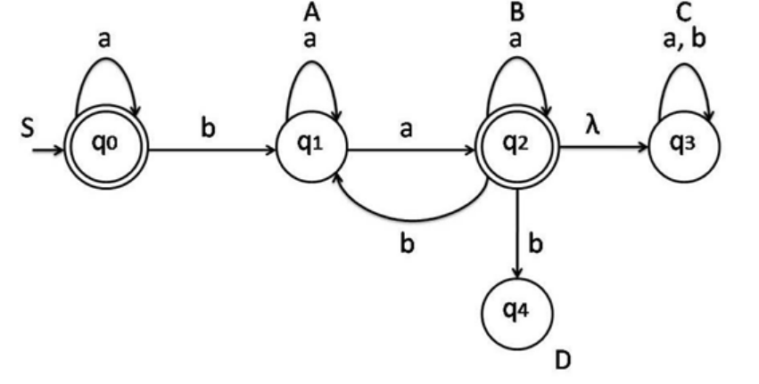
- a. What is a Finite Automata? [2+8]
b. Convert the following Non-Deterministic Finite Automata (NFA) to Deterministic Finite Automata (DFA).
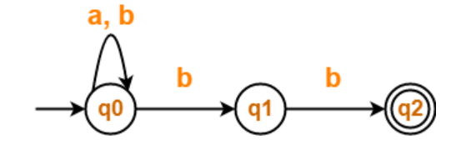

- a. What is Ambiguous grammar?
b. Show that the following grammar is ambiguous.
S aSbS
S bSaS
S Ɛ

********************************************************************************************

