Date:28-02-2022
Registration number:

ST. JOSEPH’S COLLEGE (AUTONOMOUS), BENGALURU-27
M.Sc. MICROBIOLOGY - I SEMESTER
SEMESTER EXAMINATION: OCTOBER 2021
(EXAMINATION CONDUCTED IN – FEBRARY/MARCH 2022)
MB 7121 – Microbial Diversity

Time- 2 ½ hrs Max Marks-70

This question paper contains 2 printed pages and four parts

- Answer any Five of the following 5X3=15
- What are carboxysomes?
- Differentiate between a phenogram and dendogram.
- Discuss any 3 kinds of thallus organisations seen in algae.
- What is the basic principle of numerical taxonomy?
- Highlight the unique features of the archaeal cell wall.
- List the characteristic features of r selected species.
- Draw a comparison between viroids and prions.

- Answer any Five of the following 5X5=25

- Fungi and plants share a close mutualistic relationship. Justify the statement.
- How does a bacteriophage decide to become a lysogen?
- Explain the principle of rRNA sequencing.
- Discuss the structure of the fungal cell wall.
- Give an account of aerobic cultivation of bacteria.
- How are viruses cultivated?
- Provide an overview of NGS.
- Answer any Two of the following 2X10=20

- Discuss the various inclusion bodies found in prokaryotes.
- Explain the replication cycle of Rotaviruses.
- Describe the life cycle of a typical Basidiomycetes member.

- Answer the following 1X10=10
- The given graph depicts the absorbance of DNA at 260nm with increasing temperature. The DNA samples have been taken from 4 independent OTUs A, M, R and X. Analyse the graph and answer the following questions.
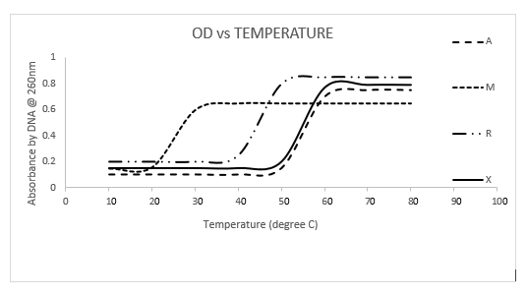
- Calculate the melting temperature of the given OTUs from the graph. (2)
- What can we conclude about the taxonomic relationship of the given OTUs from the graph? Support your response with justified explanation. (4)
- Explain the principle of the technique used to establish taxonomic relationship. (4)

