DATE:05-03-22
Registration number:

ST. JOSEPH’S COLLEGE (AUTONOMOUS), BENGALURU-27
BCOM IFA – III SEMISTER
END SEMISTER EXAMINATION: OCTOBER 2021
(Examination conducted February-March 2022)
BC IFA 3219 – Financial Management - 1

Time- 2 ½ hrs Max Marks-70

This paper contains __4___ printed pages and four parts

Section A

I. Answer any five of the following (2 x 5 = 10 marks)
- Which of the following tasks would typically be carried out by a member of the financial management team?
  - Evaluating proposed expansion plans
  - Review of overtime spending
  - Depreciation of non‐current assets
  - Apportioning overheads to cost units
- The agency problem means that shareholder wealth is not being maximised
  - TRUE
  - FALSE
- Max Co is a large multinational company which expects to have a $10m cash deficit in one month’s time. The deficit is expected to last no more than two months. Max Co wishes to resolve its short‐term liquidity problem by issuing an appropriate instrument on the money market. Which of the following instruments should Max Co issue?
A Corporate loan notes
B Interest rate futures
C Commercial paper
D Equity shares
- Although cash needs to be invested to earn returns, businesses need to keep a certain amount readily available. Which TWO of the following are reasons for holding cash?
A Movement motive
B Transactions motive
C Precautionary motive
D Asset motive
- Which TWO of the following government actions would lead to an increase in aggregate demand?
A Increasing taxation and keeping government expenditure the same
B Decreasing taxation and increasing government expenditure
C Decreasing money supply
D Decreasing interest rates

- Which of the following is an advantage of implementing just‐in‐time inventory management?
A Quality control costs will be eliminated
B Monthly finance costs incurred in holding inventory will be kept constant
C The frequency of raw material deliveries is reduced
D The amount of obsolete inventory will be minimised

Section B

II. Answer any three of the following (5 x 3 = 15 marks)
- A stakeholder group is one with a vested interest in the company. List out any five stakeholders and their conflicts between/within the group.
- Differentiate between money market and capital market.
- Dysxa Co has limited the capital investment funds in its Delta division to $7 million. The division has identified five possible investment projects, as follows:
Project | Initial investment | NPV
A | $ 30,00,000 | $ 60,00,000
B | $ 20,00,000 | $ 32,00,000
C | $ 10,00,000 | $ 17,00,000
D | $ 10,00,000 | $ 21,00,000
E | $ 20,00,000 | $ 36,00,000
These projects are divisible and cannot be deferred or repeated. Projects C and E are mutually exclusive. Determine the net present value of the optimum investment schedule for Delta division.
- The minimum cash balance of $20,000 is required at Deepdas Co, and transferring money to or from the bank costs $50 per transaction. Inspection of daily cash flows over the past year suggests that the standard deviation is $3,000 per day. The interest rate is 0.03% per day. Calculate:
  - The spread between the upper and lower limits
  - The upper limit
  - The return point.

Section C

III. Answer any two of the following (15 x 2 = 30 marks)
- A company has the following capital structure
Equity share capital of Rs.200000 (Rs.100 each)
Retained earnings Rs.100000
9% preference shares Rs.120000
7% debentures Rs.80000
Company requires another Rs.250000. To get this amount following options are available
    - issue 2000 equity shares of Rs.100 each at a premium of Rs.25 per share
    - completely through 10% preference shares
    - completely through 8% debentures
Tax rate-50% and EBIT- 12% on the entire capital. The P/E ratio for the 1st alternative is 10.7, 8.5 in the 2nd alternative and 7.85 in the 3rd alternative. 0n the basis of EPS, suggest the best alternative and also find the market price of the shares in each of the alternatives.
- Dolphin Canteen is a subsidised college canteen service, which requires to be evaluated by the management to assess, amongst other things, whether it is financially sound and offers value for money. Suggest the appropriate measures of achievement that could be set for the service.
- HotSpot Co is considering how to finance the acquisition of a machine costing $750,000 with an operating life of five years. There are two financing options.
Option 1: The machine could be leased for an annual lease payment of $155,000 per year, payable at the start of each year.
Option 2: The machine could be bought for $750,000 using a bank loan charging after tax interest at an annual rate of 7% per year. At the end of five years, the machine would have a scrap value of 10% of the purchase price. If the machine is bought, maintenance costs of $20,000 per year would be incurred. The company pays 30% tax every year.
Evaluate whether HotSpot Co should use leasing or borrowing as a source of finance, explaining the evaluation method which you use.

Section D

IV. Answer the following
(15 x 1=15 marks)
- JBL Plc is contemplating the purchase of a machine for $750,000 which can produce 50,000 units at 100% capacity. The company will be running the machine at following capacities in four years.
Year capacity
- 30%
- 50%
- 60%
- 90%
The selling price per unit is $45 and variable cost is $17. The fixed cost is $120,000 and machine is depreciated at 20% per annum at SLM with a salvage value of $150,000. Tax rate is 30%, paid one year in arrear. There was no borrowing and company needs working capital of 15% on contribution which is required at the end of each year. The cost of capital is 15%.
  - Calculate the net present value of the proposed investment and comment on your findings. (10 marks)
  - Discuss the reasons why the net present value investment appraisal method is preferred over the other investment appraisal methods such as payback, ARR and IRR (5 marks)

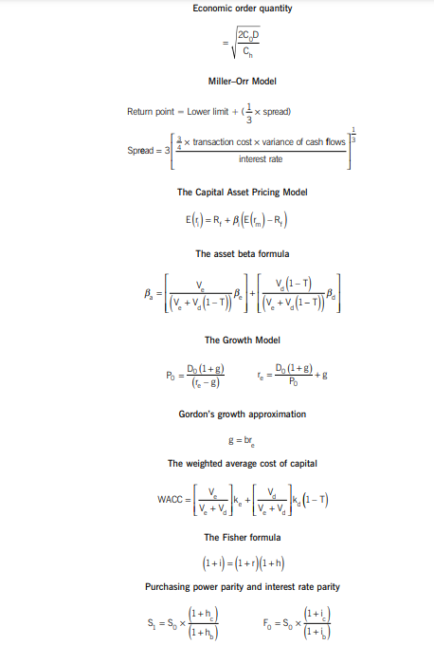
Formulae Sheet

