Register Number:
DATE:12-03-2022

ST. JOSEPH’S COLLEGE (AUTONOMOUS), BANGALORE-27
B.Com IFA – III SEMESTER
SEMESTER EXAMINATION: OCTOBER 2021
(Examination conducted in February-March 2021)

BCIFA 3319: Marketing Management

Time- 2 ½ hrs Max Marks-70

This paper contains ___3__ printed pages and four parts
Section A
I. Answer any five of the following (2 x 5 = 10 marks)
- List any four elements of the microenvironment of marketing.
- Give two examples of unsought goods.
- What is the USP of a product? Also state the USP of a product of your choice,
- Enumerate the meaning of consumer behaviour.
- What is psychological pricing? Give an example
- State any two benefits of digital marketing.

Section B
II. Answer any three of the following (5 x 3 = 15 marks)
- Briefly explain the various consumer distribution channels.
- Diagrammatically depict the product life cycle and briefly explain the same.
- Write a short note on targeting strategies.
- Briefly explain any five factors that influence consumer behaviour.

Section C
III. Answer any two of the following (15 x 2 = 30 marks)
- Explain the various marketing approaches with examples.
- a) Does marketing create need or does it recognise consumer needs? Elaborate your stance with the real life examples. (10 marks)
b) Highlight any five current ethical issues in marketing and briefly explain the same (5 marks)
- Answer the following:
  - Enumerate the various stages of new product development.(10marks)
  - Explain why new products fail. (5 marks)

Section D
III. Answer the following (15marks)

- Peru Brand: A Symbol Linking The Entire Country

Peru needed a strong and positive country brand that stood out, drew attention, and was able to transmit a clear promise. The objective was to create a competitive advantage for the country to gain international exposure in tourism, exports and investments.
In 2011 PromPeru (Commission for the Promotion of Peru for Exports and Tourism) along with the Ministry of Foreign Trade and Tourism, created Peru Brand in association with various Peruvian companies and start-ups that collaborate with each other in order to improve Peru's image in the world
The new brand identity was built around Peru’s flavours, colours and living history.
It was built to attract more tourists to both the new and the modern Peru, mirroring all its beauty, diversity and generosity.

“Peru is now an international destination that offers attractions and opportunities that are unique in the world, due to its natural and cultural treasures.”, explains branding agency Futurebrand on its website.

The brand needed to be used within a variety of sectors (tourism, gastronomy, investments…), which is why the agency decided to keep the brand’s name simple. The entire identity was built around the word “Peru” and no frills were added to the name.
The Logo
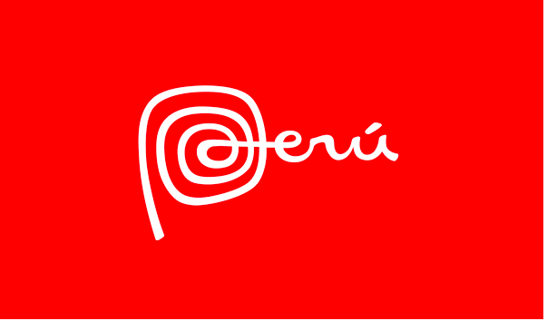
“The spiral shape of the capital letter “P” takes its inspiration from one of the graphic motifs found throughout all the ancient cultures that flourished in our land, and it represents evolution, change, and transformation. It also evokes a fingerprint, in line with the concept that “There is Peru for everyone”, explains the official website of the country.”
The red colour chosen for the logo is a reflection of the intense and vibrant red on Peru’s flag, which represents the dynamic culture and people of the country.
The country possesses different facets and aspects, the brand identity design could not just rely on the colour red, and was also built upon a multi-coloured palette. The colours symbolize the diversity of Peru’s regions and landscapes, and its energetic and stimulating character.
More than 200 companies have requested PromPerú the license for the use of Peru Brand, which is free from its website. Among the areas where this brand is most used is tourism, agriculture, textiles and hotels. Under the philosophy of making Peru known to the world, Peru Brand performs and participates in different events every year. Up to now, the campaigns of Peru Brand have had a reach of 2.491 million people worldwide, results that are they are reflected in the best positions the country has reached in different rankings. According to the Country RepTrak (a study that measures the reputation of countries), Peru is the third Latin American country with the best reputation in the industrialized countries environment, residing its strengths in the kindness of its people and its natural environment.
Questions
  - Briefly explain the importance of branding. (5 marks)
  - How has Peru gone about creating brand Peru? Was the country successful in building a strong brand? Discuss.(5 marks)
  - Explain the cultural influences that has been considered in designing the brand logo for Peru. (5marks)

